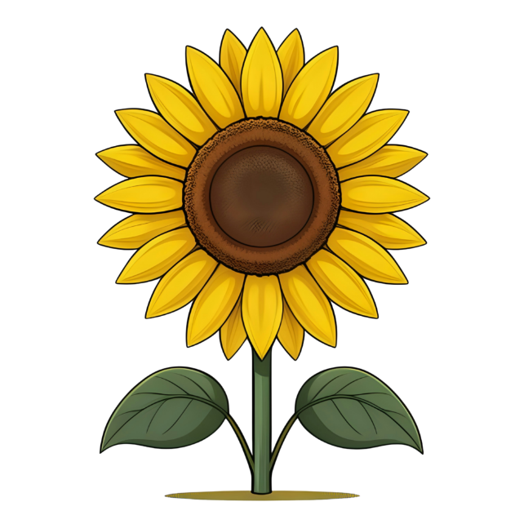
PSHE
I can calm myself down using a strategy that works for me. I am managing my feelings. I show control with my emotions. I can think about how others feel. I can manage when routines change. I can talk about why we need to wash our hands. I can play nicely with others and extend others play. I help others who are upset. I am beginning to solve conflicts with others. I am showing more social confidence.
Theme – lifecycles/Minibeasts/farm

Communication and Language

Listens more carefully. Knows why we should listen. Enjoying listening to longer stories. Pays more attention to what is happening in the stories being read. Knows they sometimes have to wait their turn when speaking. Responds to simple questions. Understanding prepositional language e.g. on, under. Asking why things are happening. I can recite or retell a past event in my life to someone else. Asking ‘where’ and ‘who’ questions. Using a wider range of vocabulary in my play. Singing some songs independently. Beginning to understand one step instructions and questions. I am responding during conversations and reasoning using the word ‘because’
Understanding the world
Use all their senses in hands-on exploration of natural materials. Explore collections of materials with similar and/or different properties. Talk about what they see, using a wide vocabulary. Plant seeds and care for growing plants. Understand the key features of the life cycle of a plant and an animal. Begin to understand the need to respect and care for the natural environment and all living things. Begin to make sense of their own life-story and family’s history. Continue developing positive attitudes about the differences between people.

Expressive Arts and Design
Begin to develop complex stories using small world equipment like animal sets, dolls and dolls houses, etc. Develop their own ideas and then decide which materials to use to express them. Join different materials and explore different textures. Create closed shapes with continuous lines and begin to use these shapes to represent objects. Draw with increasing complexity and detail, such as representing a face with a circle and including details. Remember and sing entire songs. Create their own songs or improvise a song around one they know.
Key texts (2 week rotation)
- A squash and a squeeze
- Superworm
- Goldilocks and the three bears.

Topic Map: EYFS - Nursery
Term: Summer 1

Physical Education
Use fine motor skills with increasing control to create cards, decorations etc.
Develop gross motor control through outdoor activities e.g. scooters, bikes, climbing frame.
Practise dressing and undressing for outdoor play and roleplay independently.

Mathematics
Begin to describe a sequence of events, real or fictional, using words such as ‘first’, ‘then...’ Understand position through words alone for example, “The bag is under the table,” with no pointing. Know that the last number reached when counting a small set of objects tells you how many there are in total. Compare quantities using language: ‘more than’, ‘fewer than’. Talk about and explore 2D and 3D shapes (for example, circles, rectangles, triangles and cuboids) using informal and mathematical language: ‘sides’, ‘corners’; ‘straight’, ‘flat’, ‘round’
Literacy
Learn simple songs and sing from memory. Understand the five key concepts about print:
• print has meaning.
• print can have different purposes
• we read English text from left to right and from top to bottom
• the names of the different parts of a book
• page sequencing. Engage in extended conversations about stories. Hear the similarities in the first spoken sounds in words. Say the first sound in words. Write some or all of their name.

