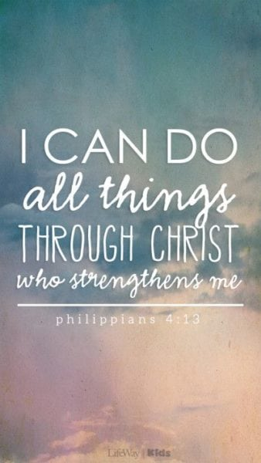
Understanding the world
- Children learn about different roles in families, work and society and explore relationships, friendships and cultural diversity

Class Book
- The Extraordinary Gardener
Other Texts
- Oliver’s vegetables
- How to find a fruit bat
- Farmer Duck

WOW Experiences
- Spanish Day
- Planting bulbs and seeds
- Visit to local park - animals
- Visit to library
- Visit to art gallery
- Sports Day

R.E – Special places
- Special places and what our church means to us

PSHE
- Know how to make friends
- Solve friendship problems when they occur
- Help others feel part of a group
- Know how to help themselves and others when they feel upset and hurt
- Know and show what makes a good relationship

Topic Map: EYFS - Reception
Term: Summer 1

Theme – Growth: Plants and animals
- Farm
- Healthy Eating
- Growing Life Cycles
- Animals around the world Animal patterns
- Habitats

Music – Oliver’s Vegetables and growth
- Listen and respond
- Explore and create using voices and instruments
- Sing
- Share and perform

Communication and Language

- Life cycle of an adult
- What babies need to develop
- What is friendship
- Farm and names of baby animals
- Parts of a plant and what it needs to grow

Expressive Arts and Design
- Create simple representations of events, people and objects
- Creates new combinations of movement and gestures in order to express and respond to feelings, ideas and experiences

Physical Education
- Throwing and catching ball skills
- Dribbling, kicking and balancing
- Experiments with different ways of moving
- Ball control exploration
- Target games and relay races
- Holds and uses a pencil effectively, use anticlockwise movement and form recognisable letters
- Shows understanding of importance of exercise, health eating, sleeping and hygiene
- How to transport and store equipment safely
- Observes the effects of activity on their bodies

Mathematics
- Recognise and count numbers to 20 and put in order
- Understand and use vocabulary of measures: weight, length and capacity
- Recall number bonds to 10
- Begin to record mathematical problems
- Sequence, order events
- Use vocabulary of addition and subtraction in practical activities
- Finds one more or one less up to 20
- To name 2D shapes and common 3D shapes
English

- Maintains attention, anticipates key events and responds to what they hear with comments, questions or actions
- Able to follow a story without pictures or props
- Begin to understand and ask and answer how and why questions
- Express views about events and characters
- Builds up vocabulary and uses talk in role play
- Can follow instructions involving several actions
- Uses past, present and future forms accurately
- Recognise a growing number of words
- Hear initial, final and dominant sounds in words
- Use phonic knowledge to read and write CVC words and ‘Red words’.

