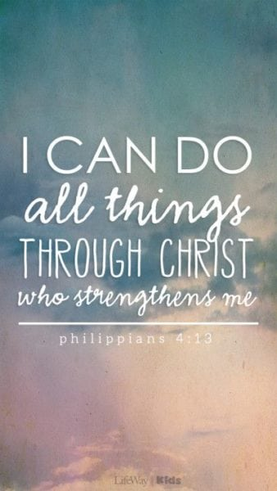
R.E - Which rules should we follow?
Key Questions
•What are rules?
•Why do we have rules?
•Who makes the rules?
•Who keeps the rules?
•Is there a difference between rules and laws?
•Who makes the law?
•What would happen if there were no rules/laws?
•Are the ten commandments still as relevant today?
•Why did Jesus bring a new commandment?
•Why do religions have rules?
DT
Anglo Saxon broach
PSHE
Relationships
*Know that different family members carry out different roles or have different responsibilities within the family
• Know that gender stereotypes can be unfair e.g. Mum is always the carer, Dad always goes to work etc
• Know some of the skills of friendship, e.g. taking turns, being a good listener
• Know some strategies for keeping themselves safe online
• Know how some of the actions and work of people around the world help and influence my life
• Know that they and all children have rights (UNCRC)
• Know the lives of children around the world can be different from their own
Computing
Simulations
• To consider what simulations are.
• To explore a simulation.
• To analyse and evaluate a simulation.
Music
Bringing Us Together
Theme: This is a Disco song about friendship, peace, hope and unity.
Facts/Info: Disco music includes strong drum and bass lines. It has quite a fast tempo with a steady dance groove and energetic electric guitar lines. Disco first appeared in the 1970s in New York.
History
Anglo-Saxons and Scots
Children will learn…
*Roman withdrawal from Britain in c. AD 410 and the fall of the western Roman Empire
*Scots invasions from Ireland to north Britain (now Scotland)
*Anglo-Saxon invasions, settlements and kingdoms: place names and village life
*Anglo-Saxon art and culture
*Christian conversion – Canterbury, Iona and Lindisfarne
PE
Indoor – Dance
*Physical: actions, dynamics, space, relationships, balance, jump
*Social: share ideas, respect, collaboration, inclusion, leadership, work safely
*Emotional: confidence, acceptance, sensitivity, perseverance
*Thinking: select and apply actions, creativity, observe and provide feedback
Outdoor – Rounders
Rounders is a striking and fielding game. The game has one fielding team and one batting team. Batters hit a small ball and score by running around the four bases on the pitch. Rounders is thought to have originated in
England as far back as the Tudor period, which was over 500 years ago.

Spanish
Seasons
Pupils will learn the four seasons of the year along with a key feature for each season in Spanish. By the end of the unit pupils will have the skills and knowledge to say which is their favourite season and why.
Wow Experiences
Trip to the Catalyst Museum
Sports Day
Topic Map: Year 3 and Year 4
Term: Summer 1

English
Text: The Journey
Writing- Narrative and Diary
SPAG
Grammar: Word
*Build on previous units & focus on:
Develop understanding of standard English forms for verb inflections (we were instead of we was)
*Grammatical difference between plural and possessive -s
Grammar: Sentence
* Build on previous units & focus on: Fronted adverbials
Grammar: Text
*Build on previous units & focus on: Nouns or pronouns to aid cohesion and avoid repetition
Grammar: Punctuation
*Build on previous units & focus on: Inverted commas and other punctuation to indicate direct
Speech
*Apostrophes for possession (plural nouns)
*Use commas after fronted adverbials
Reading
•Listen to and discuss a wide range of fiction, poetry, plays, non-fiction and reference books or textbooks
• Increase their familiarity with a wide range of stories (including fairy stories*)
•Participate in discussion about both books that are read to them and those they can read for themselves
•Identify simple themes and conventions in an increasing range of books
•Retrieve and record some information from non-fiction
•Identify how language, structure and presentation contribute to meaning.
Mathematics
Mass
*Measure, compare, add and subtract: lengths (m/cm/mm); mass (kg/g); volume/capacity (l/ml) (Y3)

Fractions
• Add and subtract fractions with the same denominator within one whole (Y3)
• Recognise, find and write fractions of a discrete set of objects: unit fractions and non-unit fractions with small denominators (Y3)
• Add and subtract fractions with the same denominator (Y4)

Science - Plants
*Identify and describe the functions of different parts of flowering plants: roots, stem/trunk, leaves and flowers.
* Explore the requirements of plants for life and growth (air, light, water, nutrients from soil, and room to grow) and how they vary from plant to plant.
*Investigate the way in which water is transported within plants.
* Explore the part that flowers play in the life cycle of flowering plants, including pollination, seed formation and seed dispersal.
Working scientifically
* Using straightforward scientific evidence to answer questions or to support their findings.
* Talk about criteria for grouping, sorting and classifying
*Asking relevant questions and using different types of scientific enquiries to answer them.
*Setting up simple practical enquiries, comparative and fair tests.
*Identifying differences, similarities or changes related to simple scientific ideas and processes
*Recording findings using simple scientific language, drawings, labelled diagrams, keys, bar charts, and tables.

