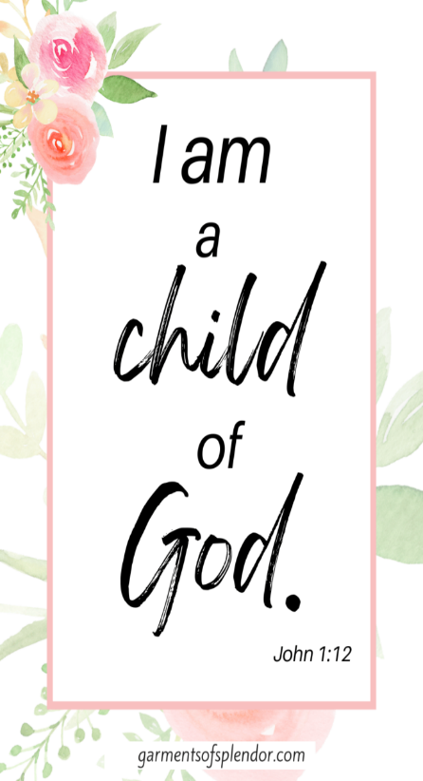
PSHE
- Talk about family celebrations and how they make us feel special.
- Encourage turn taking, sharing and teamwork.
- Explore emotions linked to excitement, surprise and gratitude.

Key texts (2 week rotation)
- The Gruffalo
- Nativity
- Ginger bread man

Communication and Language

- Learn and use new vocab linked to celebrations (festival, candle, fireworks, gift, decorate)
- Engage in roleplay using themed props.
- Develop confidence in speaking during group discussions.

Understanding the world
- Seasonal changes – autumn to winter
- Light and Dark
- Use technology to look at festivals, lights and songs from different cultures.

WOW Experiences
- School library visits
- Acorn Farm visit
- Art Gallery visit
- Library visit
- Fire brigade visit

R.E – Christmas
- How do we celebrate Jesus’s birthday?

Topic Map: EYFS - Nursery
Term: Autumn 2

Theme - Let’s celebrate
- Diwali
- Guy Fawkes/Bonfire Night
- Remembrance Day
- Christenings
- Christmas

Music - My Stories
- Listen and respond
- Explore and create using voices and instruments
- Sing
- Share and perform

Expressive Arts and Design
- Christmas cards
- Wrapping paper
- Christmas cookies
- Christmas crafts and decorations
- Christmas list
- Christmas pictures
- Advent calendar

Physical Education
- Use fine motor skills with increasing control to create cards, decorations etc.
- Develop gross motor control through outdoor activities e.g. scooters, bikes, climbing frame.
- Practise dressing and undressing for outdoor play and roleplay independently.

Mathematics
- Shapes in the environment
- Recognise and create patterns (rangoli, wrapping paper).
- Compare quantities (more/fewer)
- Begin to use positional language e.g. ‘under the tree.’
- 1-1 correspondence numbers 1-5.
- Numerals 1-5
- Oral counting daily.
- Finger gnosis- Grow me, show me, throw me.
- Numbers in the environment (door numbers-shelf numbers)
Literacy
- Enjoy listening to and joining in with celebration stories, rhymes, and songs.
- Recognise and talk about characters, events, and settings in familiar stories.
- Understand that print carries meaning and can be used for different purposes (cards, labels, lists).
- Begin to put meaning to marks
- Develop a growing awareness of rhythm, rhyme, and initial sounds in words.

