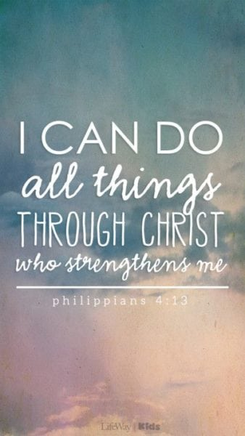
Geography
Rainforest
* To locate the world’s rainforests and understand why they are near the Equator.
* To describe the physical features and climate of a rainforest.
* To understand how plants, animals, and people live in the rainforest.
* To understand why rainforests are important and how humans affect them.

PSHE
Healthy Me
• Know how exercise affects their bodies
• Know why their hearts and lungs are such important organs
• Know that the amount of calories, fat and sugar that they put into their bodies will affect their health
• Know that there are different types of drugs
• Know that there are things, places and people
that can be dangerous
• Know a range of strategies to keep themselves safe
• Know when something feels safe or unsafe
• Know that their bodies are complex and need taking care of
Computing
Email
• To think about different methods of
communication.
• To open and respond to an email using
an address book.
• To learn how to use email safely.
• To add an attachment to an email.
• To explore a simulated email scenario.
PE
Indoor – Dance
*Physical: actions, dynamics, space, relationships, balance, jump
*Social: share ideas, respect, collaboration, inclusion, leadership, work safely
*Emotional: confidence, acceptance, sensitivity, perseverance
*Thinking: select and apply actions, creativity, observe and provide feedback
Outdoor – Athletics
Physical: sprint, jump for distance, push throw, pull throw, balance, run
Social: collaborate, work safely
Emotional: determination, perseverance
Thinking: observe and provide feedback, comprehension, explore technique
Spanish
Healthy Lifestyle
In this unit pupils will learn the nouns and articles/determiners for 10 ‘healthy’ and 10 ‘less healthy’ foods, along with the 1st person singular conjugation of the high frequency verbs ‘to eat’ and ‘to drink’. By the end of this unit pupils will be able to say what they eat and do not eat, and drink and do not drink to stay healthy.
Music
The Dragon Song
Themes: Traditional Folk tunes from around the
world, celebrating our differences and being kind to one another.
Facts/info: This song tells the story of Lesley the
Dragon who flies around the world in search of
friendship. Think about the issues of kindness,
respect, friendship, acceptance and happiness.
R.E
Easter – Sadness and Joy
Key Questions:
•Is it possible to describe the events of Holy Week and Easter simply as events of joy or sadness?
•Is the cross a symbol of sadness or joy?
•How do the services held in churches during Holy Week and Easter reflect the sadness and joy?
•Is Good Friday the beginning or the end?
•Is Easter Sunday the end or the beginning?

WOW Experiences
Swimming lessons
Art
Rainforest –
Painting/Collage:
Henri Rousseau
Topic Map: Year 3 and Year 4
Term: Spring 2

English
Text: The Great Kapok Tree

Writing-
Non-fiction Outcome: Persuasive Letter

SPAG
Grammar: Word
- Develop understanding of grammatical difference between plural and possessive –s
Grammar: Sentence
- Noun phrases expanded by the addition of modifying adjectives, nouns and prepositions
- Fronted adverbials
Grammar: Text
use adverbials and conjunctions
for cohesion
Grammar: Punctuation
- Plural Possessive Apostrophes

Reading
•Listen to and discuss a wide range of fiction, poetry, plays, non-fiction and reference books or textbooks
• Increase their familiarity with a wide range of stories (including fairy stories*)
•Participate in discussion about both books that are read to them and those they can read for themselves
•Identify simple themes and conventions in an increasing range of books
•Retrieve and record some information from non-fiction
•Identify how language, structure and presentation contribute to meaning.
Science
Light

*To recognise that they need light in order to see things and that dark is the absence of light
*To notice that light is reflected from surfaces
*To recognise that light from the sun can be dangerous and that there are ways to protect their eyes
* To recognise that shadows are formed when the light from a light source is blocked by an opaque object
* To find patterns in the way that the size of shadows change

Mathematics
Fractions
• Recognise, find and write fractions of a discrete set of objects: unit fractions and non-unit fractions with small denominators (Y3)
• Compare and order unit fractions, and fractions with the same denominators (Y3)
• Recognise and use fractions as numbers: unit fractions and non-unit fractions with small denominators (Y3)
• Measure, compare, add and subtract: lengths (m/cm/mm); mass (kg/g); volume/capacity (l/ml) (Y3)
• Recognise and show, using diagrams, equivalent fractions with small denominators (Y3)
• Recognise and show, using diagrams, families of common equivalent fractions (Y4)
Mass and Capacity
Measure, compare, add and subtract: lengths (m/cm/mm); mass (kg/g); volume/capacity (l/ml) (Y3)

