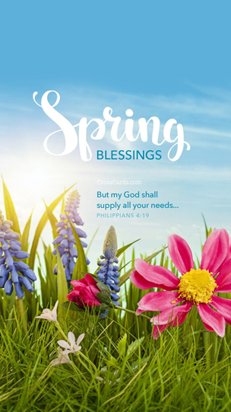
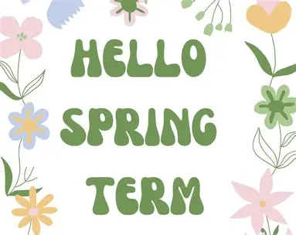
Computing
This half term, children will continue to develop their skills in using spreadsheets to organise, analyse and present data. They will learn how to enter and edit data, use formulas and functions to perform calculations, create graphs and charts to visualise information, and explore how spreadsheets can help solve real-life problems. Pupils will also practise checking and refining their work, ensuring accuracy and understanding patterns in data.

Spanish
At School/Around Town
In this unit pupils will build on prior knowledge of Spanish to talk about School and explore places around their local town.

Art
Food Printing
Children will explore pattern, texture, and colour through food printing. They will experiment with a range of materials to create repeated patterns and designs.
Music
Make you feel my love
Children will listen to the song Make You Feel My Love, exploring musical structure, tempo, and expression. They will sing confidently and develop performance skills while discussing how music can convey emotions.
R.E
Jesus the Teacher
Children will explore Jesus’ role as a teacher through parables and stories from the Bible. They will consider the messages Jesus shared, how he taught others, and what these teachings mean for Christians today, encouraging reflection on values and beliefs.
Geography
Enough for Everyone

Pupils will learn about the distribution of the world’s resources and consider whether they are shared fairly. They will explore issues such as sustainability, trade, and human impact on the environment, developing an understanding of global responsibility.
Topic Map: Year 5 & 6
Term: Spring 1

PE
Outdoor – Tennis
Children will develop coordination, accuracy, and control through racket skills, rallies, and simple game play, working both independently and as part of a team.
Indoor – Gymnastics
Pupils will create and perform sequences using gymnastic apparatus, focusing on balance, strength and movement.

Class Novel/Book
The ways of the Wolf by Smriti Halls

PSHE
Dreams and Goals
The class will reflect on their personal aspirations, identify goals, and consider steps needed to achieve them. They will explore resilience, teamwork, and how to manage challenges while celebrating achievements.
Mathematics
Year 5
This half term, children will be learning fractions, pupils will recognise and convert equivalent fractions, work with mixed and improper fractions, and compare and order fractions less than and greater than one. Children will also build on their understanding of multiplication and division. They will practise dividing numbers with remainders and apply their skills to solve a variety of problems, developing confidence in reasoning and mathematical thinking.
Year 6
This half term, we’ll be continuing our lessons to further our understanding and deepen our knowledge of fractions and measurements. Children will build on prior learning by simplifying and comparing fractions, adding and subtracting them (including mixed numbers), and exploring multiplication and division of fractions. They will also apply these skills in real-life contexts, such as finding fractions of amounts and sharing items fairly. Later, pupils will extend their learning to measuring and converting between metric and imperial units, using everyday examples like cooking or distances in kilometres and miles. We will also introduce ratio, helping children recognise and compare quantities, understand proportional relationships, and apply this knowledge to problem-solving.
English

Writing- Documentary Narrative/
Balanced Argument
Based around our class novel, children are to write a documentary narrative in first-person based on the events in one of following illustrations they will explore. To write a balanced argument based on re- introducing wolves to the UK, comparing both arguments in support of for and against the subject.

SPAG
Over the course of this half term, we will cover the following SPaG objectives:
- Semi-colons within a list (e.g., On our school trip, we visited London, where we saw the Tower of London; Oxford, where we explored the university; and Bath, where we visited the Roman Bath).
- Using the colon to introduce a list (e.g., For our picnic, we packed the following: sandwiches, fruit, juice and cookies).
- Correct use of expanded noun phrases.
- Synonyms (e.g., similar words with same meanings) Antonyms (e.g., the opposite of a word).
Reading
- Increase familiarity with a wide range of books, including myths, legends, traditional stories, modern fiction, fiction from other cultures and literary heritage texts.
- Identify and discuss themes and conventions across a wide range of writing.
- Draw inferences about characters’ feelings, thoughts and motives from their actions, and justify inferences with evidence from the text.

Science
Properties of Materials
This topic helps children understand how different everyday materials can be compared and grouped based on their physical properties, such as hardness, solubility, transparency, conductivity and magnetic response. They will also learn how some materials dissolve to form solutions and how these can be separated and recovered, and begin to explain why certain materials are chosen for specific purposes. These aims reflect the National Curriculum expectations to compare and group materials by properties, describe dissolving and separation techniques, and use evidence to explain material uses.

Reversible and irreversible changes
Pupils will explore how materials can change through processes like dissolving, mixing, heating or cooling, and identify which changes are reversible (such as melting or dissolving) and which are not (such as burning or reactions that form new substances). This supports the National Curriculum objectives to demonstrate reversible changes and explain that some changes create new materials that cannot easily be reversed.

