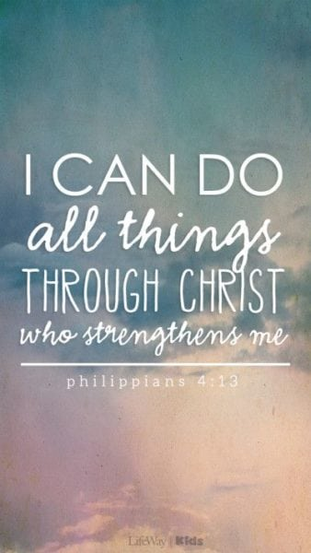
Art

Flowers
Explore flowers through drawing, painting and collage.
Exploring the floral artwork of Georgia O’Keefe

R.E.

Jesus – Friend to everyone

Stories of Jesus’ miracles
Increasing awareness that Jesus was an extraordinary person who welcomed everyone as a friend.
Geography

U.K. Countries and Cities
Learning to identify the four countries of the U.K.
Capital cities.
Key human and physical cities.
Map skills

Topic Map: Key Stage 1
Term: Spring 1
PSHE – Dreams and Goals
Achieving realistic goals
Perseverance
Learning strengths
Learning with others
Group co-operation
Contributing to and sharing success

Computing

Spreadsheets

Introducing spreadsheets.
Understanding cells and columns.
Inserting images.

Music
‘I wanna play in a band’.
Rock music
Find the pulse.
Listening to instruments.
Perform and share.

Class Novel/Book

The Bog Baby
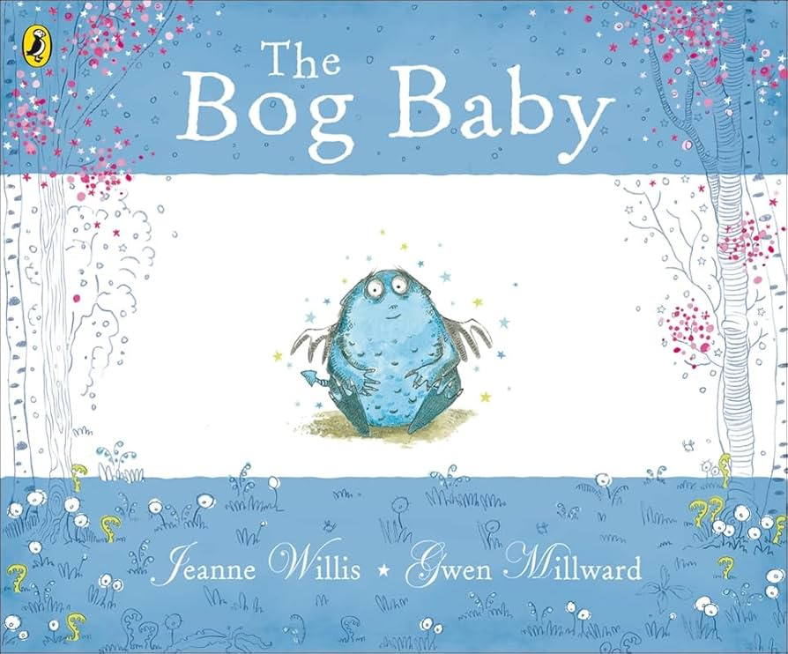

PE

Yoga
Copy and repeat yoga poses, to develop an awareness of strength and flexibility.

Target games
Aim, overarm and underarm throw, strike a target, hit a moving target.
Spanish
Seasons
Science
Plants (light and dark)

Exploring plants
Plant parts
Planting from seeds

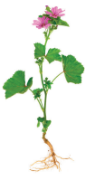

Mathematics
Y1
Place Value
Within 20
Understand teens
1 more, 1 less
Number line to 20

Addition and subtraction
Within 20
Number bonds to 20
Doubles and near doubles

Y2
Money
Counting coins
Counting notes
Making amounts
Calculating with money
Providing change

Multiplication and division

Equal groups
Making and adding equal groups
Multiplication symbol
Multiplication sentences
Doubling and halving
2s, 5s and 10s times tables
English

Literacy Counts

A finding narrative

Formation of nouns by compounding

Subordination (when, if, that, because)

Past and present verbs

Use of the suffix –ly to turn adjectives into adverbs Form adjectives using suffixes -ful and –less

Learn how to use co-ordination (or, and, but, so) Sentence indicates its function as a question and an exclamation Expanded Noun Phrases for description and specification

Correct choice and consistent use of past and present tense throughout writing

Use of capital letters, full stops, question marks and exclamation marks to demarcate sentences

Apostrophes to mark where letters are missing in spelling and for singular possession in nouns Commas to separate items in a list

Read Write Inc Phonics/Ready Steady Read Together

Handwriting

