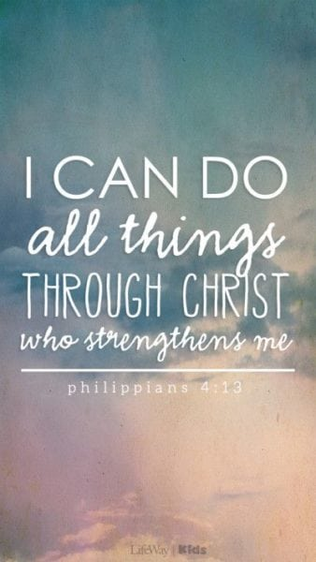
Class Novel/Book
Hansel and Gretel by Neil Gaiman

R.E
Christmas around the World
Children will explore the Christmas story and its importance to Christians. They will learn how Christian beliefs are shown through Christmas celebrations and compare how the festival is celebrated around the world.

PE
Outdoor - Basketball
Basketball is an invasion game where pupils learn attacking and defending principles. They develop skills, strategies and tactics to maintain possession, move the ball and score.
Indoor - Gymnastics
Pupils develop balancing, rolling, jumping and inverted movements and explore partner work such as synchronisation and mirroring.

PSHE
Celebrating Differences
The class explore culture and cultural differences, linking this to racism and reflecting on their own attitudes towards others. They revisit bullying, discussing rumours, name-calling, and both direct and indirect bullying, as well as ways to discourage such behaviour.

History
Leisure and Entertainment in Liverpool
Children will learn how leisure and entertainment in Britain have changed over time. They will explore how technology, work and society have influenced holidays, sport, music, cinema and television. By comparing past and present, pupils will understand how people’s free time has evolved and what this reveals about life in different periods.

Topic Map: Year 5 & 6
Term: Autumn 2

Computing
This half term, children will learn how to present data clearly and effectively using digital graphing tools. They will use 2Graph and 2Calculate to create a range of common graph types, including comparative bar charts, pie charts and line graphs. As they explore these tools, they will learn how different features help make information easy to understand. By the end of the unit, children will be able to choose appropriate graphs to present data and use their findings to support an argument.

Spanish
At School
In this unit pupils will learn the nouns and definite articles/determiners for 10 school subjects in the foreign language.
Christmas
Children will get into the festive spirit by learning some Spanish Christmas Jingles – FELIZ NAVIDAD!

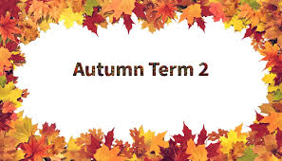
Music
Classroom Jazz
The children learn about jazz music through listening, improvising, and performing.

English

Writing- Persuasive Letter

Children are to write a persuasive letter based on a different character’s viewpoint and possibility for persuading another character.

SPAG
Over the course of this half term, we will cover the following SPaG objectives:
- Use modal verbs (e.g., might, should, will, must) or adverbs (e.g., certainly, possibly) to indicate degrees of possibility.
- Use parenthesis to add extra information (using brackets, dashes or commas).
- Understand the difference between formal and informal language
- Use relative clauses, beginning with who, which, where, when, whose, that or with an implied relative pronoun.
Reading
Over the course of this half term, we will cover the following Reading objectives:
- Increase familiarity with a wide range of books, including myths, legends, traditional stories, modern fiction, fiction from other cultures and literary heritage texts.
- Identify and discuss themes and conventions across a wide range of writing.
- Draw inferences about characters’ feelings, thoughts and motives from their actions, and justify inferences with evidence from the text.

Science
Space
In our Space unit, children will learn about the Sun, Earth and Moon, exploring how they move and interact. They’ll study the planets of the Solar System, model their orbits, and investigate how ideas about space have changed over time. Through hands-on activities, children will discover how day and night occur, why Earth has seasons, and how the Moon orbits our planet.
Global Warming
In our Global Warming unit, children will learn what global warming is and explore how it is caused by greenhouse gases and human activity, such as burning fossil fuels. They’ll investigate how rising temperatures affect our planet, including the impact on animals, plants and people. Children will also consider how changes in weather patterns can lead to flooding and drought. Finally, they’ll think about ways to care for the environment by reducing their carbon footprint and making more sustainable choices at home and in school.

Mathematics
Year 5
Children will develop their understanding of number and calculation. They will practise mental strategies and work with addition and subtraction of large numbers, including multi-step problems and checking answers by rounding. We will explore multiples, factors, prime, square and cube numbers, and learn to multiply by 10, 100 and 1,000. In fractions, pupils will recognise and convert equivalent fractions, work with mixed and improper fractions, and compare and order fractions less than and greater than one.

Year 6
This half term, we’ll be diving into fractions and measures in fun, practical ways. Children will learn how to simplify and compare fractions, add and subtract them (including mixed numbers), and even multiply and divide fractions. They’ll also explore real-life applications, such as finding fractions of amounts in recipes or sharing items fairly. Later, we’ll move on to measuring and converting between metric and imperial units, using everyday examples like cooking, distances in kilometres and miles, and understanding how these measures work in real life.

