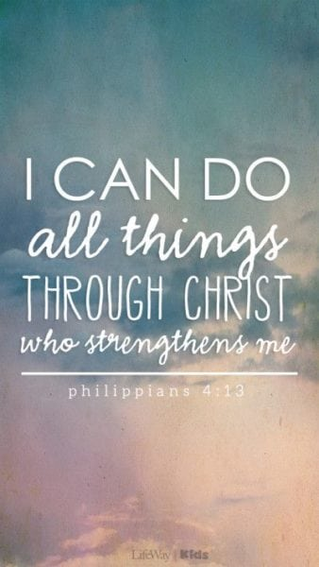
Class Book
- Star in the Jar by Sam Hay
Other Texts
- Room on the Broom
- Stickman
- Nativity

Understanding the world
- Space
- Light and Dark

WOW Experiences
- Acorn Farm visit
- Art Gallery
- Library
- Fire brigade
- Post office

R.E – Christmas
- How do we celebrate Jesus’s birthday?

PSHE
- Accept that everyone is different
- Include others when working and playing
- Know how to help if someone is being bullied
- Try to solve problems
- Use kind words
- Know how to give and receive compliments

Topic Map: EYFS - Reception
Term: Autumn 2

Theme - Let’s celebrate
- Remembrance Day
- Halloween
- Diwali
- World Space Week
- Guy Fawkes/Bonfire Night
- Christenings
- Christmas

Music - My Stories
- Listen and respond
- Explore and create using voices and instruments
- Sing
- Share and perform

Communication and Language

- Listen to stories
- Use a wider range of vocabulary
- Understand what a question is
- Talk about familiar books
- Use talk to organise themselves and their play

Expressive Arts and Design
- Christmas cards
- Wrapping paper
- Christmas cookies
- Christmas crafts and decorations
- Christmas list
- Christmas pictures
- Advent calendar

Physical Education
- Develop the ability to jump in a range of ways from one space to another with increasing control
- Create a sequence using a jump and a balance
- Develop the ability to roll in a range of ways
- Control their body when rolling in a range of ways
- Perform a sequence with confidence and control

Mathematics
- Composition of 1 – 5
- Subitise 1 -5
- 1 more
- 1 less
- Number bonds 1 -5
- Identify and name shapes with 4 sides
- Combine shapes with 4 sides
- Shapes in the environment
English

- Represent words in print
- Orally rehearse sentences and Word Count the number of words spoken prior to writing.
- Focus on a simple sentence.
- Combining words to make labels, captions, lists, phrases and short sentences
- Support correct use of the Sentence Accuracy Check.
- Listen to and talk about stories to build familiarity and understanding.
- Learn new vocabulary from texts.
- Recognise four parts of a simple narrative – opening, build up, problem and ending.
- Retell the story in own words
- Letter formation
- Separation of words with spaces
- Personal pronouns
- Common Exception red words

