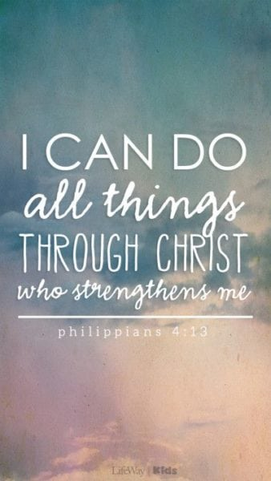
History
Nurturing Nurses
Learn who Florence Nightingale was and why she is remembered
Compare Nightingale with Mary Seacole, understanding how they improved hospitals

Remembrance

Poppy symbol
Peace, kindness and remembering
Topic Map: Key Stage 1
Term: Autumn 2

PSHE – Celebrating Difference
Accept that everyone is different
Include others when working and playing
Know how to help if someone is being bullied
Try to solve problems
Try to use kind words
Know how to give and receive compliments

Computing

Creating Pictures

Using a digital art tool to create art in different traditional styles

Music
Ho Ho Ho
Listen and appraise styles of music-Christmas, big band, Elvis, Motown, Freedom Songs

Class Novel/Book

The Night Gardener

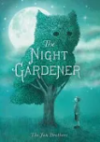
PE

Gymnastics
Shapes, balances, travelling actions, shape jumps, barrel roll, straight roll and forward roll

Fitness
Run, stamina, skip, co-ordination, agility, strength, balance and jump
R.E.

Christmas: Journey to Bethlehem

Explore the Christmas story through the journeys to Bethlehem made by Mary and Joseph and those who travelled to visit the Christ Child
WOW Experiences
Nativity
An Elephant in a Boat
Spanish
Seasons
Greetings
Science
Humans

Exercise, Food, hygiene, teeth

Materials
Explore
Wood, paper and cardboard
Brick and rock
Glass and plastic
Metal
Fabrics
Objects and materials
Waterproof

Mathematics
Y1
Addition and Subtraction
Within 10
Subtraction
Fact families
Add and subtract 1 and 2

Shape
2D and 3D shapes – sorting, recognising and naming

Y2
Addition and Subtraction
Up to 100
Add and subtract 10
10 more 10 less
Subtract 2 digit numbers

Shape

2D and 3D shapes – edges, faces, vertices
English

Literacy Counts

Diary recount writing

Use of the suffix –ly to turn adjectives into adverbs Form adjectives using suffixes -ful and –less

Learn how to use co-ordination (or, and, but, so) Sentence indicates its function as a question and an exclamation Expanded Noun Phrases for description and specification

Correct choice and consistent use of past and present tense throughout writing

Use of capital letters, full stops, question marks and exclamation marks to demarcate sentences

Apostrophes to mark where letters are missing in spelling and for singular possession in nouns Commas to separate items in a list

Read Write Inc Phonics/Ready Steady Read Together

Handwriting

