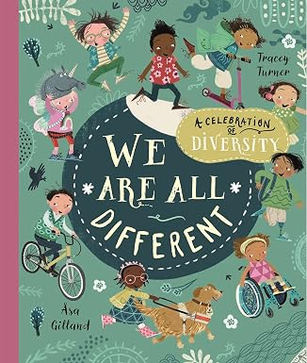
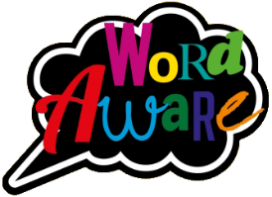
KNOWLEDGE ORGANISER
Books that will be supporting my learning:
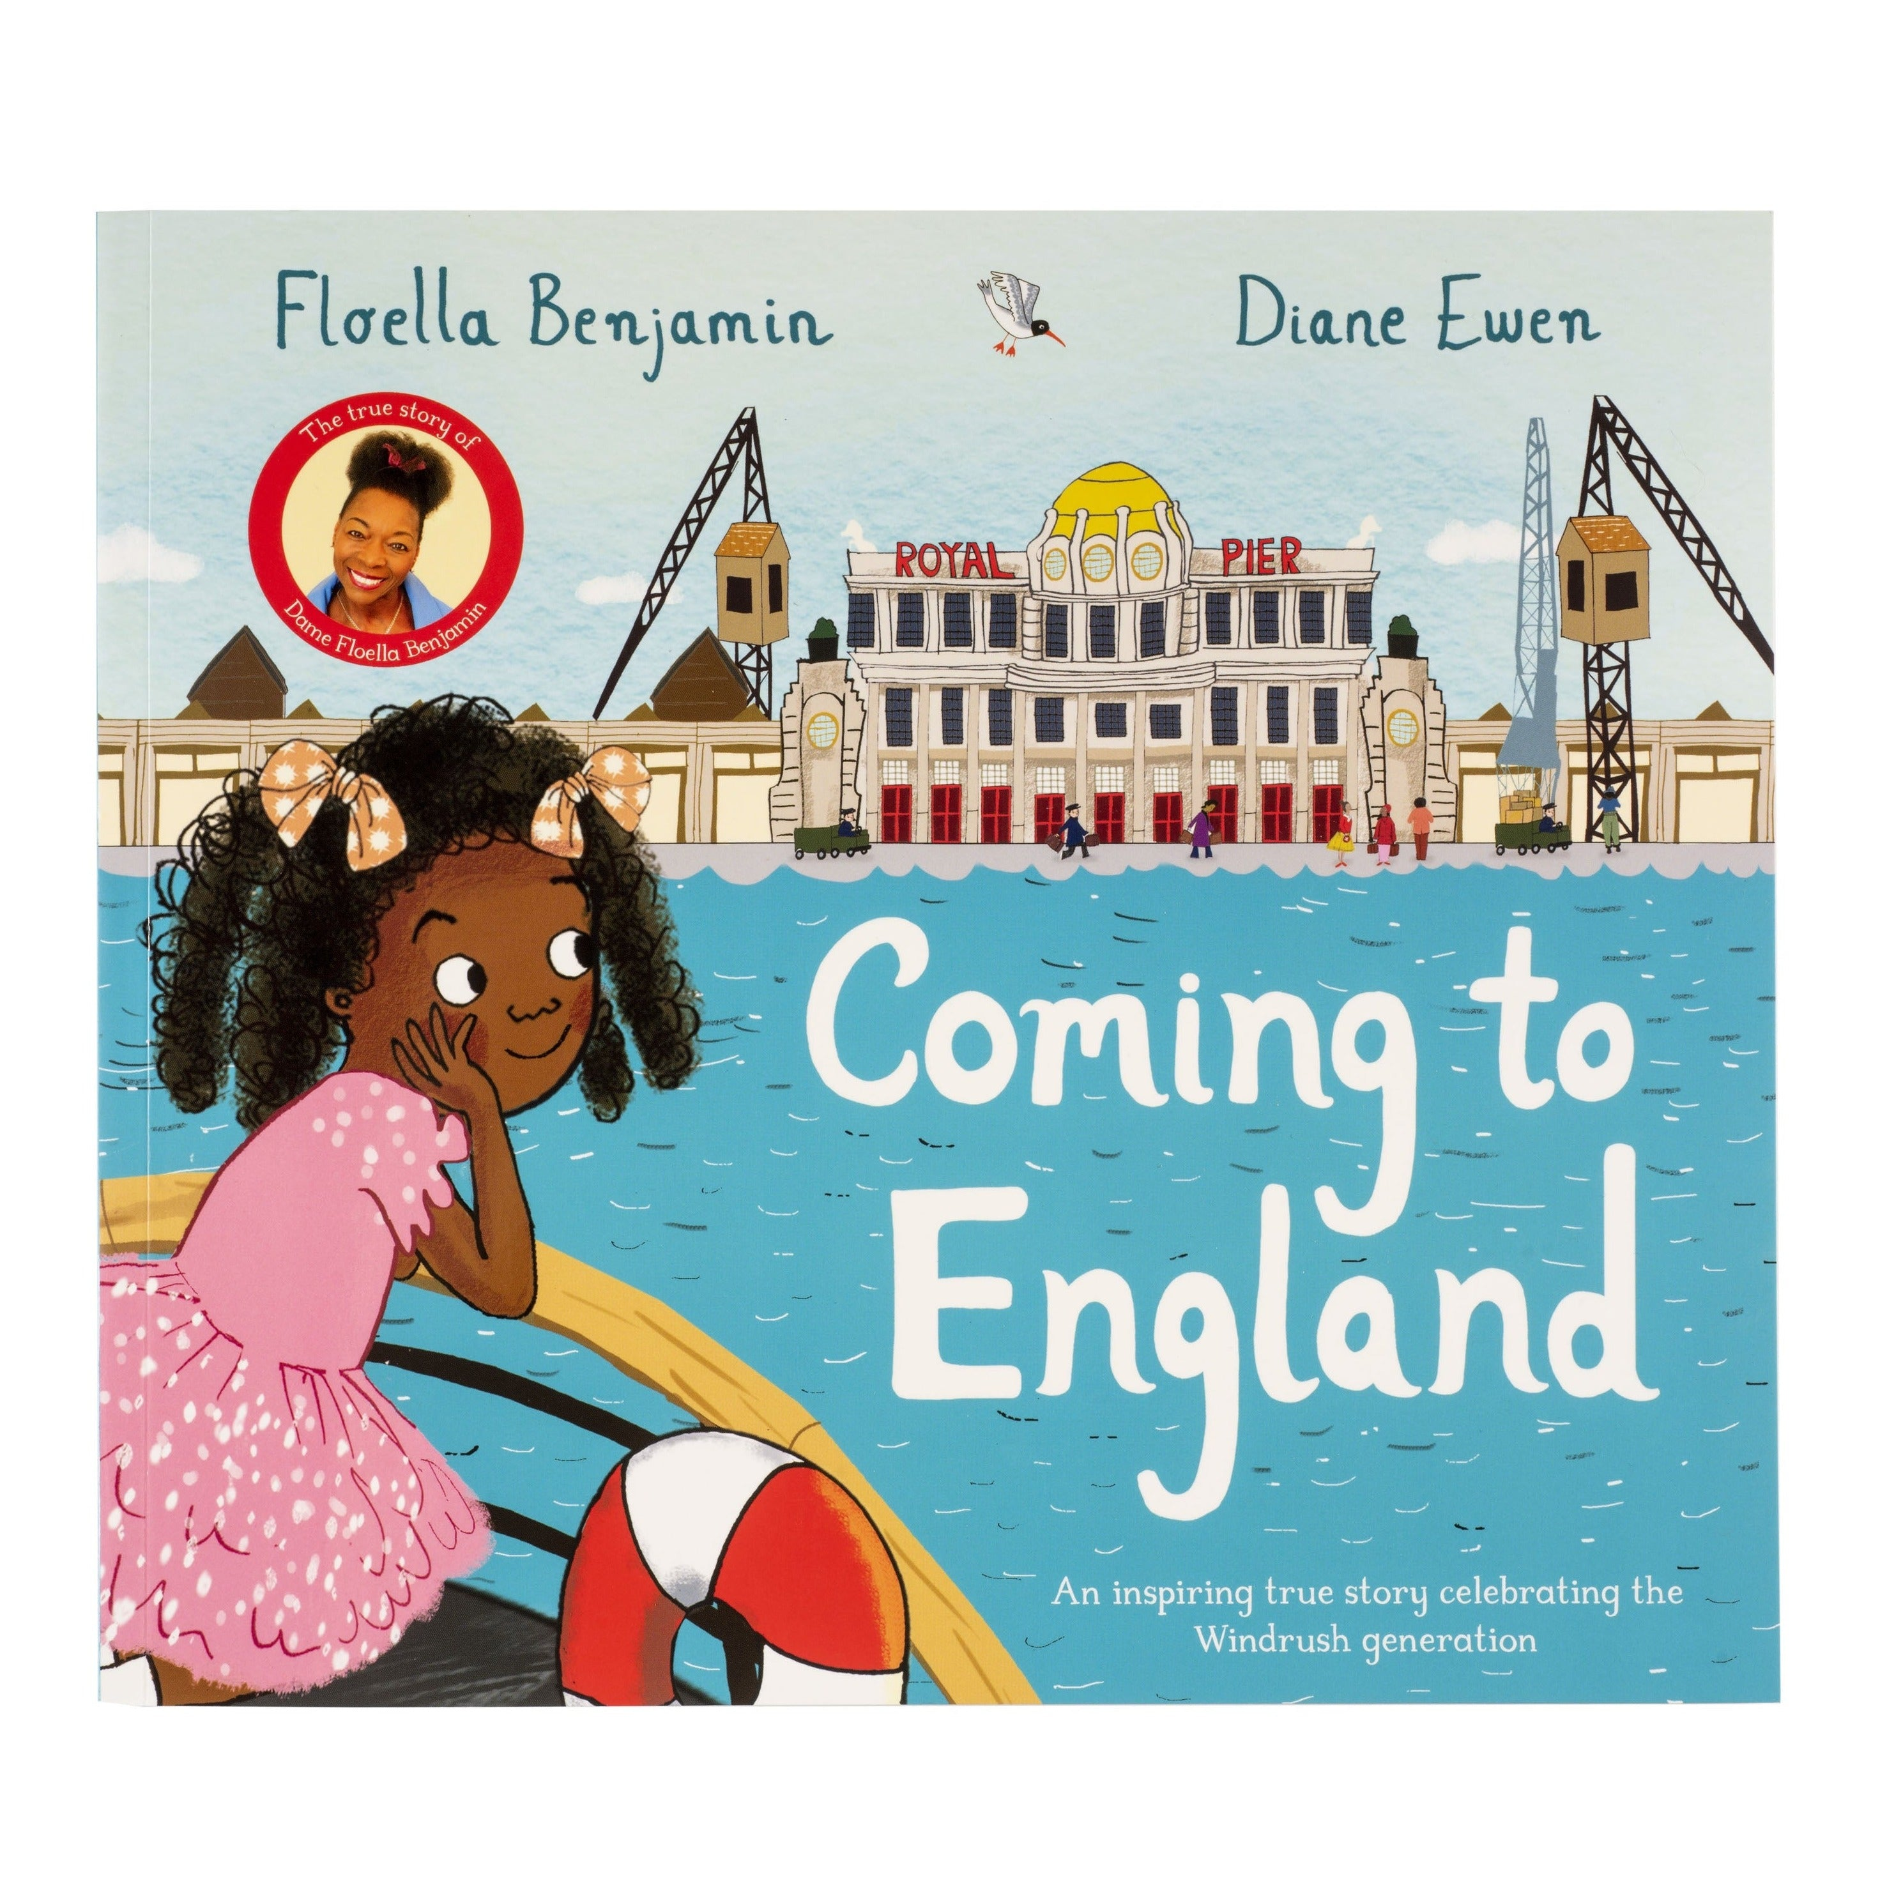
GOLDILOCKS WORDS
These are words that the children will be exposed to and will be encouraged to use during the teaching of this topic.
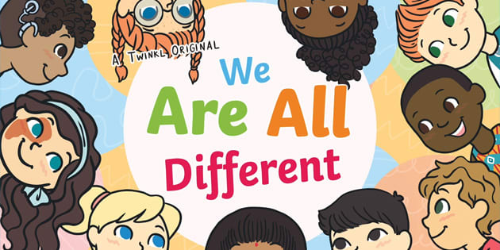
Year: Year 3 Term: Autumn 1
IMAGE | WORD | DEFINITION
  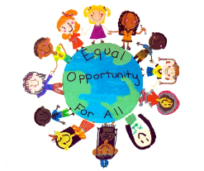 | Opportunity | An opportunity is a chance to do something good, fun, or helpful, or a special moment
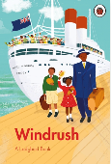 | Immigration | An immigrant is a person who moves permanently to another country from their native land.
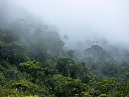 | Windrush | The Windrush Generation refers to the Caribbean settlers who arrived in Britain after WWII.
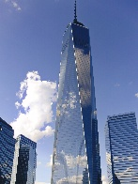 | Humid | Having a high amount of water vapour; damp; moist.
 | Skyscraper | A very tall building with many stories, or floors.
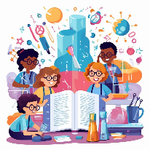 | Experience | What you learn or feel when you do something or see it happen.

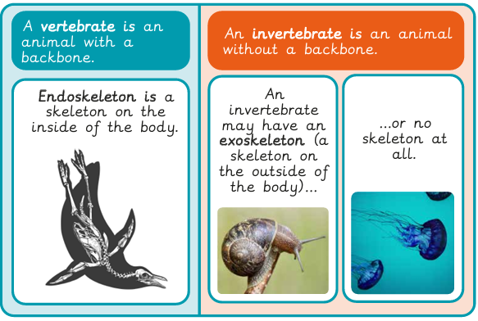
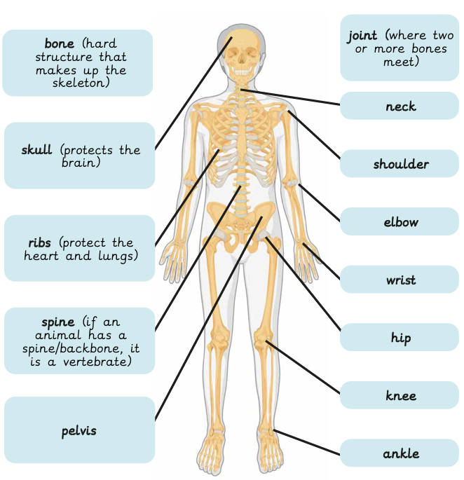
Key dates:
Friday 25th September Macmillan Coffee Morning
Friday 2nd October – Flu Vaccine in school
Thursday 8th October – Harvest Festival at St Johns Church at 9:15 am

What will I be learning?
Maths – This term in Year 3, we will be learning about place value. We will explore how numbers can be represented in different ways, compare and order numbers, and identify the value of each digit. We will also develop our estimation skills. Alongside this, we will be practising our times tables, focusing on a different times table every two weeks. We will then move on to learning about addition and subtraction, developing efficient methods for solving calculations and applying these skills to problem-solving activities.
English – This term in Year 3, we will initially focus on the presentation of our work, handwriting and SPaG (Spelling, Punctuation and Grammar). We will then concentrate on using prepositions to show time and place, grouping ideas into paragraphs, and learning how to punctuate speech correctly.
This term in Year 3, we will learn about the Windrush Generation. We will explore how people from the Caribbean helped rebuild Britain after the Second World War and discover how their music, food and traditions have become an important part of British culture.
This term in Science, we will learn all about movement and nutrition. We will discover how our bodies move, how our muscles and bones work together, and why eating a healthy, balanced diet helps us stay strong and healthy.

