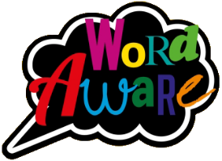
KNOWLEDGE ORGANISER
GOLDILOCKS WORDS
These are words that the children will be exposed to and will be encouraged to use during the teaching of this topic.
Books that will be supporting my learning:
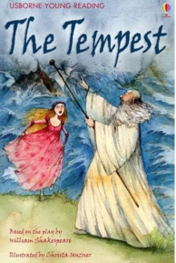
Year: 2 Term: Summer 2
IMAGE | WORD | DEFINITION
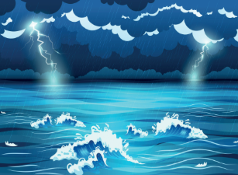 | Tempest | A violent storm.
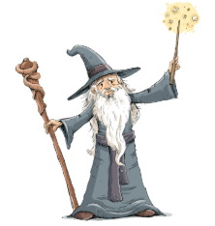 | Sorcerer | Someone who uses magic.
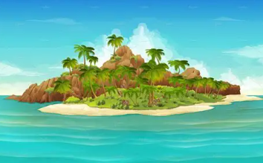 | Island | A piece of land surrounded by water.
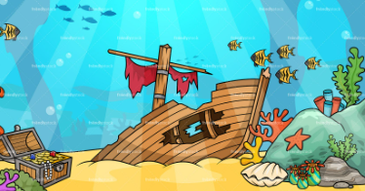 | Shipwreck | When a ship is destroyed or badly damaged at sea.
 | Spirit | A ghost or magical being.
 | Freedom | The state of being free, not controlled by others.

WE LOVE SHAKESPEARE!

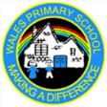
What will I be learning?
Maths – Statistics & Position & Direction
English – Retelling the story based on the book ‘The Tempest’ by Rosie Dickins.
Science- Making connections: Plant based materials
DT- Textiles: The Tempest puppet characters
P.E. – Multi-skills & rounders
PSHE- Changing Me
Music – Instruments – Musical storytelling
Please support your child to complete at least X3 reads at home per week with an adult. It ensures pupils can practice and secure knowledge taught in class in previous weeks and build their confidence and fluency to read aloud by themselves. Try and ask a range of questions to your child to build their comprehension skills. This is vital in Y2 to build an understanding of the text.

Key dates:
Mon1st June – INSET DAY
Tues 2nd June – Return to school
w/c 15th June – Healthy Lifestyles week
Wed 17th June – KS1 Sports Day @ 9:30am
Wed 24th June – Back up Sports Day
Mon 13th July – Transition Week
Fri 17th July – Last day before Summer
Mon 20th July – INSET DAY

