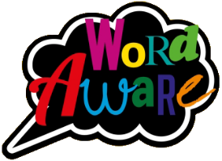
KNOWLEDGE ORGANISER
GOLDILOCKS WORDS
These are words that the children will be exposed to and will be encouraged to use during the teaching of this topic.
Books that will be supporting my learning:
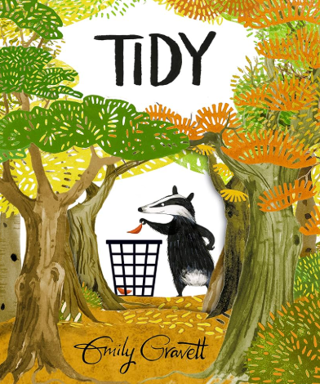
Year: 2 Term: Summer 1
IMAGE | WORD | DEFINITION
 | Environment | The surroundings or conditions where people or animals live.
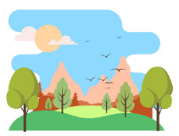  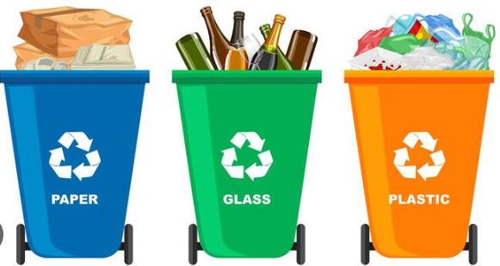 | Recycle | Changing waste into reusable materials.
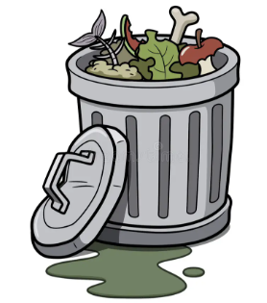 | Waste | Unwanted or unusable material that is no longer needed or wanted.
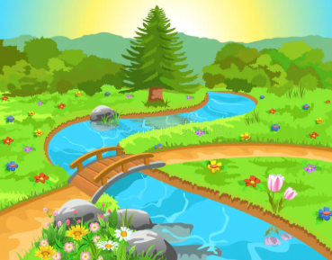 | Nature | The world around us and the living this in it e.g., plants, animals.
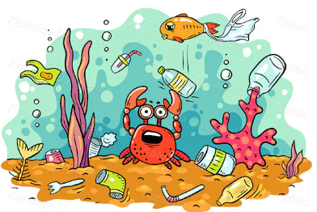 | Pollution | Harmful materials coming into the natural envrionment.
 | Community | A group of people living in the same place.
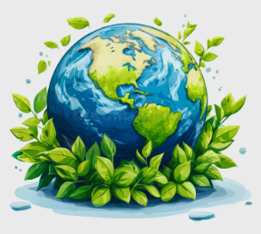
CLEAN, GREEN WORLD
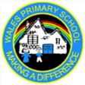
Key dates:
13/04/26 – Return to school

04/05/26 – School closed for May Day Bank Holiday

22/05/26 – School closes for May Spring Bank holiday
What will I be learning?
Maths – Fractions & Time.
English – Writing a letter based on the book ‘Tidy’ by Emily Gravitt.
Science- Children will learn about Plant growth.
Geography – Learning will be focused on Coasts: Seas/Oceans, human and physical features.
DT- Children will be using clay to create textured plant models.
P.E. - Children will be focusing on Running, throwing & jumping.
PSHE- Children will learn about living in the wider world: Online safety.
Music – Singing – On this island.
Please support your child to complete at least X3 reads at home per week with an adult. It ensures pupils can practice and secure knowledge taught in class in previous weeks and build their confidence and fluency to read aloud by themselves. Try and ask a range of questions to your child to build their comprehension skills. This is vital in Y2 to build an understanding of the text.

