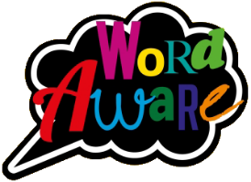
KNOWLEDGE ORGANISER
GOLDILOCKS WORDS
These are words that the children will be exposed to and will be encouraged to use during the teaching of this topic.
Books that will be supporting my learning:
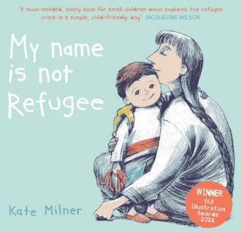
Year: 2 Term: Spring 2
IMAGE | WORD | DEFINITION
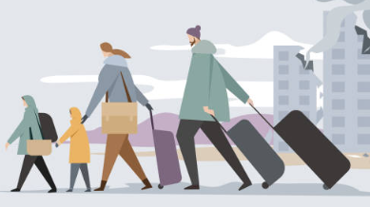 | Refugee | Someone who has been forced to leave their country to escape danger.
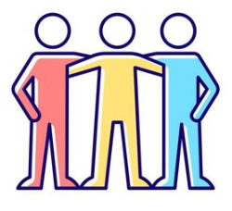 | Belong | Feeling like you are a part of something and are accepted and wanted.
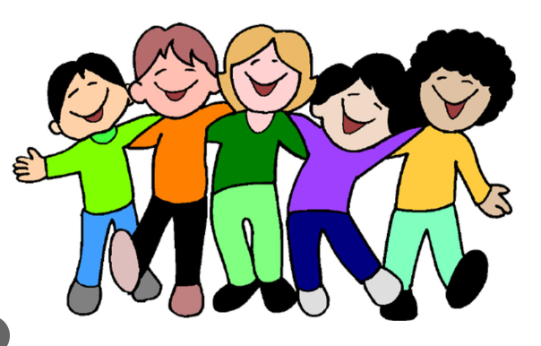 | Relationship | The way that two or more people are connected e.g., friends, siblings.
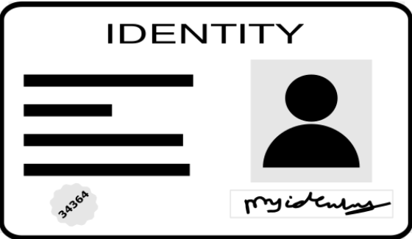 | Identity | The things that make you, you!
 | Accepting | .Being kind and understanding that everyone is different.
 | Community | A group of people living in the same place.

WHERE DO I BELONG?
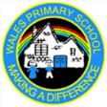
Key dates:
- Mon 23rd Feb INSET DAY
- Tue 24th Feb Return to school
- Thurs 5th March World Book Day!
- Tue 17th March Parent Meetings for Y2 1pm-6:30pm
- Thurs 26th March Easter Service @ St Johns Church at 9:15am
- Fri 27th March Break up for Easter holidays!
What will I be learning?
Maths – Length & Height and Mass, Capacity & Temperature.
English – Recount diary writing based on the book ‘My Name is Not Refugee’ by Kate Milner.
Science- Children will learn about microhabitats.
History- Children will learn about explorers and their discoveries.
DT- Children will be learning about balanced diets and making their own balanced diet pizza.
P.E. - Children will be focusing on Multi-skills (games, agility & balance) – Wednesdays.
PSHE- Children will learn about relationships and how to keep friendships healthy.
Music – Pitch – Musical Me.
Please support your child to complete at least X3 reads at home per week with an adult. It ensures pupils can practice and secure knowledge taught in class in previous weeks and build their confidence and fluency to read aloud by themselves. Try and ask a range of questions to your child to build their comprehension skills. This is vital in Y2 to build an understanding of the text.

