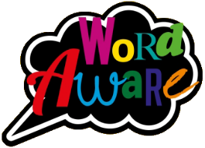
KNOWLEDGE ORGANISER
Books that will be supporting my learning:
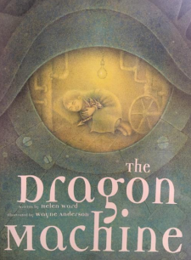
GOLDILOCKS WORDS
These are words that the children will be exposed to and will be encouraged to use during the teaching of this topic.
Year: 2 Term: Spring 1
IMAGE | WORD | DEFINITION
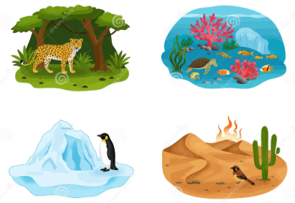 | Habitat | The environment where animals and plants live.
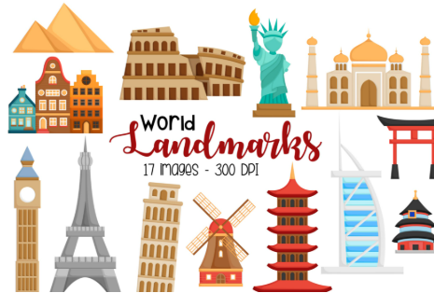 | Landmark | An object or feature that people recognise or is important.
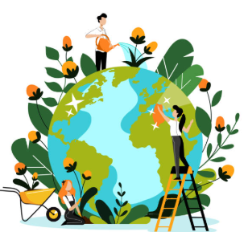 | Environment | The natural world and places that people, animals and plants live in.
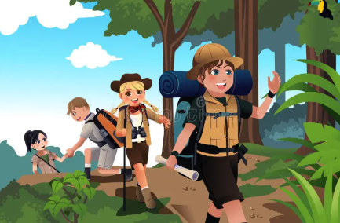 | Adventure | An unusual or exciting experience.
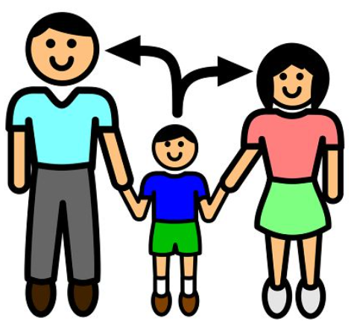 | Dependent | Needing something or someone to support or help you.
 | Community | A group of people living in the same place.

OUR WORLD AROUND US
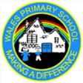
Key dates:
Mon 5th Jan – Return to school

Wed 4th Feb – Meeting for Y1 and some Y2 parents to support your child with phonics screen check

Mon 9th – 15th Feb – Children’s Mental Health Week

Fri 13th Feb – Break up for half term

What will I be learning?
Maths – Money & Multiplication and Division.
English – Fiction writing based on the book ‘The Dragon Machine’ by Helen Ward.
Reading- X2 reads in school with an adult plus daily recap teaching and learning of taught phonemes and words and how to blend to read and segment to spell.
Science- Children will learn about different habitats and which animals live in each.
Geography- Children will learn about wonderful places in the world; Landmarks, Oceans & Habitats.
Art- Children will be printing using a range of materials and resources.
P.E. - Children will be focusing on Gymnastics (balance) – Tuesdays.
PSHE- Children will learn about living in the wider world: our community.
Music – Calls and response – animals.
Please support your child to complete at least X3 reads at home per week with an adult. It ensures pupils can practice and secure knowledge taught in class in previous weeks and build their confidence and fluency to read aloud by themselves. Try and ask a range of questions to your child to build their comprehension skills. This is vital in Y2 to build an understanding of the text.

