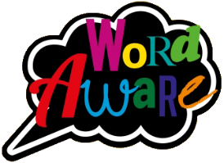**KNOWLEDGE ORGANISER**

Books that will be supporting my learning:

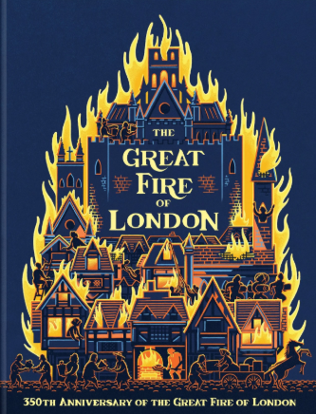

**GOLDILOCKS WORDS**

These are words that the children will be exposed to and will be encouraged to use during the teaching of this topic.

**Year: 2 Term: Autumn 2**

|  |  |  |
| --- | --- | --- |
| **IMAGE** | **WORD** | **DEFINITION** |
|  | Materials | What something is made of. |
|  | Embers | When wood or coal continues to burn in a dying fire. |
|  | Change | When something is made different or replaced. |
|  | Effect | .When something changes as a result of an action. |
|  | History | When you learn about things that have already happened. |
|  | Tale | Usually a made up story. |

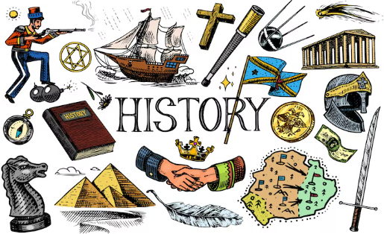 **A TALE THROUGH TIME**

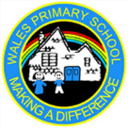

**Key dates:**

Mon 3rd Nov – return to school

Fri 7th Nov – Remembrance service at St Johns Church 9:15am

Wed 12th Nov – Y2 Parents evening

Fri 14th Nov – Children in need (non-uniform)

Tue 9th Dec – KS1 Nativity 2pm & 6:15pm

Thurs 11th Dec – Christmas Dinner

Thurs 18th Dec – Pantomime

Fri 19th Dec – Break up for Christmas holidays!

What will I be learning?

**Maths –** Addition & Subtraction & Shape.

**English –** Information report writing based on the book ‘The Great Fire of London’ by Emma Adams.

**Reading-** X2 reads in school with an adult plus daily recap teaching and learning of taught phonemes and words and how to blend to read and segment to spell.

**Science-** Children will explore the uses of everyday materials.

**History-** Children will learn about The Great Fire of London.

**DT-** Children will be constructing models of Pudding Lane Bakery.

**P.E. -** Children will be focusing on Dance (agility) – **Tuesdays.**

**PHSE-** Children will learn about physical health and growth.

**Music –** Myths & Legends (structure)

**Swimming** – Wednesdays.

Please support your child to complete at least X3 reads at home per week with an adult. It ensures pupils can practice and secure knowledge taught in class in previous weeks and build their confidence and fluency to read aloud by themselves. Try and ask a range of questions to your child to build their comprehension skills. This is vital in Y2 to build an understanding of the text.