**KNOWLEDGE ORGANISER**

Books that will be supporting my learning:

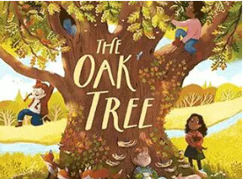 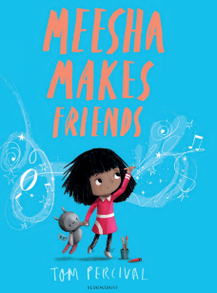  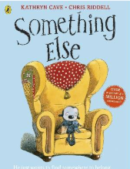 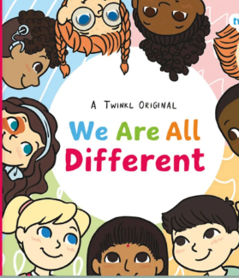

**GOLDILOCKS WORDS**

These are words that the children will be exposed to and will be encouraged to use during the teaching of this topic.

**Year: 1 Term: Autumn 1**

|  |  |  |
| --- | --- | --- |
| **IMAGE** | **WORD** | **DEFINITION** |
|  | Character | The qualities of an individual. |
|  | Growth | Becoming larger. |
|  | Change | When something is made different or replaced. |
|  | Age | The length of time something has existed. |
|  | Senses | The way the body experiences things from the outside. |
|  | Friendship | Being friends with others. |



**Key dates:**

.09.25 Phonics and Early reading parent’s workshop

Macmillan Coffee morning in the school hall

School photographs

Harvest festival at St Johns church

October Half Term

What will I be learning?

**Maths –** Place Value to 10, addition and Subtraction within 10.

**English –** Recount writing: diary entry using work based on the book Meesha Makes Friends by Tom Percivil.

**Reading-** X2 reads in school with an adult plus daily teaching and learning of new phonemes and words and how to blend to read and segment to spell.

**Science-** Children will learn about the body parts and the senses.

**History-** Children will learn about how they are making history.

**Art-** Children will learn drawing skills and focus on the artist Keith Haring.

**P.E. -** Children will learn throwing and catching skills.

**PHSE-** Children will learn how their body and responsibilities change as they grow older.

**Music –** Pulse and pattern.



Please support your child to complete at least X3 reads at home per week with an adult. This is vital in Year 1. It ensures pupils can practice and secure knowledge taught in class in previous weeks and build their confidence and fluency to read aloud by themselves.

**Contact details:**

To contact Mrs Askey re learning and behaviour enquiries please email:

[kaskey@walesprimary.co.uk](mailto:kaskey@walesprimary.co.uk)

To pass on messages re medical, change of collection etc please see Mrs Baxter on the gate each morning or email/ phone the school office:

[school@walesprimary.co.uk](mailto:school@walesprimary.co.uk)

Tel: 01909 770236