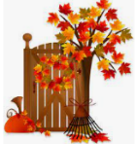
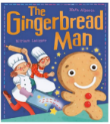
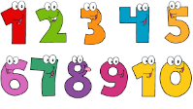
Topic
Our topic for this half term is exploring the school environment and ‘The Gingerbread Man.’
We will:
- Meet the key people from around the school
- Discuss new beginnings and how that makes us feel
- Help each other to make new friends
- Learn how to keep ourselves and our friends safe
- Explore a range of books including The Gingerbread Man, Rosie’s Walk, Owl babies, The very Helpful Hedgehog, Seasons, Goodnight Owl, Day and Night, The Colour Monster, Kitchen Disco, Amazing Grace and The Gruffalo.
- Go on an Autumn walk around the school and notice changes to the environment.
- Bake gingerbread
Forest school Friday
From Friday 18th September, children will be taking part in ‘Forest School Friday’s’. This entails a child-centered, educational process in a natural woodland setting that supports holistic growth through hands-on experiences, play, and exploration. Some of the things will involve: using mud, clay, leaves, stones, and sticks to create natural sculptures. Using magnifying glasses, collecting items and building habitats, planting , spot bugs and animals, and identify local plants and trees. Your child will have lots of fun and WILL GET DIRTY! Therefore we ask for them to come to school in clothes you do not mind getting wet and dirty.

Literacy
In Literacy we will be telling stories through pictures and re-telling stories to our friends. We will be practicing writing our names. We will be drawing pictures from the Gingerbread Man, labelling them; focussing on initial sounds. Retell the story of ‘The Gingerbread Man’ using puppets and actions.
Phonics
We will be starting to teach our new phonics scheme – Read, Write, Inc. The children learn phonemes (sounds) using graphemes (a letter or group of letters) and mnemonic (a picture with a phrase) to help the children remember and recognise different sounds.

PE
In PE this half-term, we are focussing on multi-skills. We will be travelling forward, backwards and sideways in curved and straight paths while contrasting speeds. Children should come in their PE Kits on a Wednesday which consists of plain black or navy short, joggers or leggings and a plain white t-shirt.

Other Events
Half term is Monday 26th October and school will reopen on Tuesday 3rd November. Please note there is a training day on Monday 2rd November.

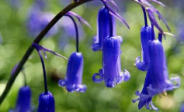Autumn 1: Autumn time, exploring the school environment and The Gingerbread Man. 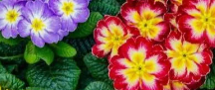
Expressive arts and designs
In expressive arts and design we will be focussing on music this half term which will include: finding a voice, learning new songs and singing with confidence. We will also explore a range of materials to paint self-portraits/family pictures and gingerbread men.

Understanding the World
In our circle time sessions and classroom environment we will be learning about other cultures and exploring the festival of Diwali, the festival of light and looking at how we celebrate the harvest festival. The children will also get an introduction to technology and will use the interactive whiteboard in the classroom.
Maths
In maths this half term we will focus on a range of skills such as:
- Count forwards and backwards 1-5, 1-10, 1-20.
- Counting rhymes - sing number songs and rhymes
- Sorting activities
- Count a set of objects (5, 10, 20)
- Count objects from a larger group and match correct numeral.
- Compare two groups of objects and say which is more and less.
- Repeating patterns.

