WEEK B

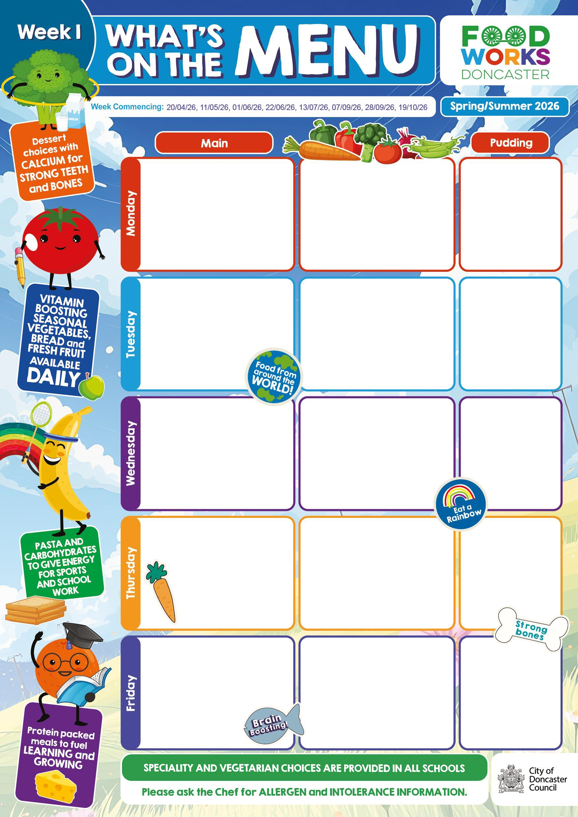
Cheese & Tomato Pizza or Quorn Pizza Burger
Pasta Salad
Peas & Sweetcorn

Sausage & Bacon or Veggie Sausage, Omelette, with Mini Potato Puffs Baked Beans & Crumpet

Roast Pork or Quorn Fillet with Stuffing
Mashed Potatoes, Gravy, Carrots & Broccoli
Crusty Bread

Chicken Korma & Rice or Tortilla Layer
Mixed Salad Naan Bread

Fish Fingers or Homemade Quiche with Chips
Baked Beans Homemade Bread

Jacket Potato with Cheese

Ham Sandwich

Jacket Potato with Tuna

Cheese Sandwich

Jacket Potato with Tuna
Butterscotch Cookie
Or Yoghurt

Chocolate Chelsea Bun
Or Yoghurt

Peaches
&
Ice Cream

Oaty Fruit Crunch
&
Custard

Rice Krispie Cake
Or Yoghurt

WEEK C

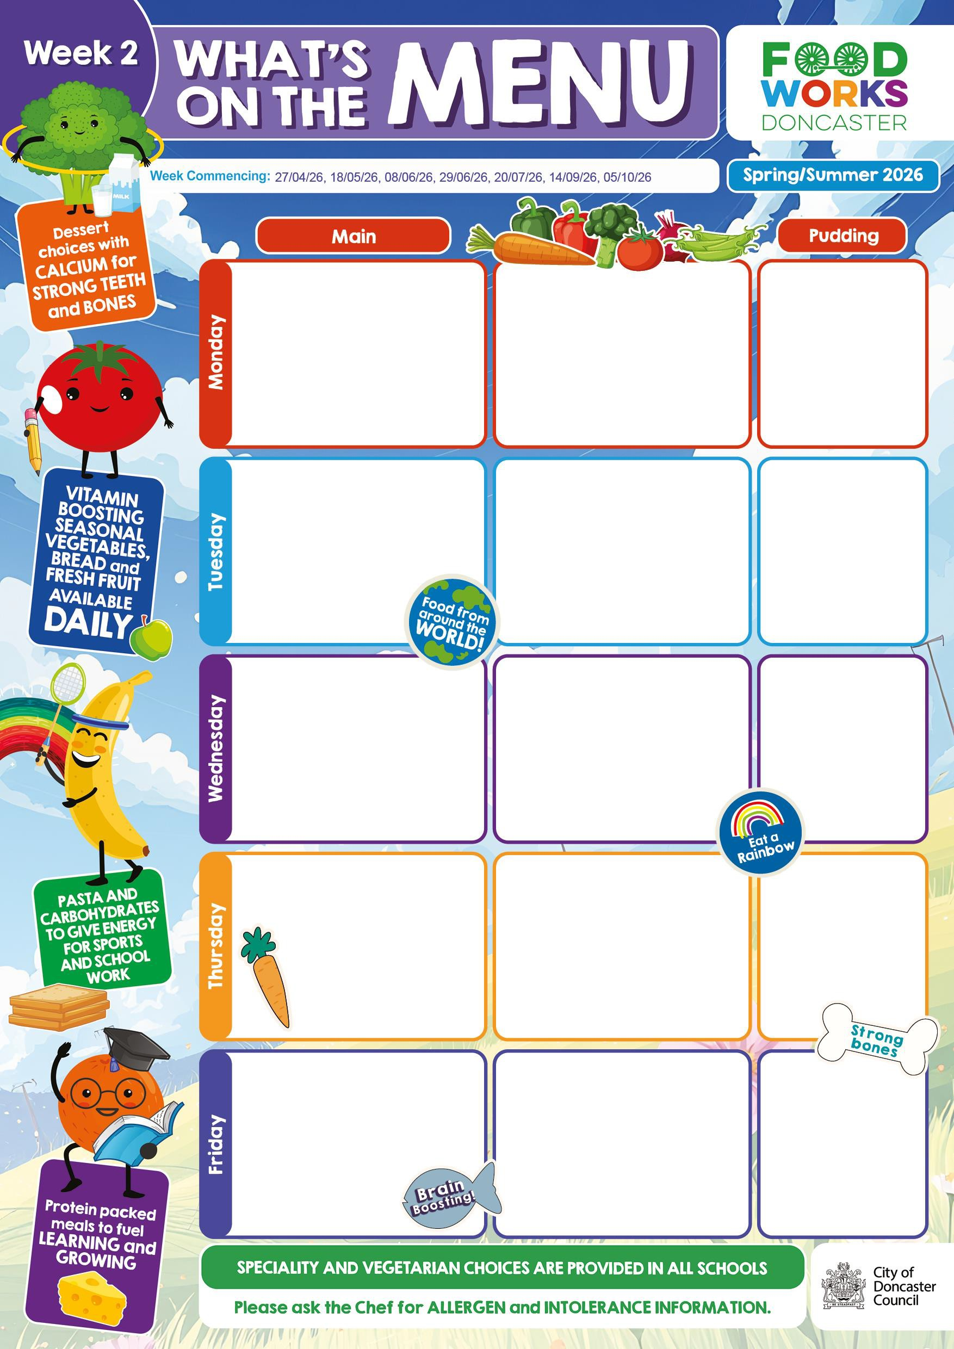
Cheesy Twist or Veggie Curry with Potato
Wedges Mixed Vegetables Tomato Focaccia

Bolognaise Pasta Bake or Macaroni Cheese
Cucumber & Carrot Sticks
Garlic Slice

Sausage, Yorkshire Pudding with Mashed Potato & Gravy or
Mexican Rice Broccoli & Carrots

Chicken Tikka Wrap or Vegetarian Roll with Crusty bread
Summer Rice Salad
Mixed Salad

Cod, Salmon Star or Cheese and Tomato
Pizza with Smiley Faces Spaghetti Hoops
Sliced Bread

Jacket Potato
Cheese and Baked Beans

Cheese Sandwich

Jacket Potato with Cheese

Cheese Sandwich

Jacket Potato Cheese and Baked Beans
Chocolate Orange Mousse

Apple Muffin Or
Yoghurt

Flapjack with Sultanas

Lemon Drizzle Cake

Doncaster Chocolate Crunch
&
Custard

WEEK A

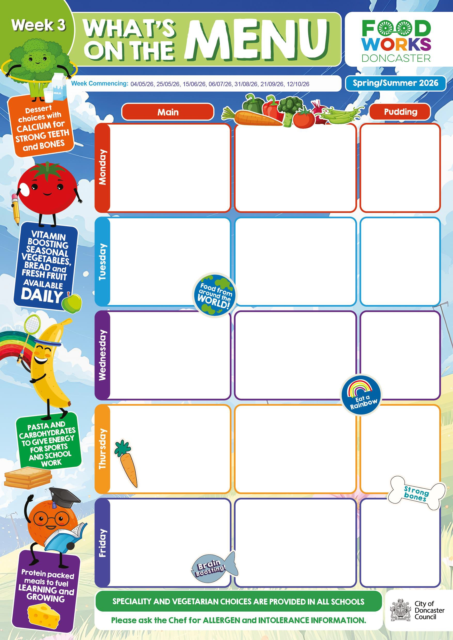
Chicken Goujons or Vegetable Frittata
Mini Potato Puffs, Baked Beans & Peas
Crusty Bread

Mediterranean Pasta Bake or Shepherdess Pie with Sweetcorn & Green
Beans Cheesy Bread

Roast Chicken or Quorn Fillet & Gravy, New Potatoes, Spring Cabbage & Carrots
Sliced 50/50 Bread

Sausage Roll with Seasoned Wedges or Five Bean Chilli, Medley
of Vegetables and Tomato Bread

Battered Fish or Ploughman’s Lunch with Chipped Potatoes,
Coleslaw & Vegetable Sticks

Jacket Potato with Baked Beans

Egg Sandwich

Jacket Potato with Cheese

Cheese Sandwich

Jacket Potato Cheese and Baked Beans
Oaty Crunch Cookie

Banana Muffin Or
Yoghurt

Summer Fruit Jelly
&
Cream

Arctic Roll &
Mandarins

Chocolate &
Pear Sponge With Custard

