Vision |  |  | An inclusive community where all children enjoy their learning and achieve their full potential
Hatchell Wood Inclusion Gateway  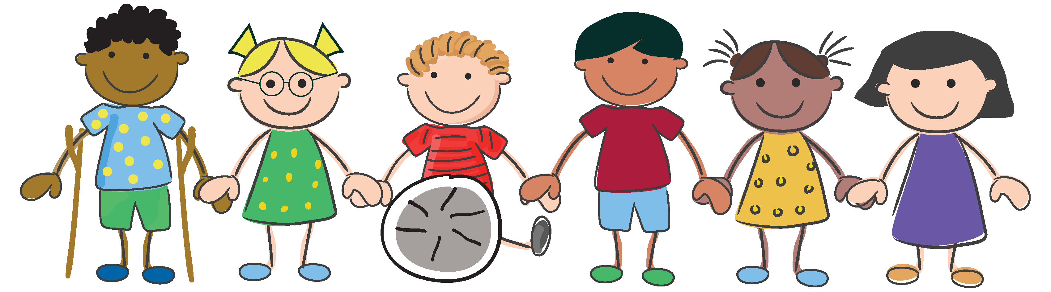  Adaptive, responsive & bespoke Inclusion |  |  | Adaptive Teaching  - Compassionate, intuitive and curious approaches  - Lessons incorporating:  - Thrive strategies  - Mental Health  - Growth Mindset  - Independence  - resilience |  | SEND Support  - Wave 1 teaching  - Support (1-1)  - Precision teaching  - Lego Therapy  - Time to Talk programme |  | Pastoral Support  - Mentoring  - Small group intervention (friendship, power and identity, loss, anger)  - Rainbows (bereavement)  - Soft starts  - Check-Ins  - Lunchtime clubs  - Parenting support |  |  |  | Parent Partnerships  - Solihull 10 week programme  - Parenting pop-ups (Y6/ Reception)  - Parent action plans (Thrive)  - Support with key transition points. |  | Outreach Partnerships  - Educational Psychologist  - Speech & Language Therapist  - Outreach partnerships from specialist provision  - ASCETS  - Play Therapist  - CAMHS  - Trusted Mentors  - Early Help Hub / Social Care Support
INTENT |  | Five Key  Curriculum Drivers | Our curriculum will give children the opportunity to: |  | Aspiration & Achievement Raising expectations and promoting success for all |  | Communication & Language Enabling every child to have a voice |  | Diversity & Respect Celebrating uniqueness and fostering unity |  | Life Skills & Experiences Preparing for life beyond school |  | Resilience & Wellbeing Supporting mental health and emotional growth
INTENT |  | Smart Seven Skills | Resilience  I can use different resources to help me achieve success.  I can do it!  I can keep going even when it is hard.  I can take a risk and have a go  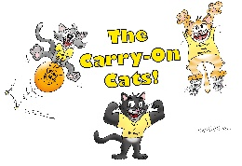 | Creative  I always try to use my imagination and work creatively in every situation.  I can ‘think outside the box’.  I can explore new ideas.  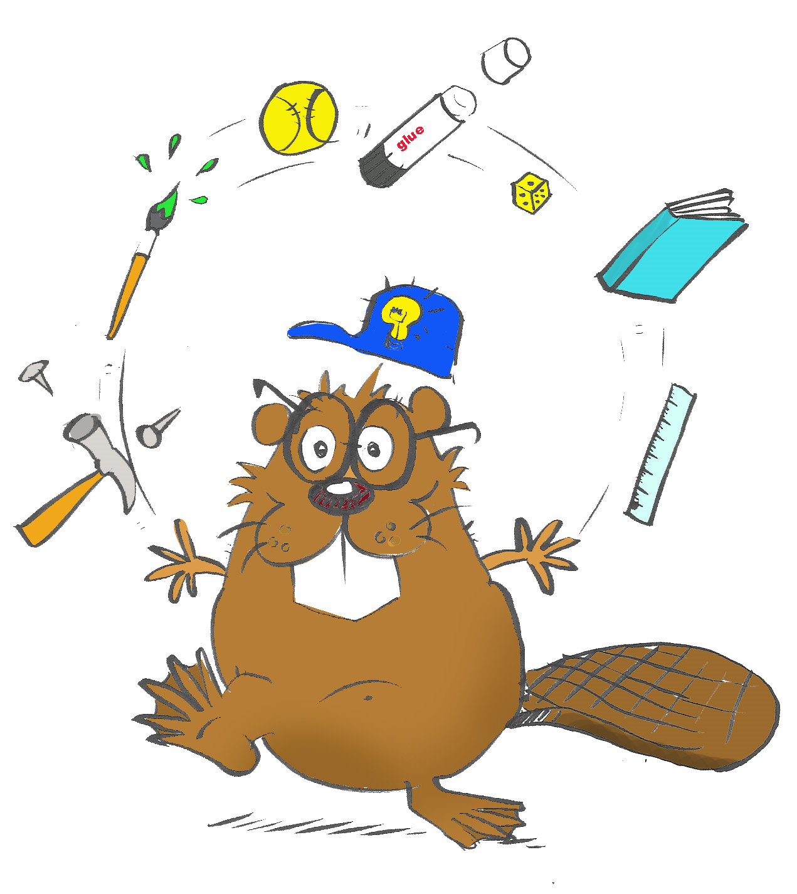 |  | Independence  I can work by myself and be responsible  I know where to go for help if I need it  I can make good decisions about my own health, safety and happiness  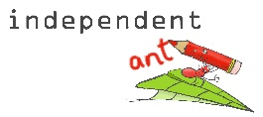 |  | Team worker  I can listen to others.  I can share and work well with others.  I can respect others’ thoughts and opinions.  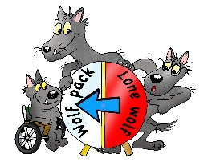 |  | Communicator  I can express my own opinions but respect the views of others.  I am willing to talk to different people.  I can use different types of communication.  I can express my feelings in an appropriate way  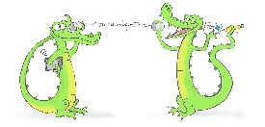 |  | Problem Solver  I can work through things.  I can decide what I need to do to finish a task.  I know that I can ask questions.  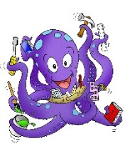 |  | Reflective  I can look at my work and see how I can make it better next time.  I know when I have done well.  I can support my friends in their learning.  

IMPLEMENTATION |  | Teaching intentions | High expectations |  | Good progress | Good subject and curriculum knowledge | Plan and teach well structured lessons |  | Adapt teaching  (Pupil groupings are flexible and not solely driven by perceived “ability” or prior attainment) | Accurate and productive use of assessment | Behaviour managed effectively |  | Wider professional partnerships
IMPLEMENTATION |  | Pathways to Read, Write and Spell |  | Mastery approach to maths |  | Science supported by White Rose |  | Little Wandle Phonics and handwriting |  | LTE |  | Early Years  The seven areas of Learning  Personal, Social and Emotional Development  Physical Development  Communication and Language development  Literacy  Mathematics  Understanding the World  Expressive Arts and Design
IMPLEMENTATION |  | Charanga Music |  | Kapow History |  | Kapow Geography |  | Kapow Art |  | Kapow RE
IMPLEMENTATION |  | Personal social and relationships education |  | Purple Mash Computing and Common Sense online safety |  | Embrace curriculum |  | Growth Mindset  (Smart 7) |  | Themed days/weeks
IMPLEMENTATION |  | Educational Visits and visitors into school |  | Charity and Fundraising Activities |  | Residential Experiences |  | Mental Health & Wellbeing |  | PE including forest School and orienteering

IMPACT |  | Our curriculum has an ambition for high achievement of all pupils irrespective of background and starting point. This achievement is represented in three key areas: | IMPACT 1: Standards  - Children make good progress from their starting points in all areas of the curriculum  - All children are given opportunities to achieve the greater depth standard  - Teaching and learning show that knowledge and skills are embedded throughout the curriculum  - Children have a broad and powerful knowledge and a wide vocabulary to understand and interpret the world  - Children progress onto secondary education with age appropriate standards in reading, writing and mathematics | IMPACT 2: Learning Behaviours  - Children are confident and successful learners, demonstrating learning values, growth mindset and the smart seven skills promoted in school  - Children know how they learn best (metacognition)  - Children can use strategies to self regulate to support them with their learning and in life | IMPACT 3: Personal Development  - Children demonstrate positivity in their learning and in their behaviour in and around school (growth mindset)  - Children are able to make the right choices for their learning and safety  - Children are able to make choices that benefit the school and local community  - Children fulfil the ‘I can’ statements of the Smart Seven  - Children progress onto secondary education with age appropriate personal skills (social skills, life skills, common sense, self regulation)

