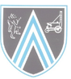

Hetton Lyons Primary School
Progression in Calculations EYFS
2022 – 2023

Policy Overview

Principles of the Policy
One of the key learning principles behind this policy is the concrete pictorial abstract approach (CPA). The concrete-pictorial-abstract approach, is based on research by psychologist Jerome Bruner, and suggests that there are three steps (or representations) necessary for children to develop understanding of a concept.
For children to have a deep understanding of the mathematical concepts being developed, they need to ‘master’ all three phases of the CPA approach. If a child has moved on from the concrete to the pictorial, it does not mean that the concrete cannot be used alongside the pictorial as an additional scaffold. If a child is working at the abstract stage, ‘proving’ something or ‘working out’ then concrete or pictorial representations could be used to develop a greater depth as pupils articulate their thinking /reasoning. Reinforcement is achieved by going back and forth between these representations. Linking abstract notation to pictorial/concrete representations and then the concrete/pictorial models to an abstract notation.

Concrete Representation
The enactive stage. Children are first introduced to an idea/skill/concept by acting it out with real objects, this could include large scale with the pupils themselves and also utilise resourced available in the outdoor environment. This is a 'hands on' stage using real objects linked to real-life and the wider curriculum and/or mathematical equipment, (i.e. counters, cubes, bead string, five and ten frames, Dienes, place value counters etc.) and it is the foundation for CONCEPTUAL UNDERSTANDING.
Pictorial Representation
The iconic stage. A child has sufficiently understood the hands-on, CONCRETE experiences performed and can now relate them to PICTORIAL representations, such as a DIAGRAM or PICTURES of the problem. PICTORIAL representations, such as the bar model, can also be used to scaffold understanding.
Abstract Representation
The symbolic stage. A child is now capable of representing problems by using ABSTRACT mathematical notation, for example: 5 ÷ 2 = 7. This is the ultimate mode.
Teachers should understand how each stage of the CPA approach can be used effectively to MODEL concepts, SCAFFOLD learning and RECORD thinking:
MODELLING: teachers to make clear links are made between CONCRETE representations (which can also be represented pictorially), PICTORIAL representations (diagrams and pictures, including bar modelling) and ABSTRACT notations.
SCAFFOLDS: children to be offered the opportunity to use appropriate CONCRETE and PICTORIAL representations to further scaffold their understanding. The scaffolds offered, must be familiar and understood by children. Children should be encouraged to consider whether scaffolds are required and for how long they require them for. CONCRETE and PICTORIAL representations are also supportive when developing children’s depth of knowledge through problem solving and reasoning experiences.
RECORDING:
CONCRETE RECORDING: when children are unable to record their thinking using PICTORIAL representation or ABSTRACT notation then their learning can be evidenced through photographic evidence and post-it notes, which detail key information regarding children’s strengths and areas of developments/gaps/misconceptions.
PICTORIAL RECORDING: children to be encouraged to represent their thinking using PICTORIAL representations, if they are unable to record using ABSTRACT notation. PICTORIAL representation also includes the use of the bar model.
ABSTRACT RECORDING: this is the ultimate mode but should not be rushed at the expense of true CONCEPTUAL UNDERSTANDING. Scaffolds, such as missing box calculations, can support children’s transition towards ABSTRACT.

Birth – 11 months: Number
Notices a change in the number of objects, images or sounds in a group of up to 3.

CONCRETE | PICTORIAL | ABSTRACT
Display favourite things.  Small groups of the same objects in treasure baskets, as well as single items (e.g. fir cones shells etc.)  Hanging mobile, occasionally changing the number of objects you hang on it.  Use songs and rhymes during personal routines linked to objects and themselves (e.g. Two Little Eyes to Look Around) pointing to their eyes.  Move with them to the rhythm patterns in familiar songs and rhymes. | Number rhyme books/pictures which are repetitive and are related to children’s actions and experiences (e.g. Peter Hammers with one Hammer)  School to agree and list the specific rhymes and stories which will be used to support number development. | Singing of familiar rhymes  (e.g. One, Two, Buckle My Shoe)

8 – 22 months: Number
- Develops an awareness of number names through action rhymes songs that relate to their experiences. | Has some understanding that things exist, even when out of sight.

CONCRETE | PICTORIAL | ABSTRACT
Display favourite things.  Small groups of the same objects in treasure baskets, as well as single items (e.g. fir cones shells etc.)  Hanging mobile, occasionally changing the number of objects you hang on it.  Use songs and rhymes during personal routines linked to objects and themselves (e.g. Two Little Eyes to Look Around) pointing to their eyes.  Move with them to the rhythm patterns in familiar songs and rhymes. | Number rhyme books/pictures which are repetitive and are related to children’s actions and experiences (e.g. Peter Hammers with one Hammer)  School to agree and list the specific rhymes and stories which will be used to support number development. | Singing of familiar rhymes  (e.g. One, Two, Buckle My Shoe)

16 - 26 months: Number
- Knows that things exist even when out of sight. | - Begins to organise and categorise objects together or into groups. | Says some counting words randomly. | Distinguish between quantities, recognising that a group of objects is more than one. | Gain and show awareness of one-to-one correspondence  through categorising belongings, starting with  ‘mine’ or ‘Mummy’s’ etc. and linked to practical everyday activities.

CONCRETE | PICTORIAL | ABSTRACT
Link the language of lots and few as children play with objects  Demonstrate how counting helps us to find out how many objects we have.  Talk about maths in everyday situations, (e.g. doing up a coat, one hole for each button)  Varied opportunities to explore ‘lots’ and ‘few’ in play.  Equip the role-play areas with things that can be sorted in different ways.  Provide collections of objects that can be sorted and matched in various ways.  Provide resources that support one-to-one correspondence,  (e.g. giving each dolly a cup).  Ensure quality of the outdoor environment matches that on the indoor, (e.g. objects to count, sort, organise etc. | Number rhyme books/pictures.  School to agree and list the specific rhymes and stories which will be used to support number development. | Use number words in meaningful contexts,  (e.g. now we have two, here is your other glove)  Talk about lots and few as they play.  Demonstrate how counting, using counting words, helps us to find how many

22 – 36 months: Number
Selects a small number of objects from a group when asked,  (e.g. please give me one, give me two). | - Have some understanding of 1 and 2, especially  - when the number is important for them. | Recites some number names in sequence. | - Begins to make comparisons between quantities. | - Uses some language of quantities, (e.g. more and a lot) | - Knows that a group of things changes in quantity when something is added or taken away.

CONCRETE | PICTORIAL | ABSTRACT
Props for children to act out number stories and rhymes (e.g. story bags).  Play games with equipment which offer opportunities for counting.  Plan a mathematical component into areas such as sand, water or other play areas. | Numbers stories and rhymes and the pictures represented within them.  School to agree and list the specific rhymes and stories which will be used to support number development.  Make a display with the children’s favourite things and talk about how many etc.  Abstract numbers to be displayed with pictorial representations of quantity. | Verbally reciting numbers.  Create and experiment with symbols and marks representing ideas of numbers.  Singing counting songs and rhymes which help to develop understanding of number, (e.g. Two Little Dickie Birds)  Play games which relate to number order, addition and subtraction (e.g. skittles, target games and hopscotch)  Abstract numbers displayed.  Number tracks, including those in the outdoor environment.

30 – 50 months: Number
- Uses some number names and number language spontaneously,  (e.g. one, two, three, lots, fewer, hundreds, how many count etc.) | - Uses some number names accurately in play. | - Use some number names and number language accurately | - Recites numbers in order from to 10. | - Knows that numbers identify how many objects are in a set. | - Sometimes matches numeral and quantity correctly. | - Shows curiosity about numbers by offering comments or asking questions. | - Recognise groups with one, two or three objects

- Compares two groups of objects, saying when they have the same number. | - Shows an interest in number problems. | - Separates (partitions) a group of three or four objects in different ways, beginning to recognise that the total is still the same. | - Match groups with the same number of objects, one to three. | - Shows an interest in numerals in the environment. | - Realises not only objects, but everything can be counted, including steps, claps or jumps. | - Recognise and continue repeating patterns

CONCRETE | PICTORIAL | ABSTRACT
Represents numbers using fingers.  Support understanding of abstraction by counting things that are not objects, (e.g. hops, jumps, clicks, claps).  Make counting purposeful with real-life opportunities, including in random layouts.  Counting money and change in role-play.  Model counting of objects in a random layout, showing the result is always the same as long as each object is only counted once.  Model and encourage the use of mathematical language in real-life situations, using practical equipment, (e.g. how many saucepans will fit on the shelf?).  Any objects linked to the environment, real-life contexts and curriculum topics (e.g. pebbles, sticks, to cars etc.).  Link objects to count, sort and group to stories,  (e.g. fruit in Handa’s Surprise).  Props for children to act out number stories and rhymes,  (e.g. story bags).  Discuss strategies for solving simple problems, (e.g. fingers).  Give meaningful contexts for children to count, linked to daily routines, (e.g. give everyone a wrist band, counting steps, claps, jumps etc.).  Help children to understand that one thing can be shared by number of pieces, (e.g. pizza).  Enable children to note the missing se when sharing things out, (e.g. there are none left). | Represents numbers with pictures.  Number stories and rhymes and the pictures represented within them and ask questions, (e.g. when one more frog jumps in how many altogether? etc.).  School to agree and list the specific rhymes and stories which will be used to support number development.  Discuss strategies for solving simple problems,  (e.g. picture clues, drawing pictures).  Encourage pupils to record their thinking with pictures. | Shows an interest in representing numbers.  Represents numbers with marks on paper or outdoor environment.  Use number language in a variety of situations, (e.g. one, two, three, lots, fewer, hundreds, how many? count etc.).  Encourage mark-making to support thinking about numbers and simple problems.  Counting aloud.  Number labels,  (e.g. for bikes in parking spaces).  Singing of familiar number rhymes.  Discuss strategies for solving simple problems, (e.g. counting).  Model and use mathematical language linked to real-life situations.

40-60+ months: Place Value and Counting
- Recognise some numerals of personal significance as appropriate,  (i.e. age, door number etc.) | - Recognise, say and identify the numerals 1 to 5 and then to 10. | - Order the numbers 1 to 5 and then to 10. | - Count forwards and backwards within the number sequence 1 to 5 and then 1 to 10. | - Count up to 3 or 4 objects by saying one number name for each item and touching each object and saying one number name for each item. | - Know that the last number in the count gives the total. | - Know that numbers identify how many objects are in a set.

- Match and compare the numbers of objects in two sets, recognising when the sets contain the same number of objects. | Recognise that the number of objects in a set does not change if they are moved around. | Use ordinal numbers in different contexts. | Count actions or objects which cannot be moved up to 10 by saying one number name for each item and touching each object and saying one number name for each item. | Count objects which can be moved up to 10 by saying one number name for each item and touching each object and saying one number name for each item. | - Begin to count objects beyond 10 by saying one number name for each item and touching each object and saying one number name for each item.

- Count out up to 6 objects from a larger group. | - Select the correct numeral to represent 1 to 5 and then 1 to 10 objects, understanding that numeral always represents that quantity. | - Estimate how many objects and check by counting them, up to 10. | - Subitise to 6, using familiar arrangement and match to the numeral, (i.e. dice, dominoes and five frames). | - Represent numbers up to 5 and then 10, using fingers. | - Understand the empty set (0) and use zero and the numeral to represent it.

Early Learning Goal: Place Value and Counting
- Count reliably with numbers from 1 to 20. | - Rote count onwards from a small number, within 20. | - Place the numbers 1 to 20 in order. | - Understand the value of all numbers to 10. | - Subitise to 10 using familiar arrangements,  - (i.e. dice, domino and dot card patterns & ten frames)

CONCRETE and PICTORIAL representations to be used to MODEL all concepts alongside the ABSTRACT notation.
Children to have independent access to CONCRETE and PICTORIAL representations to SCAFFOLD their learning, therefore CONCRETE/PICTORIAL SCAFFOLDS can and should be used (where appropriate) alongside the questions/activities/ideas within the ABSTRACT section below.
Children to be challenged to develop their understanding without the use of SCAFFOLDS and to also record at an ABSTRACT level, but this should not be at the expense of true CONCEPTUAL UNDERSTANSDING or before they are ready.
As the questions/activities/ideas develop a greater depth to children’s knowledge then CONCRETE/PICTORIAL SCAFFOLDS may be required to support children to problem solve and to explain their reasoning.
CONCRETE | PICTORIAL | ABSTRACT
Encourage estimation using objects, (e.g. estimate how many sandwiches to make for the picnic).  Any objects linked to the environment, real-life contexts and curriculum topics for children to sort, count, order and label, including counting beyond 10 tings, (e.g. pebbles, sticks, toy cars etc.)    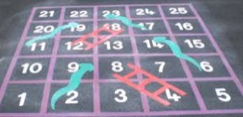    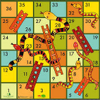    Mathematical equipment: five frames, Numicon, counters, Unifix cubes, bead strings, dot cards.  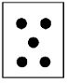    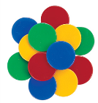  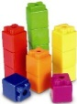    Include five frames on a big scale in the outdoor environment or marked on hall floors etc.  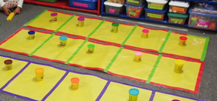  Children to be involved in making 3D displays, (e.g. their own pictograms of lunch choices).  Create opportunities for children to experiment with a number of objects, written numeral and written number word and being able to match them together.  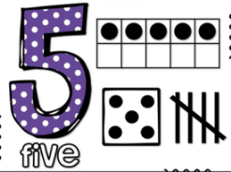  Props for children to act out number stories and rhymes (e.g. story bags).  Small world boxes to support pupils to create number stories. Using box lids from paper boxes and links to the environment, real-life contexts and curriculum topics etc.  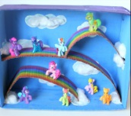  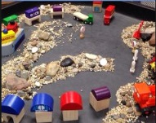  Use objects to support with counting  (e.g. objectives linked to real-life and the wider curriculum, including those suitable for use in the outdoor environment)  Use a range of mathematical equipment to support with counting, (e.g. five and ten frames, counters, bead string, Numicon, bundles of straws etc.)  Ensure abstract numbers are linked to concrete resources and pictorial representations to scaffold and develop conceptual understanding.  Introducing the vocabulary of ‘ones’ through a range of objects, mathematical equipment including tens frames.  Introduce the vocabulary of ‘tens’ through bundles of straws, Numicon.  Ensure abstract numbers are linked to concrete resources and pictorial representations to scaffold and develop conceptual learning.    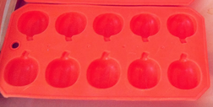  Tens frames, including egg boxes & ice cube trays, paper copies and big scale marked on hall floor and in the outdoor environment.  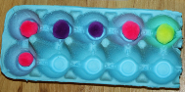  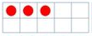  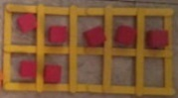  Teach children to subitise using unfamiliar pattern order, (e.g. dot cards, dice and dominoes).  Teac children to subitise using familiar pattern order up to ten, (e.g. five and ten frames).  Develop subitising with a range of dominoes and dice games embedded into every day practice. | Any picture representation of the numbers, linked where possible to real-life contexts and curriculum topics.    Birthday cake  and candles  A range of ‘games’ using a dice and dominoes with the pictorial representation of the familiar number patterns up to 6.  Children to be involved in making displays  (e.g. their own pictograms of lunch choices).  Number rhymes and stories – school to agree and list the specific rhymes and stories which will be used to support number development.  Display interesting books about number.  Encourage children to record what they have done (e.g. pictures or tallying).  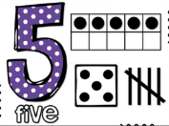  Create opportunities for children to experiment with a number of objects, written numeral and written number word and being able to match them together.  Ensure abstract numbers are linked to concrete resources and pictorial representations to scaffold and develop conceptual learning.  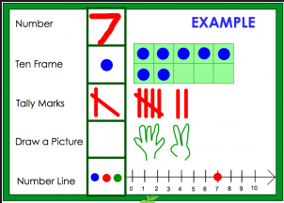  Pictorial representations of objects to support with counting.  Abstract numbers from 1 – 20 displayed in classroom environment and ‘areas’ to support with verbal counting alongside a pictorial representation of the quantity.  Teach children to subitise using unfamiliar pattern order, (e.g. dot cards, dice and dominoes).  Teach children to subitise using familiar pattern order up to ten, (e.g. five and ten frames).  Develop subitising with a range of dominoes and dice games embedded into every day practice. | Abstract numbers, including numbers represented in real life and within the classroom environment and ‘areas’.  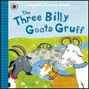    Books  Door numbers  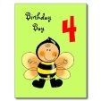    Birthday cards  and cakes  Encourage the use of mathematical language,  (e.g. have you got enough to give me three?).  Display numerals in purposeful contexts,  (e.g. a sign showing how many can play in an area).  Make tactile numeral cards made from sand paper, velvet or string.  Create opportunities for children to experiment with a number of objects, written numeral and written number word and being able to match them together.  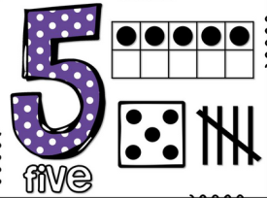  Make books about numbers that have meaning, (e.g. favourite numbers, birth dates, telephone numbers).  Model and encourage standard notation of recording where appropriate.  Use 100 square to show number patterns, including in the outdoor environment.  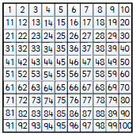  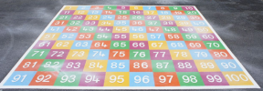  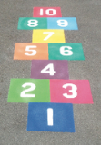  A range of different number tracks for reference and in play, including in the outdoor environment.  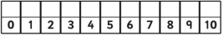  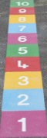  Play games which involve counting,  (e.g. hide and seek).  Emphasise the empty set and introduce the concept of nothing or zero.  Use number vocabulary.  Ensure abstract numbers are linked to concrete resources and pictorial representations to scaffold and develop conceptual learning.  Verbal counting of numbers.  Abstract numbers from 1 – 20 displayed in classroom environment and ‘areas’ to support with verbal counting alongside a pictorial representation of the quantity.  Link the teaching of subitising with the abstract numeral the picture represents.

40-60+ months: Calculating
- Use the language of ‘more’ and ‘fewer’ to compare two sets of objects. | - Find the total number of items in two groups by counting all of them  AUGMENTATION | - Find one more or one less from a group of up to 5 objects. | - Find one more or one less from a group of up to 10 objects. | - Partition and recombine small groups of up to 10 objects. | - In practical activities and discussion, begin to use the vocabulary involved in adding and subtracting. | - Begin to identify own mathematical problems based on own interests and fascinations.

Reception: Addition & Subtraction
- Say the number which is one more and one less than a given number, up to 20. | - Derive and recall addition facts for totals to at least 5, (e.g. 1 + 3, 2 + 3). | - Derive and recall addition doubles for all numbers to at least 5 (to a total of 10), (e.g. 4 + 4). | - Add and subtract a pair of single-digit numbers, without crossing the tens boundary, (e.g. 4 + 5, 8 – 3).  AUGMENTATION  AGGREGATION

CONCRETE and PICTORIAL representations to be used to MODEL all concepts alongside the ABSTRACT notation.
Children to have independent access to CONCRETE and PICTORIAL representations to SCAFFOLD their learning, therefore CONCRETE/PICTORIAL SCAFFOLDS can and should be used (where appropriate) alongside the questions/activities/ideas within the ABSTRACT section below.
Children to be challenged to develop their understanding without the use of SCAFFOLDS and to also record at an ABSTRACT level, but this should not be at the expense of true CONCEPTUAL UNDERSTANSDING.
As the questions/activities/ideas develop a greater depth to children’s knowledge then CONCRETE/PICTORIAL SCAFFOLDS may be required to support children to problem solve and to explain their reasoning.
CONCRETE | PICTORIAL | ABSTRACT
See separate section: CPA Approach for Addition & Subtraction, for further guidance.  A range of ‘games’ using a dice or dominoes, including those for the outdoor environment. Make these readily available and teach children to use them. Develop work with parents on the use and impact. A range of games using dice and moving counters up to 10.  Mathematical equipment: five frames, Numicon, counters, Unifix cubes, bead strings, dot cards.  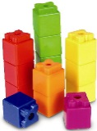  Include five frames on a big scale in the outdoor environment or marked on hall floors etc.  Children to be involved in making 3D displays, (e.g. their own pictograms of lunch choices).  Props for children to act out number stories and rhymes (e.g. story bags).  Show interest in how children solve problems and value their different solutions (e.g. with concrete equipment, pictorial representations or attempt to record in abstract form).  Discuss with children how problems relate to others they have met, and their different solutions, (e.g. with concrete equipment, pictorial representations or attempt to record in abstract form).  Talk about the methods children use to answer a problem they have posed, (e.g. with concrete equipment, pictorial representations or attempt to record in abstract form).  Encourage children to make up their own story problems for other children to solve, (e.g. verbally, modelled with concrete resources or drawing pictorially).  Encourage children to extend problems  (e.g. what if there were three people instead of two? Using concrete equipment, pictorially represented or verbally discussed.)  Encourage children to be creative in identifying and devising problems and solutions in all areas of learning using a wide range of number resources and objects linked to real-life contexts and the wider curriculum.  Help children to understand that five fingers on each hand make a total of ten fingers altogether, or that two rows of three eggs make six eggs altogether.  Small world boxes to support pupils to create number stories. Using box lids from paper boxes and links to the environment, real-life contexts and curriculum topics etc.  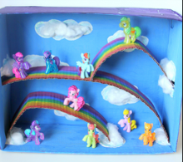  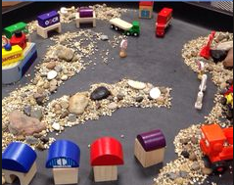  Using fingers to support calculation.  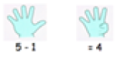  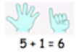  Groups of objects linked to real-life and the wider curriculum to calculation with and compare saying which has more or less, which group is bigger or smaller.  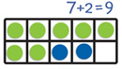  Mathematical equipment such as Unifix cubes, bead strings, Numicon, counters, five and ten frames.  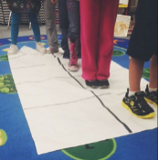  Consider big scale tens frames marked on hall floor, within the classroom and in the outdoor environment.  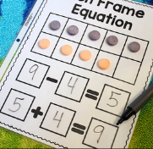  Link together concrete and abstract recording.  Numicon to add and subtract and find one more and less.  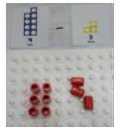  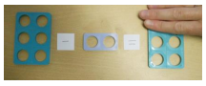  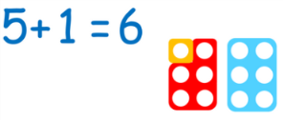  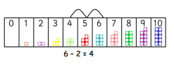 | See separate section: CPA Approach for Addition & Subtraction, for further guidance.  Children to be involved in making displays,  (e.g. their own pictograms of lunch choices).  Number rhymes and stories – school to agree and list the specific rhymes and stories which will be used to support number development.  Encourage children to record what they have done (e.g. pictures or tallying).  Show interest in how children solve problems and value their different solutions (e.g. with concrete equipment, pictorial representations or attempt to record in abstract form).  Discuss with children how problems relate to others they have met, and their different solutions, (e.g. with concrete equipment, pictorial representations or attempt to record in abstract form).  Talk about the methods children use to answer a problem they have posed, (e.g. with concrete equipment, pictorial representations or attempt to record in abstract form).  Encourage children to make up their own story problems for other children to solve, (e.g. verbally, modelled with concrete resources or drawing pictorially).  Encourage children to extend problems  (e.g. what if there were three people instead of two? Using concrete equipment, pictorially represented or verbally discussed.)  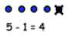  Pictorial representations to support calculation.  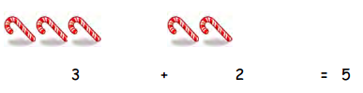  Pictorial representations of tens frames:  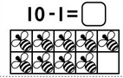  Pupils encourage to record their own pictures to scaffold calculation. | See separate section: CPA Approach for Addition & Subtraction, for further guidance.  Use 100 square to show number patterns, including in the outdoor environment.  A range of different number tracks for reference and in play, including in the outdoor environment.  Verbal counting to support calculation.  Respond to and understand vocabulary relating to calculation.  Use number stair cases to show a starting point and how you arrive at another point when something is added or taken away.  Use rhymes, songs and stories involving counting on and counting back in 1s, 2s, 5s and 10s.  Show interest in how children solve problems and value their different solutions (e.g. with concrete equipment, pictorial representations or attempt to record in abstract form).  Make sure children are secure about the order of numbers before asking what comes after or before each number.  Discuss with children how problems relate to others they have met, and their different solutions, (e.g. with concrete equipment, pictorial representations or attempt to record in abstract form).  Talk about the methods children use to answer a problem they have posed, (e.g. with concrete equipment, pictorial representations or attempt to record in abstract form).  Encourage children to make up their own story problems for other children to solve, (e.g. verbally, modelled with concrete resources or drawing pictorially).  Encourage children to extend problems  (e.g. what if there were three people instead of two? Using concrete equipment, pictorially represented or verbally discussed.)  Make clear links between concrete resources and abstract record – scaffold this through blank number sentences/missing boxes  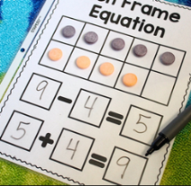  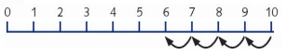  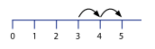  Physical number lines and tracks to support calculation and problem solving, including big scale marked in the classroom environment and outdoor environment.

Reception: Multiplication & Division
Derive and recall doubles of all numbers to 5, (e.g. double 2). | Solve problems including doubling. | Solve problems including halving. | Solve problems including sharing.

CONCRETE and PICTORIAL representations to be used to MODEL all concepts alongside the ABSTRACT notation.
Children to have independent access to CONCRETE and PICTORIAL representations to SCAFFOLD their learning, therefore CONCRETE/PICTORIAL SCAFFOLDS can and should be used (where appropriate) alongside the questions/activities/ideas within the ABSTRACT section below.
Children to be challenged to develop their understanding without the use of SCAFFOLDS and to also record at an ABSTRACT level, but this should not be at the expense of true CONCEPTUAL UNDERSTANSDING or before children are ready.
As the questions/activities/ideas develop a greater depth to children’s knowledge then CONCRETE/PICTORIAL SCAFFOLDS may be required to support children to problem solve and to explain their reasoning.
CONCRETE | PICTORIAL | ABSTRACT
See separate section: CPA Approach for Multiplication and Division, for further guidance.  Use a range of mathematical equipment and objects linked to real-life and the wider curriculum.  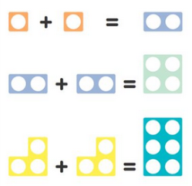  Numicon:  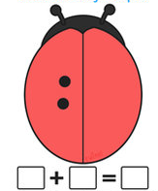  Lady birds using spots. | See separate section: CPA Approach for Multiplication and Division, for further guidance.  A range of pictorial representations to model key concepts.      Children to be encouraged to record their thinking using pictorial representations. | See separate section: CPA Approach for Multiplication and Division, for further guidance.  Make links to all practical resources with abstract recording, support this with blank number sentences:  □ + □ = □

