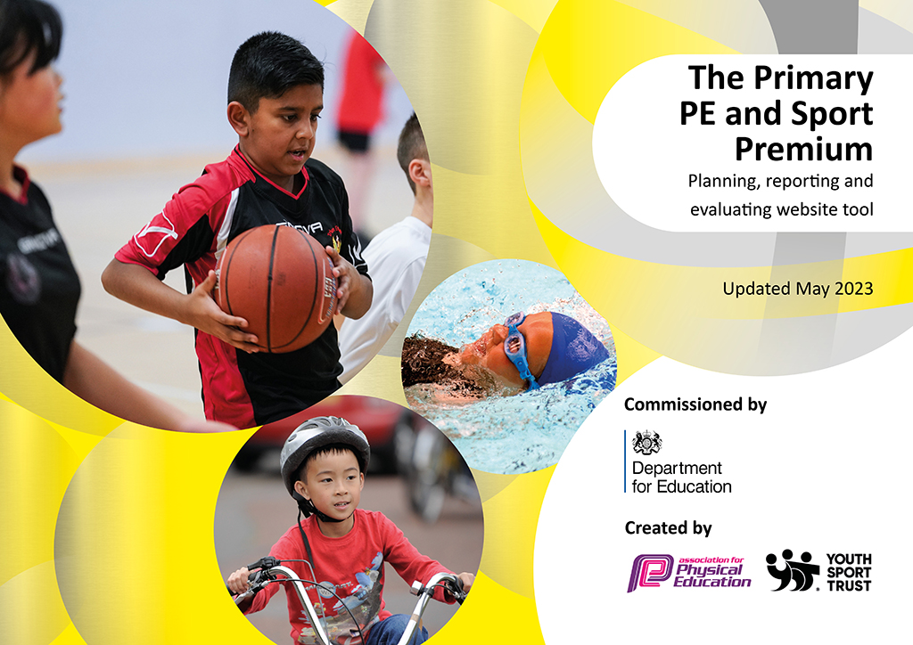
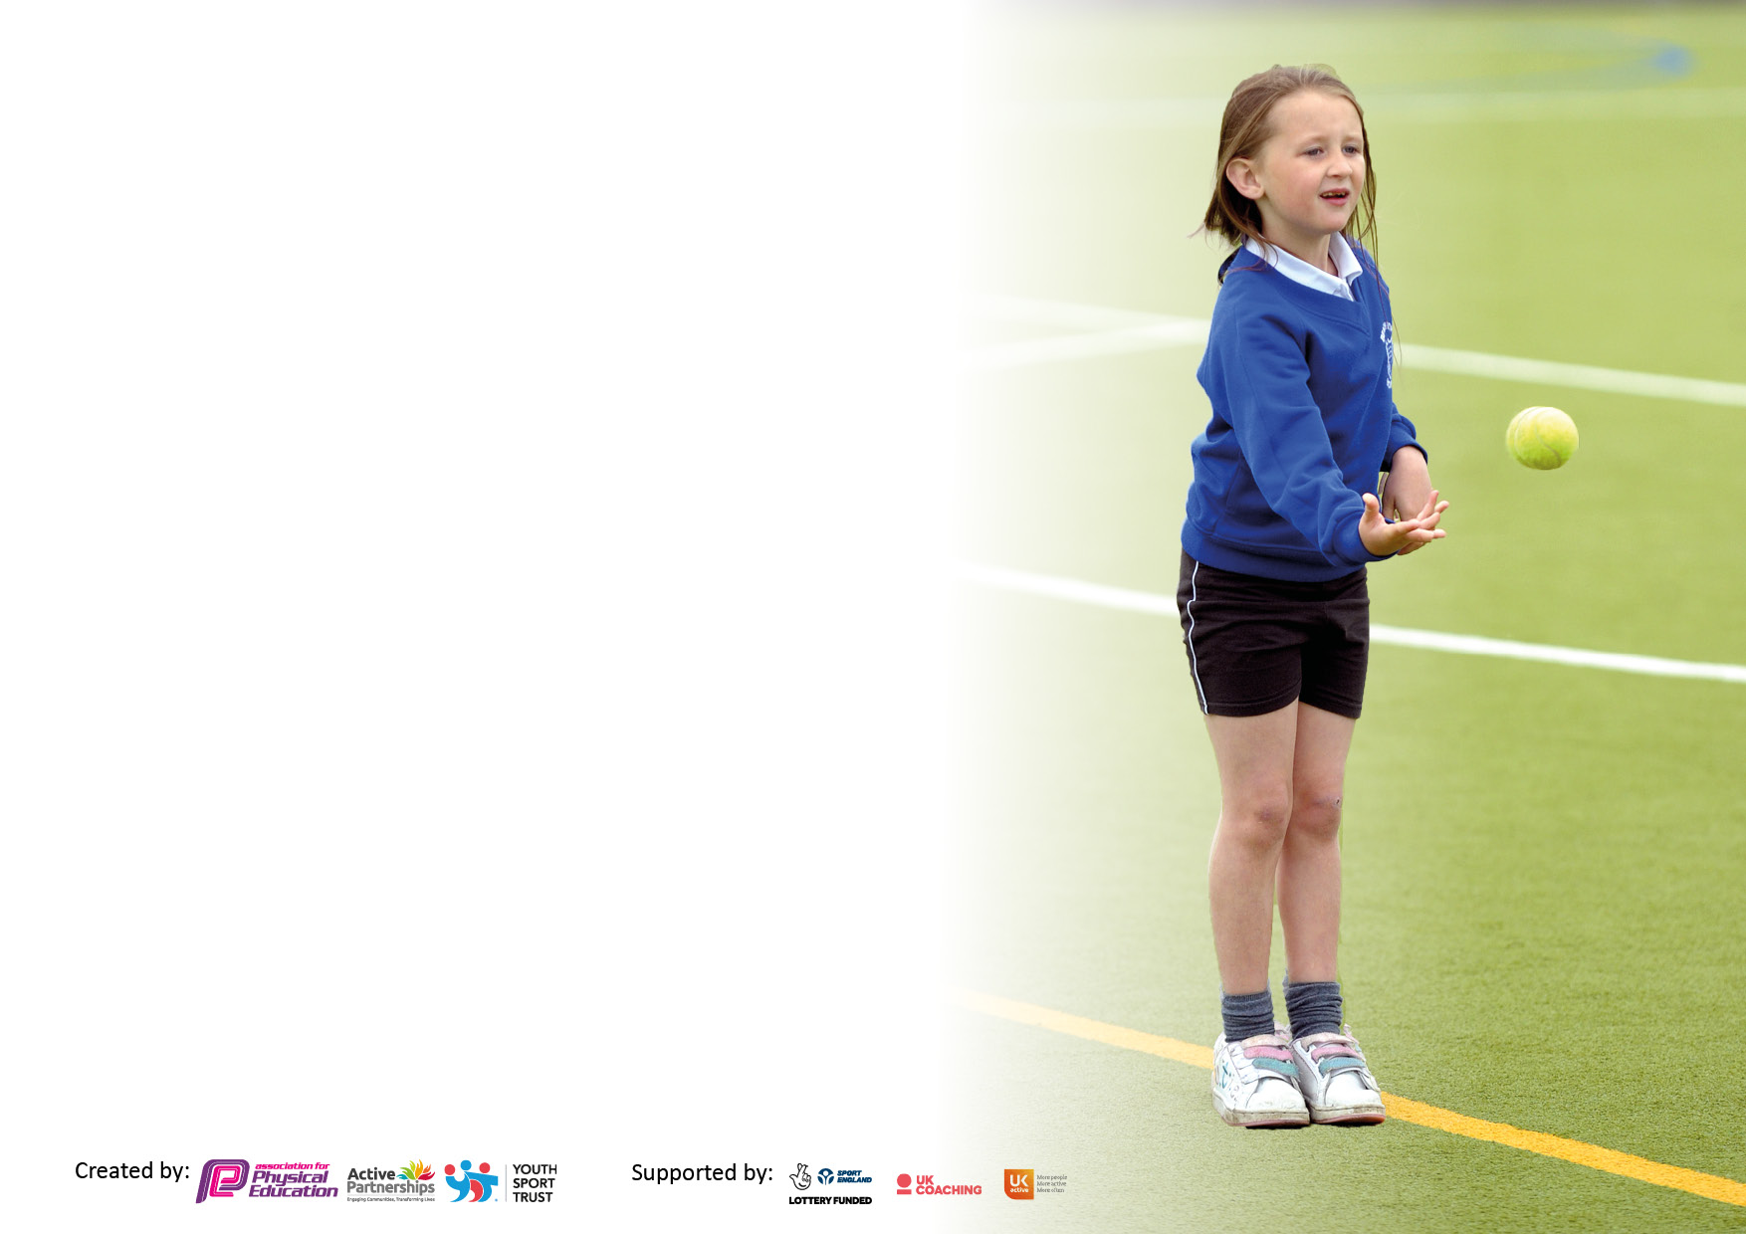

It is important that your grant is used effectively and based on school need. The Education Inspection Framework makes clear there will be a focus on ‘whether leaders and those responsible for governors all understand their respective roles and perform these in a way that enhances the effectiveness of the school’.

Under the Quality of Education Ofsted inspectors consider:
Intent - Curriculum design, coverage and appropriateness
Implementation - Curriculum delivery, Teaching (pedagogy) and Assessment
Impact - Attainment and progress

To assist schools with common transferable language this template has been developed to utilise the same three headings which should make your plans easily transferable between working documents.

Schools must use the funding to make additional and sustainable improvements to the quality of Physical Education, School Sport and Physical Activity (PESSPA) they offer. This means that you should use the Primary PE and sport premium to:

- Develop or add to the PESSPA activities that your school already offer
- Build capacity and capability within the school to ensure that improvements made now will benefit pupils joining the school in future years
- The Primary PE and sport premium should not be used to fund capital spend projects; the school’s budget should fund these.

Please visit gov.uk for the revised DfE guidance including the5keyindicatorsacrosswhichschoolsshoulddemonstrate an improvement. This document will helpyoutoreviewyourprovisionandtoreportyourspend.DfEencouragesschools to use this template as an effective way of meeting the reporting requirements of the Primary PE and Sport Premium.

We recommend you start by reflecting on the impact of current provision and reviewing the previous spend.

Schools are required to publish details of how they spend this funding, including any under-spend from 2021/2022, as well as on the impact it has on pupils’ PE and sport participation and attainment. The funding should be spent by 31st July but the DfE has stated that there will be no clawback of any unspent money so this can be carried forward into 2023/24.

We recommend regularly updating the table and publishing it on your website throughout the year. This evidences your ongoing self-evaluation of how you are using the funding to secure maximum, sustainable impact. Final copy must be posted on your website by the end of the academic year and no later than the 31st July 2023. To see an example of how to complete the table please click HERE.

Details with regard to funding
Please complete the table below.

Total amount carried over from 2022/23 | £0
Total amount allocated for 2022/23 | £17,260
How much (if any) do you intend to carry over from this total fund into 2023/24? | £0
Total amount allocated for 2023/24 | £16,000 + £10 per pupil  £17,280
Total amount of funding for 2023/24. Ideally should be spent and reported on by 31st July 2024. | £ 17,280
Swimming Data
Please report on your Swimming Data below.

Meeting national curriculum requirements for swimming and water safety.

N.B. Complete this section to your best ability. For example you might have practised safe self-rescue techniques on dry land which you can then transfer to the pool when school swimming restarts.
Due to exceptional circumstances priority should be given to ensuring that pupils can perform safe self-rescue even if they do not fully meet the first two requirements of the NC programme of study
What percentage of your current Year 6 cohort swim competently, confidently and proficiently over a distance of at least 25 metres?  N.B. Even though your pupils may swim in another year please report on their attainment on leaving primary school at the end of the summer term 2024.  Please see note above | 70%
What percentage of your current Year 6 cohort use a range of strokes effectively [for example, front crawl, backstroke and breaststroke]?  Please see note above | 10%
What percentage of your current Year 6 cohort perform safe self-rescue in different water-based situations? | 75%
Schools can choose to use the Primary PE and sport premium to provide additional provision for swimming but this must be for activity over and above the national curriculum requirements. Have you used it in this way? | Yes/No

Action Plan and Budget Tracking
Capture your intended annual spend against the 5 key indicators. Clarify the success criteria and evidence of impact that you intend to measure to evaluate for pupils today and for the future.

Academic Year: 2023/24 | Total fund allocated: | Date Updated: September 2023
Key indicator 1: The engagement of all pupils in regular physical activity – Chief Medical Officers guidelines recommend that primary school pupils undertake at least 30 minutes of physical activity a day in school |  |  |  | Percentage of total allocation:
74%
£12,803.70
Intent | Implementation |  | Impact
Your school focus should be clear what you want the pupils to know and be able to do and about  what they need to learn and to  consolidate through practice: | Make sure your actions to achieve are linked to your intentions: | Funding allocated: | Evidence of impact: what do pupils now know and what can they now do? What has changed?: | Sustainability and suggested next steps:
Increase physical activity at lunchtimes, ensuring all pupils have access to high quality led sessions and a diverse range of activities. | Employ sports coach to deliver a daily physical session.  Set up timetable so that each class attends a session a week. | £5,700 | Engagement at lunchtime has increased exceptionally well. This was also noted in our OFSTED inspection where behavior was a strength and lunchtime provision commented on. Children are active for the whole hour and are experiencing a wide range of sports. | Continue to provide lunch clubs for all year groups.  Engage lunchtime staff in the coach led sessions as a CPD opportunity.
Ensure all pupils have access to an after-school sports club which is led by highly trained experts and allows them to take part in a diverse range of activities. | Employ sports coach to deliver 2 x weekly sports clubs after school. One targeted at EYFS/KS1 and one targeted at KS2. Monitor attendance and pupil experiences. | £3,110.04 | This year children had access to a range of clubs. Uptake was high with clubs always reaching the 18 maximum. Children attended across year groups. | Following reflection, clubs to focus on Y1-6 for the whole year with Reception pupils being allocated a focus club in the Summer term.
Provide additional catch up swimming lessons for Year 6 pupils who have not yet met the expected standard in swimming in KS2. | Swimming sessions – Summer Term | £1923.66 | 70% of year 6 pupils could swim 25 metres confidently and 75% could perform safety techniques. | Develop and look for opportunities to support further children using a range of strokes.
Encourage further opportunities for independent physical activity during playtimes and lunchtimes. | New playground markings focused on fitness. | £2070 | Playground markings provide further opportunity for active play including ball skills and team games. | Consider other opportunities in the playground. Ensure staff can utilize these too within teaching.
Create zoned area on playground for younger pupils to access physical activity daily independently. | New Zoning Area | £160 | Children can access outdoors freely to take part in outdoor activity. | Monitor use of this.
Key indicator 2: The profile of PESSPA being raised across the school as a tool for whole school improvement |  |  |  | Percentage of total allocation:
£300
2%
Intent | Implementation |  | Impact
Your school focus should be clear what you want the pupils to know and be able to do and about  what they need to learn and to  consolidate through practice: | Make sure your actions to achieve are linked to your intentions: | Funding allocated: | Evidence of impact: what do pupils now know and what can they now do? What has changed?: | Sustainability and suggested next steps:
Pupils to recognize and celebrate the importance and value of sport, in particular athletics, linked to this year’s Olympic Games. | Year 6 “Olympics” Day led by Coaches and staff – variety of competitive games promoting Olympic Values and personal challenges. Children rewarded with medals. | £300 | Pupils fully engaged and active all day. | Consider other sporting events to link to next year.

Key indicator 3: Increased confidence, knowledge and skills of all staff in teaching PE and sport |  |  |  | Percentage of total allocation:
5%
£814.99
Intent | Implementation |  | Impact
Your school focus should be clear | Make sure your actions to | Funding | Evidence of impact: what do | Sustainability and suggested
what you want the pupils to know | achieve are linked to your | allocated: | pupils now know and what | next steps:
and be able to do and about | intentions: |  | can they now do? What has
what they need to learn and to |  |  | changed?:
consolidate through practice:
Continue to use PE Passport to plan PE sessions to ensure progress throughout the school, the sports are taught and to ensure staff are teaching well-planned, pedagogical lessons. | PE Passport renewed and used across school. | £300 | Staff have used PE Passport to access planning that is well-planned and sequential. PE Passport Journey Maps now being used as a form of assessment for PE to support staff. | Continue to use PE as means to support teachers with mixed year group planning. Use alongside PE coaches to assess and deliver sessions.
Provide training/CPD opportunities for lunchtime staff so that they feel confident in leading and delivering physical sessions at playtimes and lunchtimes. | Organise lunchtime timetable so that lunchtime staff can observe activities taught by PE experts/sports coaches. | £5,700 (see Key Indicator 1 – included in this cost) | Zones on the playground are now set up and all areas are active and fully engaging pupils. Some staff are pro-active in utilizing training. | Further look for CPD opportunities for playtime staff.
Provide dance coaching/training for relevant staff. | 2 x afternoons of Dance Sessions for Year 6 pupils and staff. | £180 (£90 per session) | Dance sessions were very successful with pupils active all afternoon. Staff felt the dance was very ambitious but were impressed with the skills of the children how they accomplished this. Staff feel more confident to develop this themselves next year. | Staff to utilize skills learnt independently next year.
Sports Week coaching/support. | Sports Coaching Group x 2 coaches to support with Sports Day.  Sports Coaching Group Workshop for all classes as part of sports week. Staff to attend workshop x 1 day – fencing KS2, Curling KS1. | £140 | Sports Day very successful – all pupils engaged and active. A mixture of competitive and enjoyable activities. All children came away with winning something.  Sports Week was very popular with pupils – they were inspired and motivated. Pupil voice was very positive with pupils thanking staff for the opportunities. | Ensure Sports Week is planned in yearly to ensure pupils get an annual opportunity to experience new sports.
Following midday staff training through the TRUST INSET, ensure they have equipment needed to put in place skills and activities taught. | Purchase braided cotton ropes. | £19.99 | Some midday staff are much more engaged and regularly setting up team games and activities. Ropes have been well used based on the games taught on the training. | Monitoring of all lunch staff utilizing equipment and engaging in active play.
Up date Forest School Training so that forest school can start running again, giving key pupils opportunities to be active outside and take part in outdoor educational activities. | Forest School Training | £175 | Forest school teacher up to date on training and now delivering sessions again. Targeted pupils are benefiting from outdoor learning. | Ensure this has high priority next year where possible.
Key indicator 4: Broader experience of a range of sports and activities offered to all pupils |  |  |  | Percentage of total allocation:
£2770
16%
Intent | Implementation |  | Impact
Your school focus should be clear | Make sure your actions to | Funding | Evidence of impact: what do | Sustainability and suggested
what you want the pupils to know | achieve are linked to your | allocated: | pupils now know and what | next steps:
and be able to do and about | intentions: |  | can they now do? What has
what they need to learn and to |  |  | changed?:
consolidate through practice:
Plan for sports week so that physical activity is promoted and children have access to a further range of diverse activities. | Book Scoot Fit as one of the diverse activities in sports week. | £585 | Sports Week was very popular with pupils – they were inspired and motivated. Pupil voice was very positive with pupils thanking staff for the opportunities. The scoot fit session in particular engaged pupils well and they were physically active for a full 45 minutes. | Consider how to implement this activity in school e.g. buying own scooters.
Further opportunity for pupils to experience a range of sports led by trained coaches. | Reward Sports Afternoon for sports day house winners led by Sports Coaching Group. | £75 | This was a motivating reward for pupils and also get pupils opportunity to work in mixed year groups within their house. | Consider further opportunities for working in houses in sports.  Allocate this reward for houses as part of competitive sport.
Residentials – Support for Parents to allow children to attend residentials by subsidising some of the cost. | Menai Residential  Pettypool | £1600 | Many children attended residential and this contribution allowed them to attend with the subsidized cost. | Due to high costs for parents, allocate this support for next year to ensure pupils still get this opportunity.  Venue for residentials changed to allow for a variety of outdoor activities closer to home to also ensure more children can access.
Summer Half Term 2 Sessions with Coaches to access more specialized sports. | Sports Coaching Group additional sessions | £510 | Sessions have allowed a variety of staff across school to take part in coaching to support the further delivery of PE and active lessons. Children have also engaged in different sports including use more specialized equipment that we don’t have in school. | Further opportunities for coaching needed to ensure staff are fully equipped tov deliver high quality PE sessions.

Key indicator 5: Increased participation in competitive sport |  |  |  | Percentage of total allocation:
2%
£55.99
Intent | Implementation |  | Impact
Your school focus should be clear | Make sure your actions to | Funding | Evidence of impact: what do | Sustainability and suggested
what you want the pupils to know | achieve are linked to your | allocated: | pupils now know and what | next steps:
and be able to do and about | intentions: |  | can they now do? What has
what they need to learn and to |  |  | changed?:
consolidate through practice:
Provide additional equipment for Sports Day to encourage different activities for healthy competition. | Purchase sports day equipment needed to ensure children can take part in varying activities. | £49.43 | New equipment allowed pupils to take part in more active obstacles e.g. agility ladders etc. These will also then complement the PE Curriculum. | Use same equipment for next year. Use throughout year so children become more familiar.
Rewards for Sports Day to develop children’s understanding and resilience when taking part in competitive sport. | Purchase stickers for all including 1st, 2nd and 3rd and taking part.  Reward Afternoon for winning houses during Sports Day – fun, active session delivered by Sports Coaches | £6.56  £75 (included in previous section cost) | All children came away with stickers. They enjoyed having these and the resilience of the children was really impressive. They had fun but celebrated those who won. | Look at other opportunities to reward for competitive sports e.g. trophies etc.

Signed off by
Head Teacher: | S. Minor
Date: | 19th July 2024
Subject Leader: | K.Clarke
Date: | 19th July 2024
Governor: | J.Smith
Date: | 24th July 2024

