ECO SCHOOLS

September 2026
We are delighted to announce that Lowton West has successfully achieved the ‘Green Flag’ status for Eco Schools. Well done to our children, parents and staff for all your hard work in making this happen.
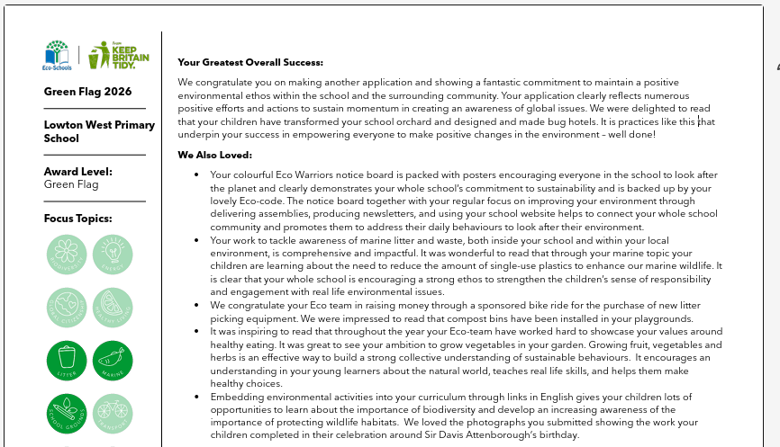
At Lowton West, our pupils and staff care deeply about environmental issues and have a strong desire to actively protect our planet.
Established in 1994, The Eco Schools Programme helps young people to develop a curiosity about the environment and lead environmental issues.
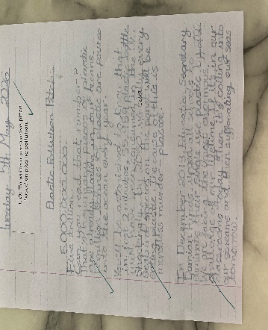 | 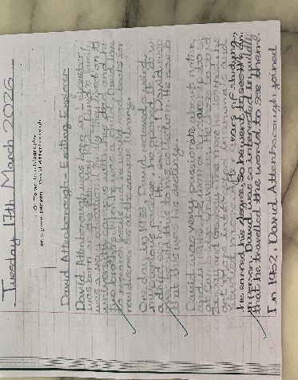

At the beginning of the school year, pupils on the Eco team carried out an Environmental review. Following this, pupils selected three topics from the ten topics shown in the poster above. Pupils chose to focus on – Biodiversity, Energy and School Grounds. As part of their chosen topics, pupils created a meadow area and developed an orchard.
Congratulations and a huge well done to everyone involved!
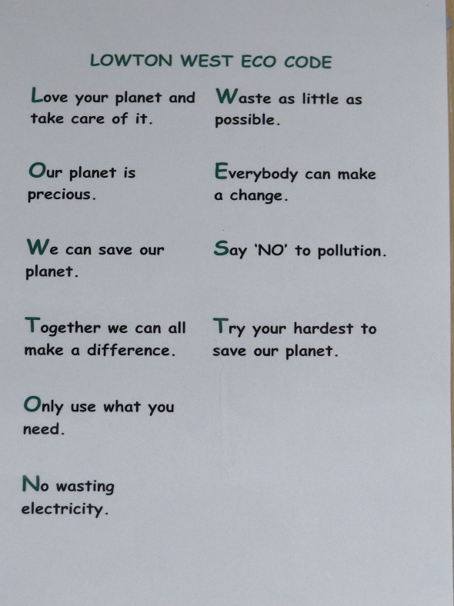 | 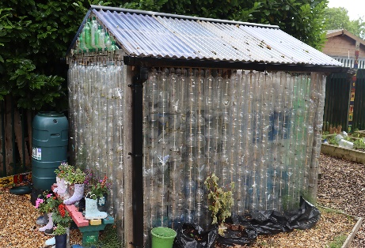
 | 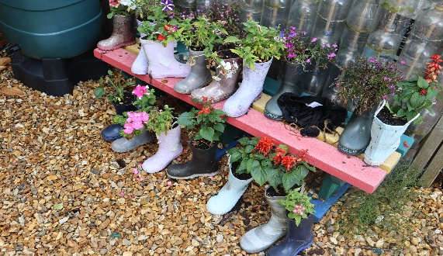
 | 