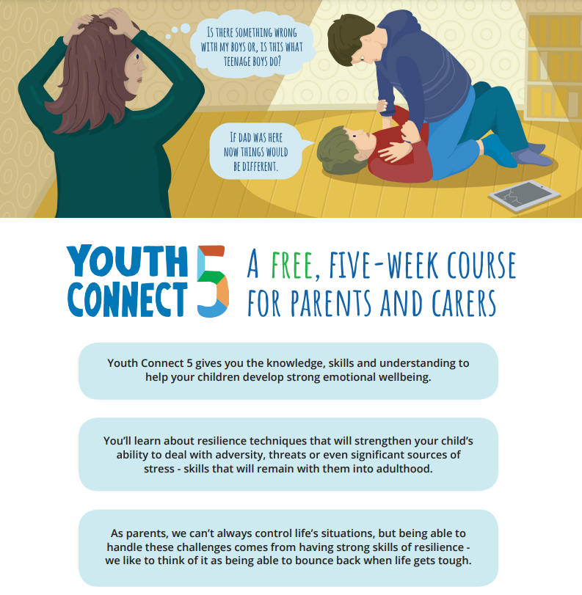
Tyldesley Family Hub site Poplar Street, Tyldesley, M29 8AX
Thursday 23rd Jan
10:00am-12:00pm
To Book a place email Earlyhelpdevelopmentteam@wigan.gov.uk

For more information, please visit
YouthConect5.org.uk



