Joke 3

What do you call a fairy that will not shower?
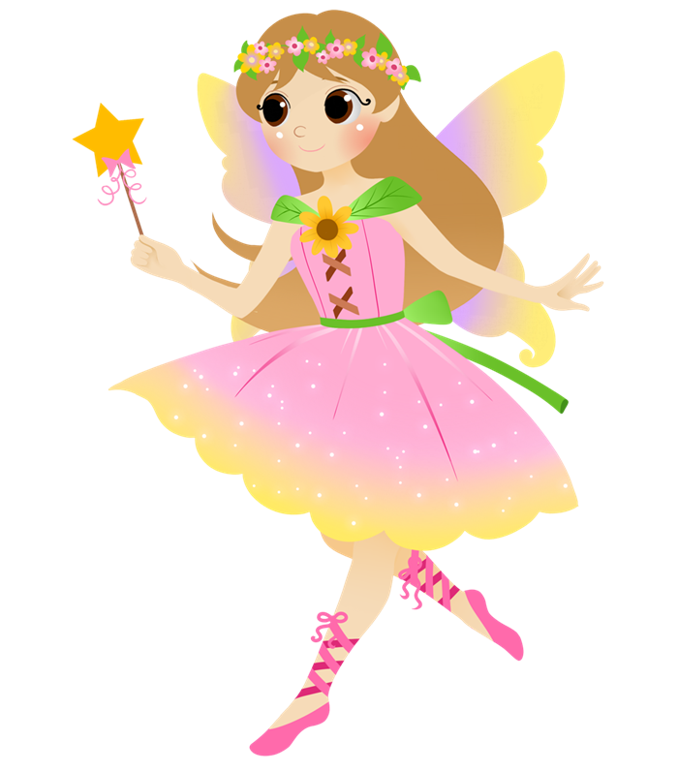

Stinkerbell!

