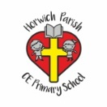 | RE Spring term 1 Year Two  Jesus, friend to everyone
Key vocabulary | Explanation/ definition | Key Knowledge
Miracle | Wonderful and surprising event, believed to have been caused by God. | - The stories in this unit can be found in the gospels in the New Testament.  - Christians believe that Jesus’ miracles reveal him to be the Son of God.  - Christians believe that we should welcome everyone and try to be a friend of all as Jesus was.  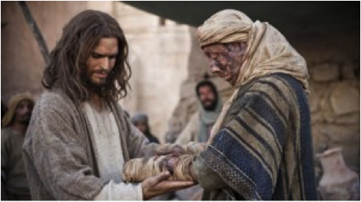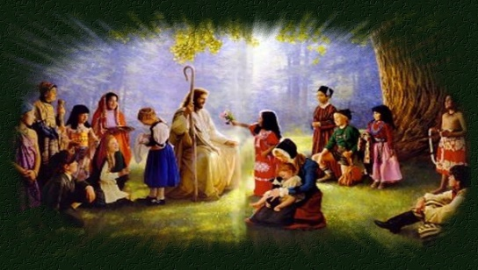
New Testament | The collection of the books of the Bible that were produced by the early Christian church.
Gospels | Any of the first four books of the New Testament.
Faith | Believing that something is true.
Trust | - To believe in and rely on someone or something.
Key skills
By the end of this unit, pupils are expected to be able to:
- Retell the stories covered in this unit.
- Tell you how these stories reveal Christian beliefs about Jesus.
- Talk about my own experiences and feelings.
- Respond sensitively to questions about my own and others experiences and feelings.
- Make links between the way a person behaves and what that person believes.

