Animals including humans have offspring that grow into adults
lamb  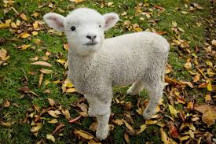 |  | sheep  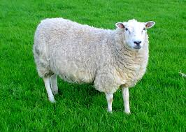
baby  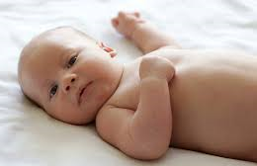 | toddler  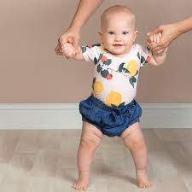 |  |  | child  
adult   |  |  | teenager  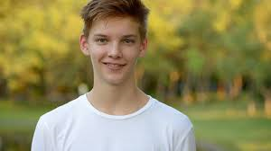
egg  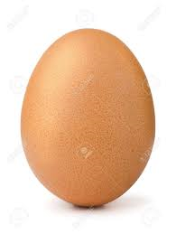 | chick  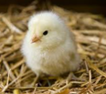 |  |  | chicken  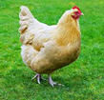
The young of some animals don’t look like their parents:
spawn  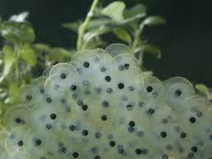 | tadpole  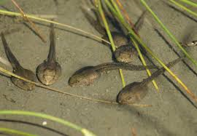 |  |  | frog  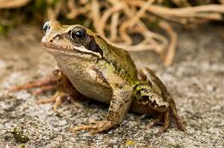
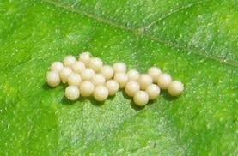  eggs |  | 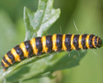  caterpillar
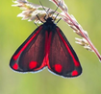  butterfly |  | 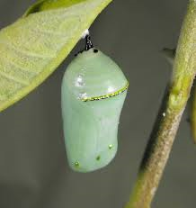  pupa
Animals including humans – Year 2
Key vocabulary
offspring | A person’s children or an animal’s young.
reproduction | The process where new animals, humans or plants are made.
growth | The process of getting bigger.
exercise | This is when you move your body physically to get fit and remain healthy. Our heartbeat increases when we exercise.
breathing | This is what we do to get oxygen in our bodies.
hygiene | Keeping clean to prevent illnesses and the spread of disease.
germs | A very small thing that can cause diseases. We cannot see them with our eyes.
disease | An illness which affects people, animals or plants.

Significant scientist
Dr Ernest Madu  (born 1960)  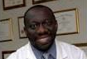 | Dr Ernest Madu is a cardiologist. His work focuses on providing affordable healthcare in low-resource nations.
All animals including humans have these basic needs to survive:
water to drink
food to eat

shelter
air to breathe

To grow into healthy adults, animals including humans need:
exercise
good hygiene

right amount and types of food

The Eatwell plate
This shows the different food groups that make up a healthy diet. 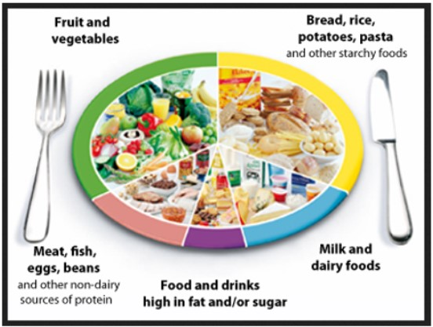

© ECM Education Consultants 2019

