PE
Gymnastics and Dance
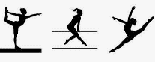
English
Diary writing in character
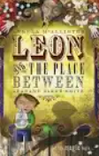

RE
What does it mean to be a Hindu in Britain today?
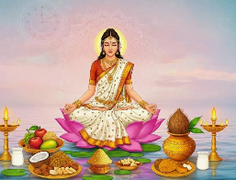
PSHE
How can we respect each other?

Music
Rock and Roll
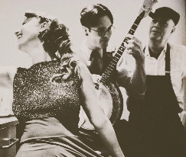
Art
Drawing: exploring tone, texture and proportion
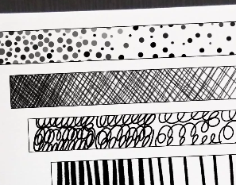
History
Anglo- Saxons
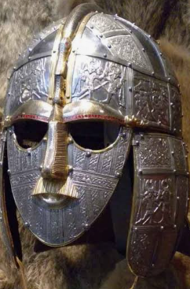
Science
Electricity and circuits
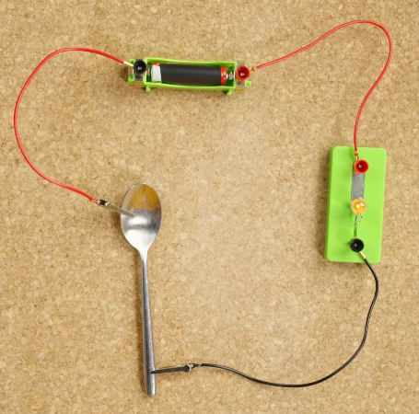
Maths
Multiplication and Division
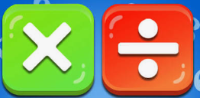
Computing
Further coding with Scratch
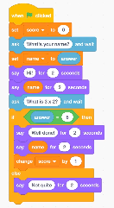
Year 4
Autumn 2 2026

