Maths
We will focus on addition and subtraction. We will be using lots of resources to make part-whole models and number sentences. We will also learn how to make a fact family.

____ + _____ = ____
Science
In the topic ‘Everyday Materials’ we will investigate the materials of some everyday items. We will then make connections between the materials they are made of and the properties they possess.

RE
We will be thinking about the key question ‘Why does Christmas matter to Christians?’.

Music
Sound patterns – fairy tales.

Computing
BeeBots – coding a set of instructions for a robot to follow.

English
We will continue to follow the structure of ‘Drawing Club’ to support children’s independent writing.
We will focus on the Year 1 skills of capital letters, full stops and adjectives.
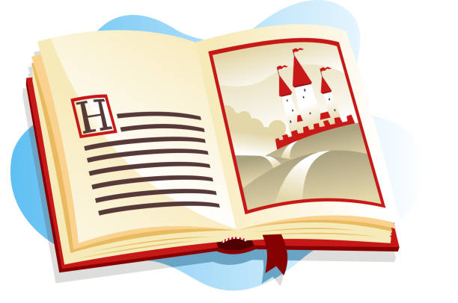

History
What is History?
In this topic we will be thinking about the past and how our lives so far could be represented as a timeline. We will also explore some similarities and differences between the present and past.

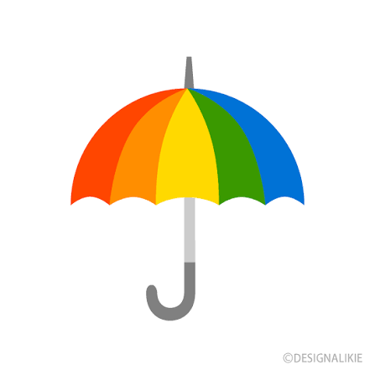


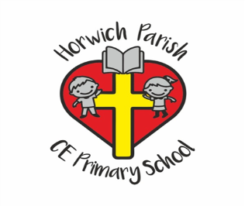
Year 1
Autumn 2 2026

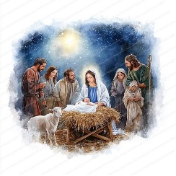
PE
Gymnastics


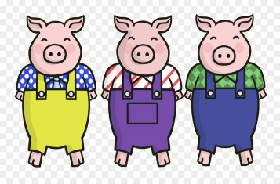
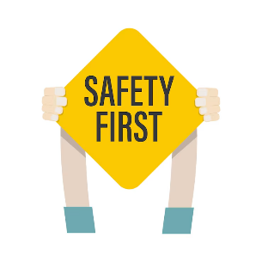
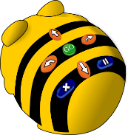
PSHE
How I make myself and others feel safe and happy?

Art
Colour splash – we will be learning about the colour wheel and practising mixing primary colours to make secondary colours.

