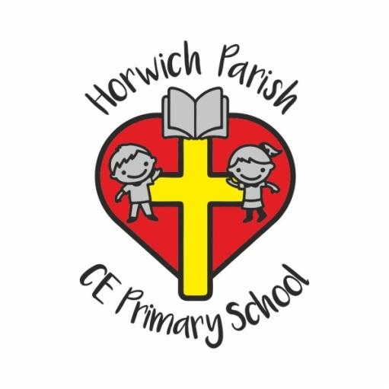
Resources
The Kapow scheme provides high-quality multimedia resources, including videos, songs, games, and cultural activities to support engagement and understanding. Classroom displays and vocabulary walls reinforce learning. Additional resources such as flashcards and online pronunciation tools are used to enhance delivery.

Planning
We follow the Kapow Primary Spanish scheme, which provides a clear, spiral curriculum ensuring progression and revisiting of key vocabulary, grammar, and cultural themes each year. The planning supports teachers with structured lessons, interactive resources, and guidance for assessment and differentiation.

Monitoring & Reporting Standards
The Subject Leader monitors teaching and learning through lesson observations, learning walks, book scrutinies, and pupil voice interviews. Staff feedback and assessment data are used to evaluate consistency and inform future planning. Progress and standards are reported to senior leaders, and outcomes are shared through curriculum reviews and reports.

Teaching Approaches
Lessons are interactive, inclusive, and adaptive to meet the needs of all learners. Teachers use a variety of approaches, including songs, games, role-play, and written tasks, to support different learning styles. There is an emphasis on listening and speaking skills before moving to reading and writing, promoting confidence and communication.

Curriculum Design & Organisation
Spanish is taught once a week across all KS2 classes.
- Year 3: Introduces core vocabulary, pronunciation, and simple sentence structures.
- Years 4–6: Build on previous knowledge to develop greater fluency, accuracy, and confidence in speaking, listening, reading, and writing.
The curriculum also embeds cultural understanding and comparisons with English.

Parental Engagement
Parents are informed of their child’s progress through end-of-year reports. Spanish vocabulary and cultural celebrations are occasionally shared via newsletters or school events such as International Languages Day, helping parents engage with and celebrate pupils’ achievements in language learning.

Assessment
Pupils are assessed half-termly using pre- and post-unit quizzes and knowledge catchers provided by Kapow. These assessments measure vocabulary retention, understanding, and skill progression. Informal assessments and teacher observations are also used to inform planning and identify next steps.

Leadership Personnel
MFL (Spanish) is taught by all KS2 class teachers, as it is only delivered in Key Stage 2. The Subject Leader is Mrs Barber. She oversees curriculum delivery, progression, and consistency across KS2.

