PE 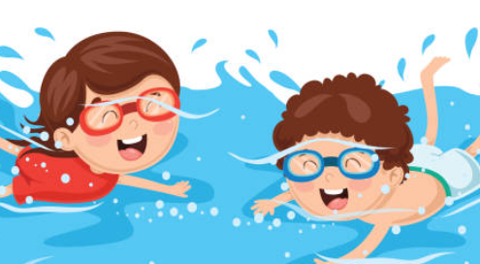
Fundamental Movement
Swimming
Computing
Throughout this half term, we will be studying safer internet use.

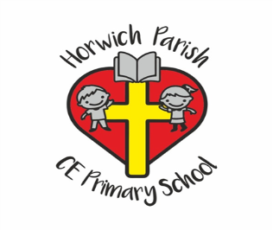
Year 5/6B
Autumn 1
English 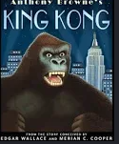
In writing skills, we will be following the classic story ‘King Kong’ to write our own story.
In Reading Skills, we will be developing our reading skills while reading ‘Viking Boy’.
Science
We will be learning about classification.
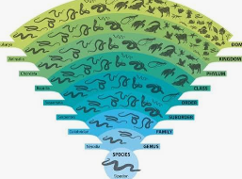
RE
We will be investigating the relationships between science and religion.
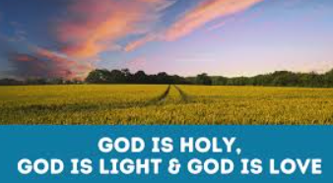
PSHE
We will be learning about healthy relationships.

Music
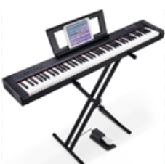
We will be studying looping and remixing
DT
This half term we will be studying electrical systems.
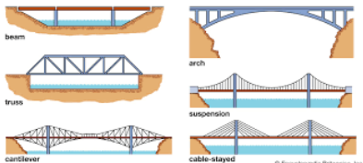
Geography

In Geography, we will be learning about the world’s population.
Maths 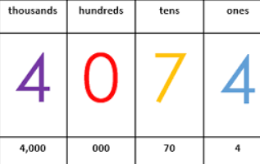
Mastery in number
Place value
Addition and subtraction

