RE – What do Christians learn from the Creation story?
We will be learning about the first Creation story from Genesis and key messages within it then move on to discuss the story of Adam and Eve.
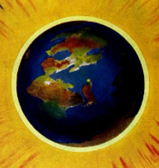

Geography – Who lives in Antarctica?
We will learn about the location, physical features and human features of Antarctica. We will plot Shackleton’s route to Antarctica and plan our own simple route around school on a map using compass points.
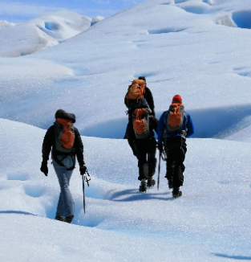

PE
ABC - Agility, balance & Co-ordination
SAQ – Speed, Agility & Quickness

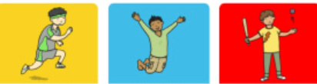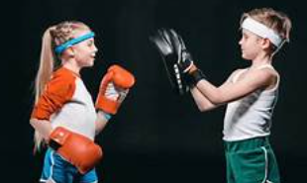

Computing – Online safety
We will be learning about:
- Beliefs, opinions and facts on the internet
- Sharing of information
- Rules of social media platforms
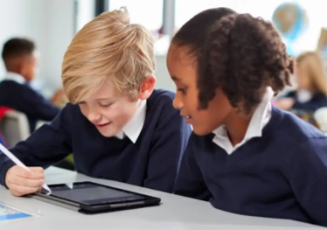

PSHE – Taking care of my mind and body
We will learn about the connection between the mind and body by recognising and describing a wide range of feelings and emotions.



Science – Forces and Magnets

We will be exploring contact and non-contact forces, including friction and magnetism and their effects.
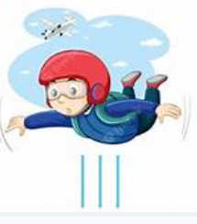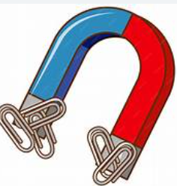

English – Seal Surfer by Michael Foreman
We will be building our writing skills to write a letter from the boy to his grandfather.

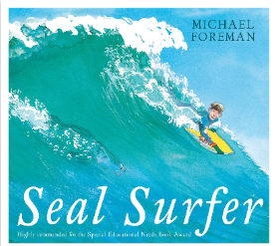
Maths – Place value, Addition and subtraction

We will learn to:
- Represent, partition, compare and order numbers up to 1000.
- Add and subtract up to 3 digit numbers.
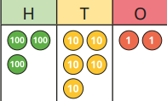

DT – Digital world – Mindful moments timer
We will be learning:
- To research and evaluate timers
- To design and program a timer
- To develop a brand identity
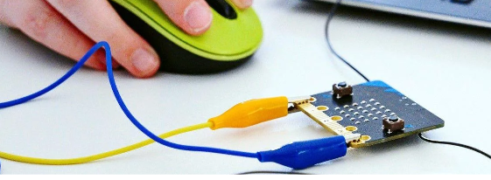.

Music – Creating compositions (Theme – Mountains)

We will be telling stories through music, creating a soundscape and adding story sound effects and a rhythm.
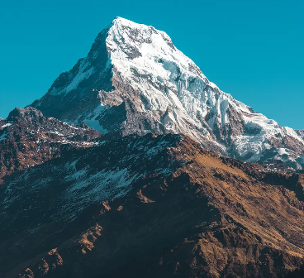

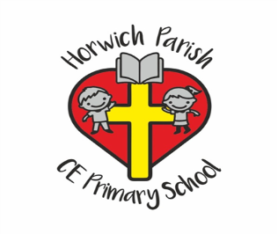
Year 3
Autumn 1

