4/5H
Autumn one
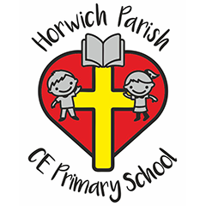
History / Geography 
This term we will be focusing on Geography when we will be looking at ‘My Region and the North Region of Brazil’
The children will learn about:
- Features of both regions
- Similarities and differences
- The main economic of Brazil and the North West

Maths
Place value (Year 4)
Place value (Year 5)
- Partition 1,000
- Find 1, 10, 100 and 1,000 more and less
- Focus on numbers to 1,000,000
- Use the power of 10
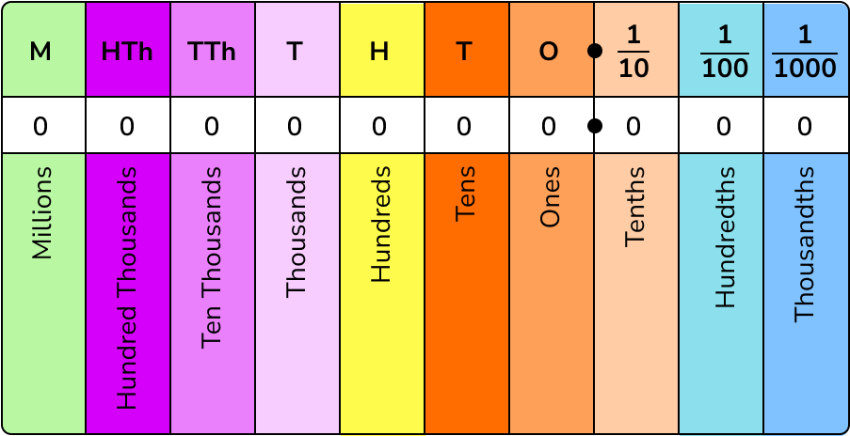
English
This term we will be reading ‘Gorilla’ by Anthony Browne
The children will write a narrative based on the story.
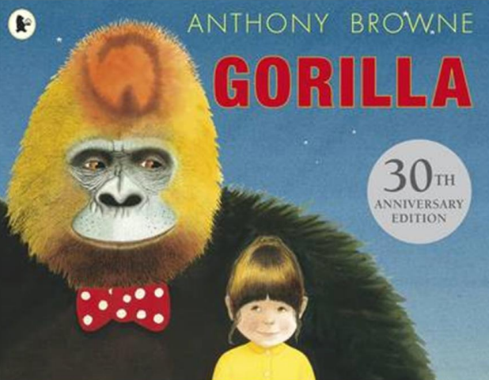

Science 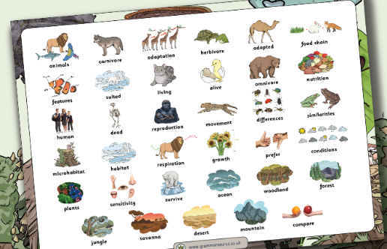
We are going to be learning about ‘Living things and their habitats’
The children will learn about:
- The seven-life process
- Sort and group animals
- Vertebrate animals
RE
We will be learning about ‘What kind of world did Jesus want? (Gospel)’
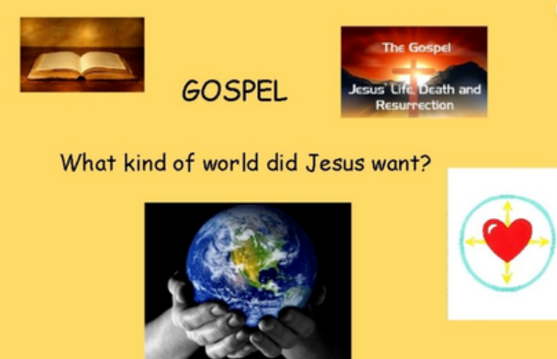
PSHE
This term the children will be learning about:
- How do my choices help me to be healthy?
- What are healthy habits?
- Why is food fuel?
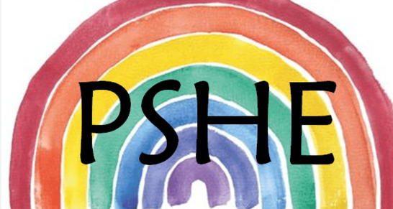
PE
This term we will be focusing on:
- Fundamental skills


Computing
This term we will be learning about Online Safety
We will be learning about:
- how to make responsible choices online
- how to keep ourselves and others safe online
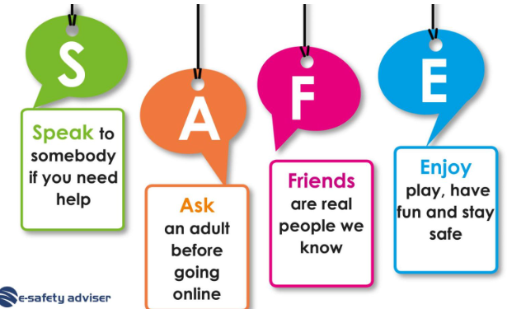

Art / DT
We are doing DT this term and we will be focusing on the ‘Digital world: monitoring devices’
We will be:
- Evaluating devices
- Programming a device
- Using 3D CAD skills
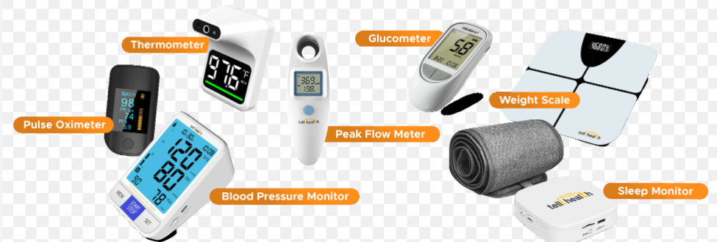
Music
We will be learning to continue to use our Brass instruments
