Maths
We will focus first on place value to 10 – learning the number bonds that make 10 and counting backwards and forwards. We will also begin to explore addition.
Science
In the topic ‘Sensitive Bodies we will be exploring the five senses. We will conduct investigations that test the use of our senses and help us to make connections to the wider world.

RE
We will be exploring the key question ‘Who do Christians say made the world?’

Music
Dynamics – the seaside
We will be using our body and instruments to replicate the sounds of the seaside.

Computing
Online Safety

English
We will continue to follow the structure of ‘Drawing Club’ to support children’s independent writing.
We will focus on the Year 1 skills of capital letters, full stops and adjectives.


Geography
Where am I?
In this topic, children will explore our local area.
We will find our town on a map of the UK, explore aerial maps of our school grounds and have a go at mapping our classroom.

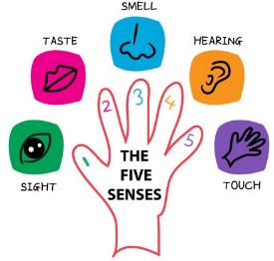
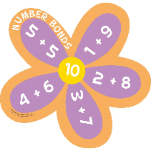



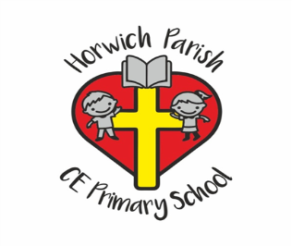
Year 1
Autumn 1 2026

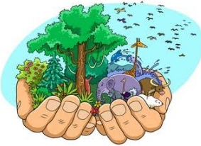
PE
ABC – Agility, Balance, Coordination.


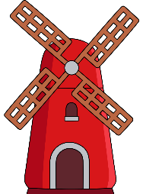
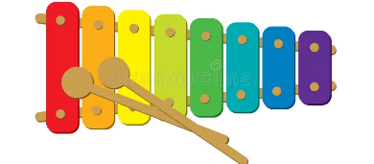
PSHE
How can we look after our feelings?

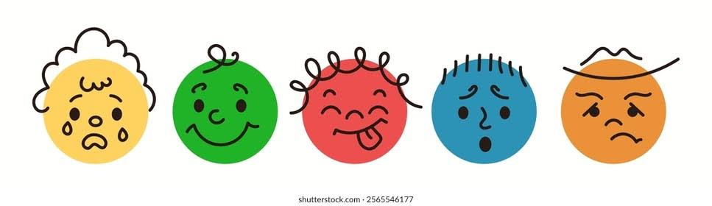
DT
Structures – designing, making and evaluating a windmill.

