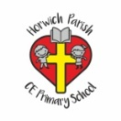 | RE Summer term 1 Year Six  Ideas about God/ Names of God in other faiths
Key vocabulary | Explanation/ definition | Key Knowledge
God | The name God is given to the spirit or being who is worshipped as the creator and ruler of the world, especially by Jews, Christians, and Muslims. | - Bible stories help to deepen our knowledge and understanding of God.  - we (Christians) believe God is three in one, the Trinity.  - God is given many names by Christians and members of non-Christian faiths. These names describe His nature and characteristics,  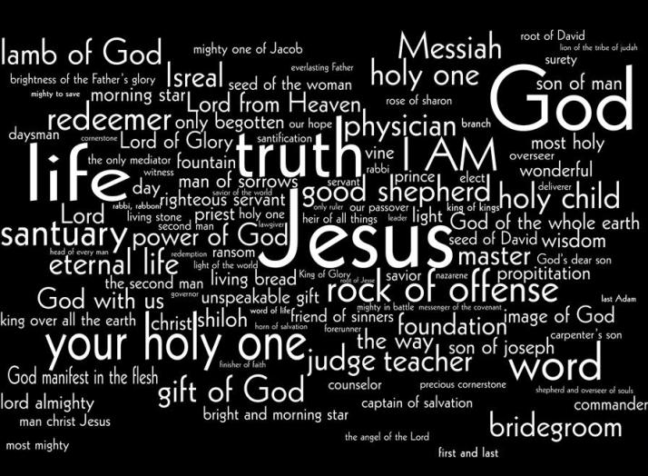  - Bible texts are used to answer questions about the characteristics and nature of God.  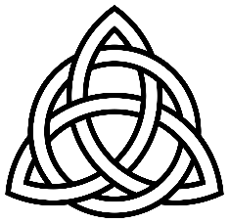  Celtic Trinity knot
Father | paternal protector or provider, the first person in the Trinity
Son | the male offspring of the Father, the second person in the Trinity
Holy Spirit | the spirit of God; the third person of the Trinity
Trinity | In the Christian religion, the Trinity or the Holy Trinity is the union of the Father, the Son, and the Holy Spirit in one God.
Celtic | of an ancient European people who are related to the Irish, Scots, Welsh, and Bretons, or of their language or culture
Allah | Allah is the name of God in Islam.
Brahman | Hindus believe Brahman is the supreme God who controls the universe
Key skills
By the end of this unit, pupils are expected to be able to:
- use religious language to show they are developing an understanding of the Trinity.
- identify the elements in Christian worship that express Christian beliefs about God.
- ask big questions and express their own views.

