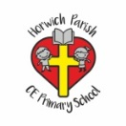 | RE Autumn Term 1 Year Three  Harvest
Key vocabulary | Explanation/ definition | Key Knowledge
Harvest | The process or period of gathering in crops, often in the Autumn time. | - People of all faiths and people with none celebrate Harvest in their own way.  - Harvest is mentioned many times in the Bible, particularly in the Old Testament.  - For hundreds of years people have thanked God for Harvest  - Harvest used to be very different particularly in farming communities.  - The Jewish harvest festival is called Sukkot.  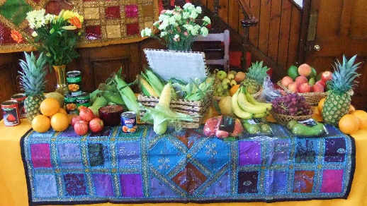  
Festival | A day or period of celebration, typically for religious reasons.
Reflect | To think deeply or carefully about something, often something that you have experienced.
Celebration | When you celebrate an important day or event.
Community | A group of people living in the same place or having a particular characteristic in common.
Sukkot | A major Jewish festival held in the autumn (beginning on the 15th day of Tishri) to commemorate the sheltering of the Israelites in the wilderness. It is marked by the erection of small booths covered in natural materials.
Tithe | One tenth of something often given as a contribution to a religious organisation.
Thankful | Feeling or showing gratitude. When you are pleased and grateful for what you have, this is an example of a time when you are thankful.
Key skills
By the end of the unit pupils will be able to:
- describe the traditional content of Christian Harvest Festival services.
- describe and explain the Jewish festival of Sukkot.
- explain why Christians celebrate harvest.
By the end of the unit pupils will know that:
- harvest has been celebrated for thousands of years.
- harvest is celebrated by people of all faiths and none.
- harvest is mentioned throughout the Old Testament.
there is a connection between Christian belief and behaviour in relation to celebrating the harvest.

