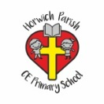 | RE Autumn term 1 Year One  Harvest: How can we help those who do not have a good harvest?
Key vocabulary | Explanation/ definition | Key Knowledge
Harvest | - The season when ripened crops are gathered. | - That the food we eat comes from all around the world.  - That not everyone in the world enjoys a good harvest.  - Christian charities are helping people in poor countries.  - That it is good to say thank you to God for the harvest.  - That the Jewish festival of harvest is called Sukkot.  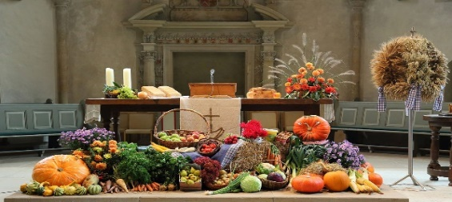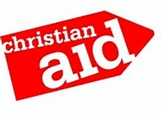  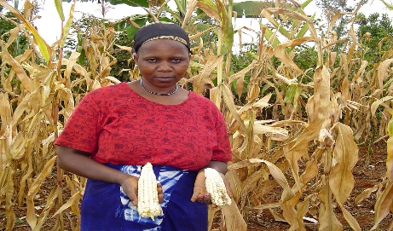  Sukkot shelter
Harvest Festival | A service in Christian churches/schools to celebrate the annual harvest, to which gifts of food are brought for charities who support those in need.
Christian Aid | A Christian organisation who are a partnership of people, churches and local organisations committed to ending poverty worldwide.
Key skills
By the end of this unit, pupils are expected to be able to:
- Say what I feel about some of the things we talked about during the harvest festival project.
- Think of ways in which I can help others.
- Tell you about the ways in which Jewish people celebrate harvest
- Talk about the harvest festival that my class helped plan and lead.

