 | PSHCE- Keeping/staying safe (Cycle safety)
Key vocabulary | Explanation/ definition | Key knowledge
Bicycle | A vehicle consisting of two wheels held in a frame one behind the other, propelled by pedals and steered with handlebars attached to the front wheel. | Be able to identify strategies to keep ourselves and others safe.  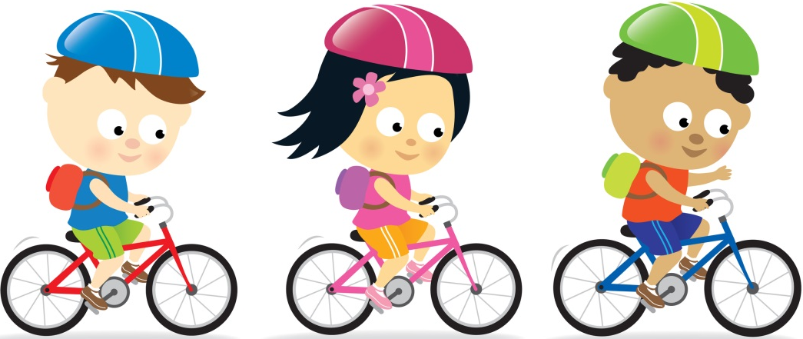  Be able to identify a risky choice.
Helmet | A hard or padded protective hat.
Reflective material | Providing a reflection; capable of reflecting light and ensuring you are seen in the dark.
Front/back lights | Lights attached to the front and back of a bicycle to ensure you can be seen.
Crossing | A safe place to cross a road.
Hazard | A danger or risk.
Risk | A situation involving exposure to danger.
Prevent | Action taken to keep (something) from happening.

 | PSHCE- Keeping/staying healthy (Healthy Living)
Key vocabulary | Explanation/ definition | Key knowledge
Balanced diet | A healthy balance of the five food groups: carbohydrates, fruit & veg, protein, dairy and fat. |   Know and understand that too much sugar, salt and saturated fat in our food and drink can affect us now and when we are older.
Saturated fat | A type of fat containing a high proportion of fatty acid molecules considered to be less healthy in the diet than unsaturated fat.
Unsaturated fat | A type of fat containing a high proportion of fatty acid molecules with at least one double bond, considered to be healthier in the diet than saturated fat.
BMI | An approximate measure of whether someone is over- or underweight.
Moderation | The avoidance of excess or extremes.

 | PSHCE- Relationships (Appropriate Touch)
Key vocabulary | Explanation/ definition | Key knowledge
Touch | Come into or be in contact with. | Know that relationships change as we grow.  Be able to identify how relationships can be healthy/unhealthy.    Learn strategies for asking for help if needed.
Appropriate | Suitable or proper in the circumstances.
Uncertain | Not completely confident or sure of something.
Uncomfortable | Causing or feeling unease or awkwardness.
Strategy | A plan of action.

 | PSHCE- Being responsible (Coming Home on Time)
Key vocabulary | Explanation/ definition | Key knowledge
Responsible | Having an obligation to do something, or having control over or care for someone, as part of one's job or role. | Understand the importance of being responsible in a range of situations.  Be able to discuss a range of situations when being on time is important.  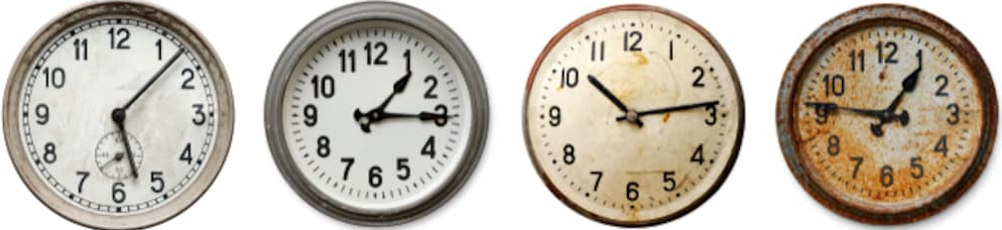
Accountable | Required or expected to justify actions or decisions; responsible.
Trust | Firm belief in the reliability, truth, or ability of someone or something.
Honesty | The quality of being honest.
Compliant | Disposed to agree with others or obey rule.
Punctual | Happening or doing something at the agreed or proper time.

 | PSHCE- Feelings and emotions (Jealousy)
Key vocabulary | Explanation/ definition | Key knowledge
Jealous | Feeling or showing an envious resentment of someone or their achievements, possessions, or perceived advantages. | Understand how we can support others who feel lonely, jealous or upset.    Learn and use a range of strategies for managing unpleasant emotions cause by feelings of jealousy.
Resent | Feel bitterness or indignation at (a circumstance, action, or person).
Self-esteem | Confidence in one's own worth or abilities; self-respect.
Trait | A distinguishing quality or characteristic, typically one belonging to a person.
Overcome | Succeed in dealing with (a problem or difficulty).
Empathy | The ability to understand and share the feelings of another.

 | PSHCE- Computer safety (Online bullying)
Key vocabulary | Explanation/ definition | Key knowledge
Cyberbullying | The use of electronic communication to bully a person, typically by sending messages of an intimidating or threatening nature. | Be able to identify cyber-bullying and its consequences.    Be able to develop coping strategies to use if we or someone we know is being bullied online.  Know how to ask for help.
Trolling | Deliberately baiting and encouraging people to argue/become upset over online content.
Peer pressure | Influence from members of one's peer group.
Ignore | Refuse to take notice of or acknowledge.
Defend | Resist an attack made on (someone or something); protect from harm or danger.
Support | Give assistance to.

 | PSHCE- The Working World (Chores at Home)
Key vocabulary | Explanation/ definition | Key knowledge
Money | A current medium of exchange in the form of coins and banknotes. | Know and understand who pays for their services that keep us healthy and safe.  Be able to identify ways in which we can help those who look after us.  Identify who covers the cost of our education.  
Tax | A compulsory contribution to state revenue, levied by the government.
VAT | Value added tax.
Salary | A fixed regular payment made by an employer to an employee.
Income | Money received, especially on a regular basis, for work or through investments.

 | PSHCE- A World without Judgement (Breaking down Barriers)
Key vocabulary | Explanation/ definition | Key knowledge
Differences | A point or way in which people or things are dissimilar. | Know and understand that being different is okay.  Know and understand how our judgements and opinions can affect others.  
Insecurities | Uncertainty or anxiety about oneself; lack of confidence.
Acceptance | Regard favourably or with approval; welcome.
Tolerance | The ability or willingness to tolerate the existence of opinions or behaviour that one dislikes or disagrees with.
Togetherness | The state of being close to another person or other people.

