 | PSHCE- Keeping/staying safe (Tying shoelaces)
Key vocabulary | Explanation/ definition | Key knowledge
Laces | Material used to tie shoes | Developing understanding of safe and unsafe scenarios  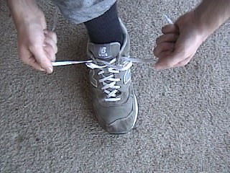
Safety | Being protective and unlikely to cause danger
Hazard | A danger or risk
Warning | Cautionary advise
Dangerous | Able or likely to cause harm
Prevention | Action to stop something arising
Accidents | An unfortunate incident

 | PSHCE- Keeping/staying healthy (Brushing teeth, healthy eating)
Key vocabulary | Explanation/ definition | Key knowledge
Milk teeth | Early teeth in children | Understand how and why to brush your teeth    Know the differences between healthy and unhealthy choices  
Floss | Clean between one’s teeth
Decay | Rot
Filling | Used to fill holes in teeth
Plaque | A sticky deposit on teeth
Oral hygiene | Keeping mouth healthy
Canine, incisors and molars | Types of teeth
Protein | A type of nutrients found in food
Food groups | Groups of nutrients made up in food
Vitamins and minerals | Compounds necessary for the healthy functioning of our bodies

 | PSHCE- Relationships (Bullying, body language)
Key vocabulary | Explanation/ definition | Key knowledge
Bullying | Repetitive unkindness to another to target them | Be able to see and understand bullying behaviours.  Know how to cope with bullying behaviours.  Understand that feelings can be shown without words.  Understand why it is important to care about other people’s feelings.  
Kindness | The quality of being friendly, generous, and considerate
Caring | Displaying kindness and concern for others
Empathy | The ability to understand and share the feelings of another
Body language | The movements used to communicate
Emotions | A strong feeling

 | PSHCE- Being responsible (Practise makes perfect, helping someone in need, schools linking)
Key vocabulary | Explanation/ definition | Key knowledge
Physical | Relating to the body as oppose to the mind | Be able to name ways you can improve in an activity or sport  Be able to see the benefits of practising an activity or sport  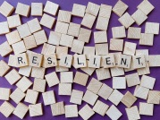  Know how you can help other people  Understand the risks of talking to people you don’t know very well in the community  
Goals | Aiming to achieve something
Achievement | Something done successfully
Resilience | Not giving up
Growth mind-set | Believing you can develop further
Enthusiasm | Intense interest
Community | A group of people living in the same area
Reliable | Can be trusted
Tolerance | Respecting others

 | PSHCE- Feelings and emotions (Worry, Anger)
Key vocabulary | Explanation/ definition | Key knowledge
Scared | Feeling fearful or frightened | Learn a range of skills for coping with unpleasant / uncomfortable emotions  Be able to recognise and name emotions and their physical effects  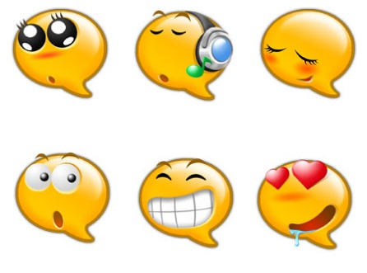
Anxious | Worried or uneasy
Nervous | Alarmed about something
Frustrated | Annoyed or disappointed
Respect | Regard for the feelings, wishes, or rights of others
Unpleasant/Uncomfortable | Causing discomfort or distress
Mental health | Psychological and emotional wellbeing
Reflective | Thinking back over an event in deep thought.

 | PSHCE- Computer safety (Image sharing, online safety day)
Key vocabulary | Explanation/ definition | Key knowledge
Privacy | Secrecy- not intruded by others | Understand how your online actions can affect others  Know the risks of sharing images without permission.  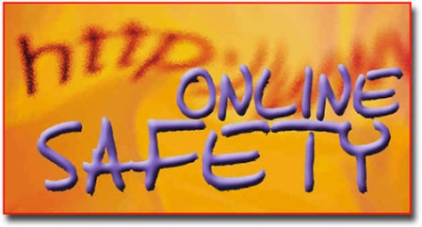
Permission | Giving allowance to someone or something
Passwords | A secret word or phrase
Image sharing | Sharing images online
Online | Controlled by or connected to a computer
ICT | Information- communication- technologies

 | PSHCE- Money matters
Key vocabulary | Explanation/ definition | Key knowledge
Sensible | Something or someone practical | Understand different ways we can receive money  Know how to keep money safe  Understand the importance of saving money  
Saving | The practise of saving money for future use
Resourceful | Having the ability to find quick and clever ways to overcome difficulties
Value | Placing importance on something or somebody
Denominations | A face value of money

