 | YEAR 3- PSHCE- Keeping/staying safe (Leaning out of windows)
Key vocabulary | Explanation/ definition | Key knowledge
Fall | Move from higher to lower level without control | Understanding of hazards in the home and outside.  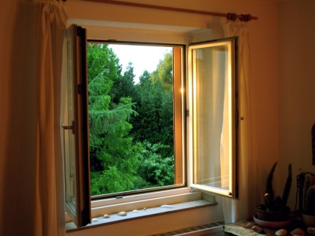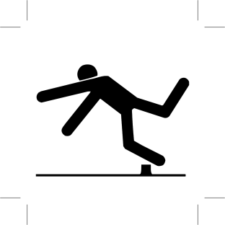
Safety | Being protective and unlikely to cause danger
Hazard | A danger or risk
Warning | Cautionary advise
Dangerous | Able or likely to cause harm
Prevention | Action to stop something arising
Accidents | An unfortunate incident

 | PSHCE- Keeping/staying healthy (Medicine)
Key vocabulary | Explanation/ definition | Key knowledge
Illness | A period of sickness affecting the body or mind. | Know, understand and be able to practise simple safety rules about medicine.    Know who we can accept medicine from
Disease | A problem in a human that is not a direct result of physical injury.
Medicine | A drug for the treatment or prevention of disease.
Prescription | An instruction written by a doctor or nurse that allows a patient to be given some medicine.
Chemist | A shop where medicine can be collected or purchased.
Overdose | An excessive dose of a drug.

 | PSHCE- Relationships (Touch)
Key vocabulary | Explanation/ definition | Key knowledge
Privacy | Where someone is not observed by others. | Understand the difference between appropriate and inappropriate touch.  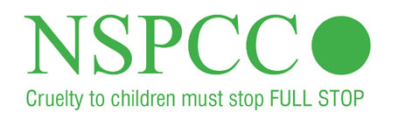  Understand personal boundaries.  https://www.nspcc.org.  uk/preventing-abuse/  keeping-children-safe/  underwear-rule
Secrets | Something that is not shared with other people.
Body | The physical structure of a person.
Appropriate | Something that is okay or acceptable.
Inappropriate | Something that is not okay or unacceptable.
Physical contact | Bodily contact.

 | PSHCE- Being responsible (Stealing)
Key vocabulary | Explanation/ definition | Key knowledge
Possession | To own something. | Be able to describe how you might feel if something is borrowed and not returned.  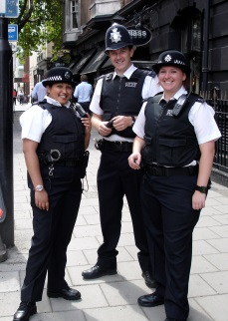  Know why it is wrong to steal.
Purchase | To buy something by paying for it.
Theft | The act of stealing.
Steal | Take another person’s property without permission without intending to return it.
Police | The police are responsible for the prevention and detection of crime.
Borrow | Take something belonging to someone else with the intention of returning it.
Honesty | Being truthful.
Return | To give something back.
Crime | An action that constitutes an offence and is punishable by law.

 | PSHCE- Feelings and emotions (Grief)
Key vocabulary | Explanation/ definition | Key knowledge
Scared | Feeling fearful or frightened | Be able to recognise and name emotions and their physical effects of grief.  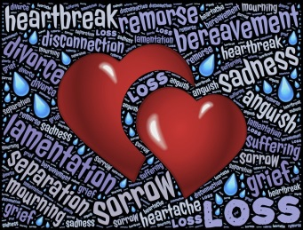  Learn a range of coping skills.
Anxious | Worried or uneasy
Nervous | Alarmed about something
Frustrated | Annoyed or disappointed
Respect | Regard for the feelings, wishes, or rights of others
Unpleasant/Uncomfortable | Causing discomfort or distress
Mental health | Psychological and emotional wellbeing
Reflective | Thinking back over an event in deep thought.

 | PSHCE- Computer safety (Making friends online)
Key vocabulary | Explanation/ definition | Key knowledge
Privacy | Secrecy- not intruded by others | Be able to identify possible dangers and consequences of talking to strangers online    Know how to keep safe in online chat rooms.
Permission | Giving allowance to someone or something
Passwords | A secret word or phrase
Image sharing | Sharing images online
Online | Controlled by or connected to a computer
ICT | Information- communication- technologies

 | PSHCE- Fire Safety
Key vocabulary | Explanation/ definition | Key knowledge
Fire Brigade | An organisation that is trained to deal with fires and other emergencies. | Who can help keep us safe?  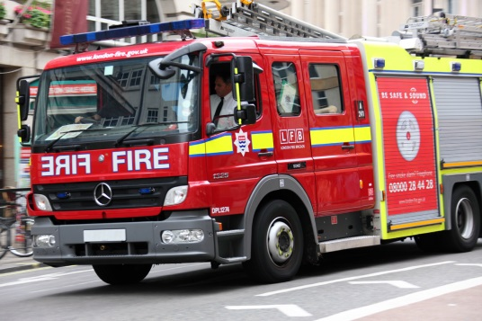  When and why should we call 999? Know what a hoax  call is
Hazard | A danger or risk.
Hoax | To trick or deceive someone.
Arson | A criminal act of deliberately setting fire to something.
Emergency | A serious often dangerous situation.

