 | PSHCE- Keeping/staying safe (Peer Pressure)
Key vocabulary | Explanation/ definition | Key knowledge
statement | Something stated in words | Understand potential outcomes of taking risks. What is peer pressure and why do we give in to it?  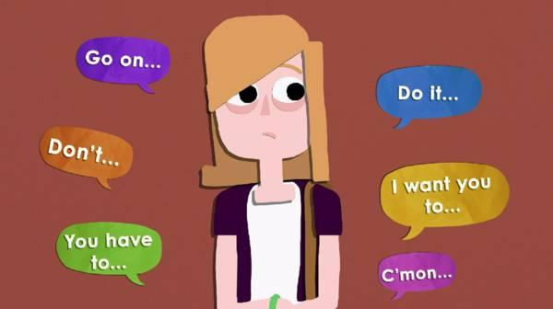
opinion | what someone thinks about something or somebody; viewpoint.
peer pressure | Influence from members of your group
risk | a chance of getting hurt or losing something.
fact | something said or known to be true.
strategy | a plan, method, or series of actions meant to perform a particular goal or effect.
consequence | that which follows; result.
encourage | to give hope or courage to; give confidence to.
influence | the power or invisible action of a thing or person that causes some kind of effect on another.

 | PSHCE- Keeping/staying healthy (Smoking)
Key vocabulary | Explanation/ definition | Key knowledge
addictive | causes you to become addicted | Understand that cigarettes contain nicotine, which is a drug, and that there are risks (physical, social and legal) related to smoking. Know and understand how smoking can affect your future health and wellbeing.  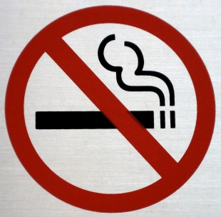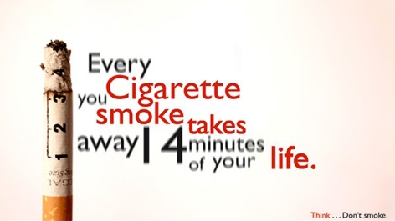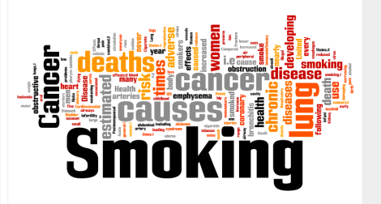
addiction | the condition of being addicted, especially to something that is not good for one's health.
nicotine | a poisonous substance found in the tobacco plant. Nicotine is what causes people to become addicted to cigarettes.
blood pressure | the pressure of the blood against the inner wall of blood vessels, esp. the arteries or the heart, as exerted by the contractions of the heart muscles, often measured as an indicator of physical health.
health | the condition of one's body or mind.

 | PSHCE- Relationships (Puberty)
Key vocabulary | Explanation/ definition | Key knowledge
puberty | the name for the time when your body begins to develop and change as you move from childhood to adult. | Understand what puberty means. Know and understand the changes that boys and girls may go through during puberty Understand why bodies go through puberty. Be able to develop coping strategies to help with the different stages of puberty.  
hormone | a substance made by certain cells in the body. Hormones move around the body in the blood and have effects on certain organs and cells. Hormones help control body processes such as growth.
adolescence | the period in a person's life between childhood and adulthood.

 | PSHCE- Being responsible (Looking out for others)
Key vocabulary | Explanation/ definition | Key knowledge
responsible | expected to take care of particular duties and jobs. | Learn skills of how to speak out when someone is being unkind to us or others Be able to describe caring and considerate behaviour Understand why it is important to be considerate and stand up to people who are not behaving in an appropriate, responsible way.  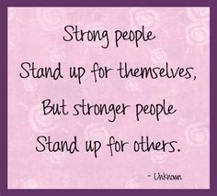
irresponsible | not having or showing responsibility; not able to be counted on or trusted.
honest | truthful, real or sincere.
considerate | thoughtful of the feelings and needs of others.
appropriate | right for the purpose; proper.
circumstance | a condition or fact connected with or having an effect on an event or situation.

 | PSHCE- Feelings and emotions (Anger)
Key vocabulary | Explanation/ definition | Key knowledge
anger | a strong emotion brought on by a person or thing that causes one great pain or trouble. | Understand more about healthy and unhealthy anger. Understand it is natural to feel angry but how it is expressed is important. How to debate.  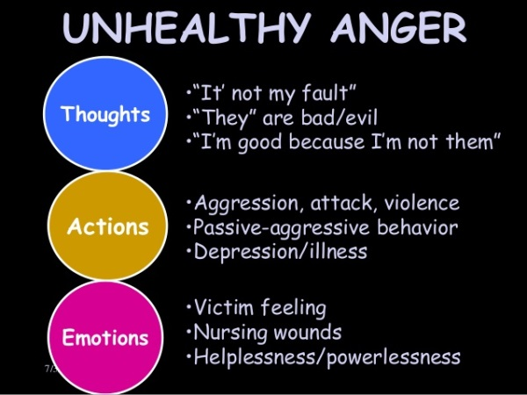
emotion | a strong feeling such as joy, hatred, sorrow, or fear. When one feels an emotion, there are physical changes such as an increase in pulse, crying, or trembling.
hostile | feeling or showing dislike; unfriendly.
aggression | The use of force or violence against another in order to dominate or achieve one's own goals.

 | PSHCE- Computer safety (Image sharing, online safety day)
Key vocabulary | Explanation/ definition | Key knowledge
privacy | secrecy- not intruded by others | Understand the consequences of potential outcomes of sharing images online. Be able to create a set of rules to follow when sharing images online. Know that there are rules and laws about sharing images online. How to overcome pressures to share online.  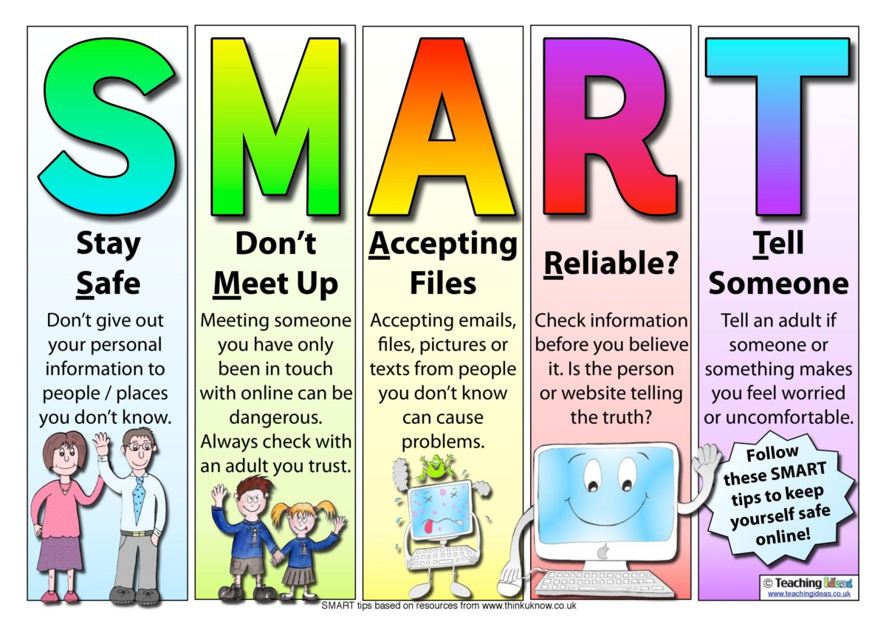
permission | giving allowance to someone or something
offensive | causing anger or hurt feelings.
image sharing | sharing images online
online | controlled by or connected to a computer
ICT | information- communication- technologies

 | PSHCE- The Working World (Enterprise)
Key vocabulary | Explanation/ definition | Key knowledge
enterprise | a plan or project that is risky, bold, or difficult to carry out | Understand the basics of saving money, be able to identify how you can help at home. Understand how to budget for items you would like to buy.  
contribute | to have a part in bringing about something
budget | a plan for how much money will be spent and earned during a certain period.
savings | money that has been collected over a period of time.

 | PSHCE- A World Without Judgement (Inclusion and Acceptance)
Key vocabulary | Explanation/ definition | Key knowledge
inclusion | the act of including or the state of being included. | What makes us different and unique? What makes the community diverse? Describe strategies to overcome barriers and promote diversity and inclusion.  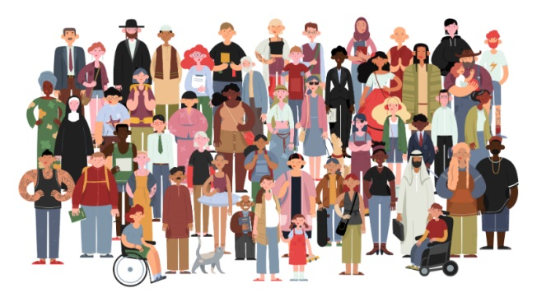
diversity | the condition of being different
stereotype | something agreeing with a pattern
accept | to receive or take willingly
acceptance | the act of accepting
discrimination | to treat some people better than others without any fair or proper reason
entitled | to give a right to

