Expressing yourself  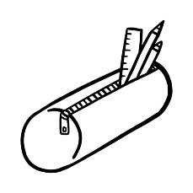Drawing and writing can help you think about your feelings or anything that's worrying you or making you feel anxious. Doing something creative can help you to feel calmer and distract you from problems. And you don't have to be "good" at art to be creative. Expressing yourself is for you.  You can try as many of these activities as you like. Or find a favourite that you can go to any time you need to  The activities are from the ChildLine calm zone, follow the link below for more activities and resources.  https://www.childline.org.uk/toolbox/calm-zone/ | Connection    Write 1 or 2 words about how you're feeling.  Using a notebook, draw a heart or a star for yourself and write 3 kind words or messages to yourself.  Remind yourself that no matter how difficult things feel, you are not alone - someone in your street, neighbourhood, town or city is likely to be feeling similar emotions to you right now.  Draw a heart or a star for someone else who is feeling like you do and write 3 kind words for them too.  You can do this for as many people you like. | Values  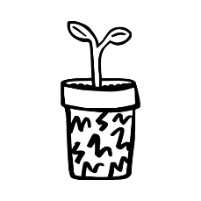  Knowing what's important to you can help you to prioritise when you're under pressure or feeling overwhelmed.  Write a list of your values and things that matter to you, like feeling calm, being kind or taking care of your pet.  Look at your list every week and decide whether these are still important or if you want to add or remove something.  When you have a difficult decision to make or too many things to do, have a look at your list to help you choose what to do next.
Stress and anxiety    We hold tension in our bodies when we're under pressure, feeling stressed or feeling anxious.  Draw the outline of a gingerbread person and add where you feel stress and anxiety in your body - that might be butterflies in your tummy, your legs feeling weak or your heart beating fast.  Draw how it feels in each part of your body and use colours or numbers to show where you feel the strongest sensations. Let go of any tension by unclenching your hands, dropping your shoulders, stretching, doing yoga or dancing and draw or write any changes on your picture. | Helping hand  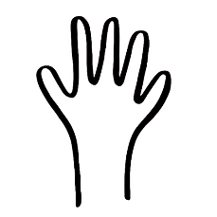  Draw the outline of your hand on paper. Follow the outline with your finger or click on it with the mouse to trace the shape as you take a slow, deep breath.  Start at the thumb, move to your other fingers and end with your little finger as you breathe in.  Trace back from the little finger to the thumb as you breathe out.  If you can't make it all the way around, you can start with tracing around the thumb and the first finger while you breathe in and around the first finger and back around the thumb as you breathe out.  You can colour in the hand after. | Mirror  Draw yourself as your closest friend or a close family member would describe you. Remember, they can see who you are as a person as well as what you look like.  Draw or write the positive qualities they notice about you, especially the ones that you find hard to see yourself. Include things like being kind, patient and fun.  .

