4/5H
Summer two
History / Geography 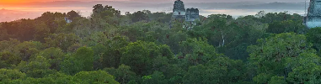
This term we will be focusing on History when we will be looking at ‘How did achievements of the ancient Maya impact their society and beyond?’
We will be learning:
- How did the ancient Maya settle in a rainforest?
- What do the remains tell us about the Maya life?
Maths
Shape and position and direction (Year 4)
Negative numbers and converting units (Year 5)
- Compare and order angles.
- Translate a on a grid.
- Count beyond 0.
- Convert units of time.
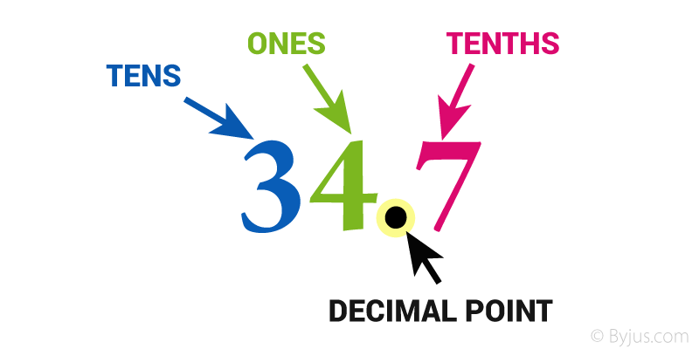
English
This term we will be reading ‘A stage full of Shakespeare stories’ by Angela McAllister.
The children will write a script.
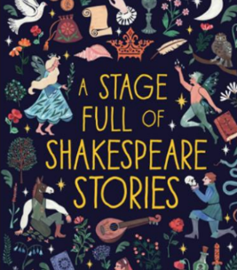
Science
We are going to be learning about making connections- how does the flow of liquid compare?
The children will learn about:
- Investigating liquids.
- Gathering, analyising and concluding data with an evaluation.
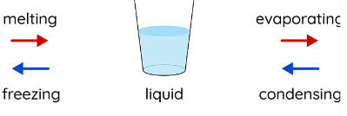

RE
We will be learning about how and why do people try to make the world a better place?
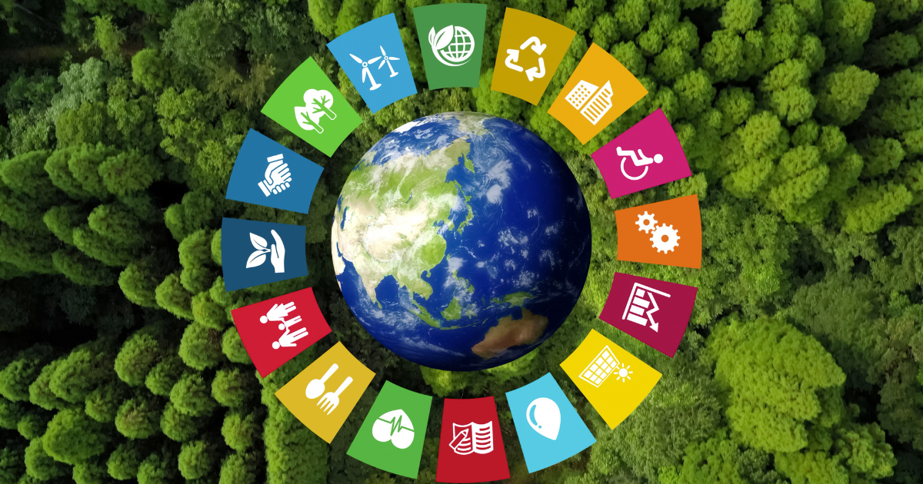
PSHE
This term the children will be learning about Economic well-being
We will be learning about:
- The value of money.
- How to look after money.
- Career choices.

PE
This term we will be focusing on:
- Pickleball (Key PE).
- Athletics.


Computing
This term we will be learning skills to showcase HTML
We will be learning about:
- Looking at webpages.
- Using purposeful codes.


Art / DT
We are doing Art this term and we will be doing Craft and Design.
We will be:
- Looking at one picture and design it in 4 different ways.
- Creating and repeating patterns.
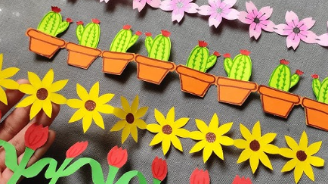
Music
We will be learning about South Africa music (instrument lessons).


