PE
Mondays – Key PE coach – Athletics
Wednesdays – Striking and fielding
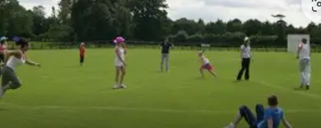

PSHE – Families & Relationships
Transition to Year 4
We will learn about:
- Respecting differences in others
- Stereotyping: Gender
- Stereotyping: Age
- Coping strategies
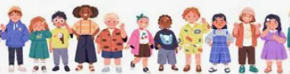

Maths – Time, Shape & Statistics
We will learn to:
- Calculate durations of time
- Solve time problems
- Recognise right angles
- Compare angles
- Recognise and describe 2-D and 3-D shapes

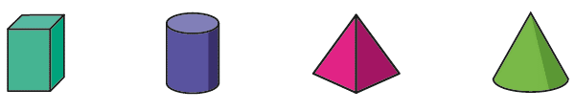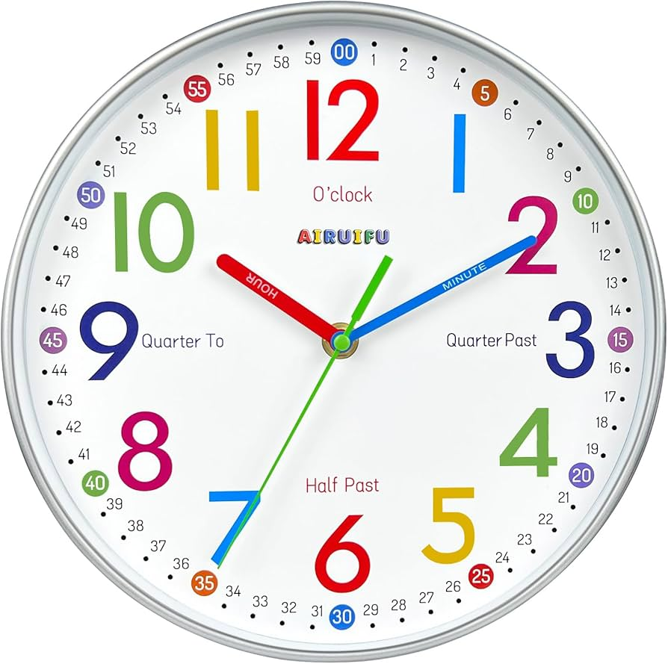

Science – Making Connections – Does hand span affect grip strength?
We will be exploring the relationship between hand span and grip strength through scientific enquiry.


That affect shadows.
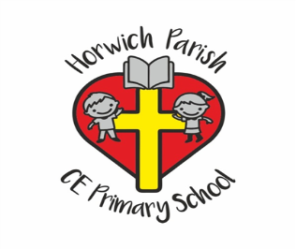
3B
Summer 2
History – What was important to Ancient Egyptians?
We will identify Ancient Egypt’s location and its key geographical features. We will explain why the River Nile was important to ancient Egyptians. We will learn about the significance of the Rosetta Stone and the importance of gods and goddesses to people in Ancient Egypt.
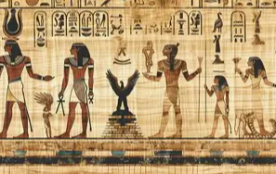

Music – Traditional instruments and Improvisation (Theme - India)

We will be learning about traditional Indian music and instruments. We will create a piece of music using a drone, rag and tal.
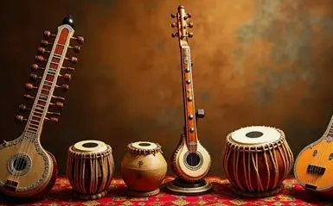

RE – How and why do people try to make the World a better place?
We will find out how Jewish, Christian, Muslim and non-religious people try to care for the world.
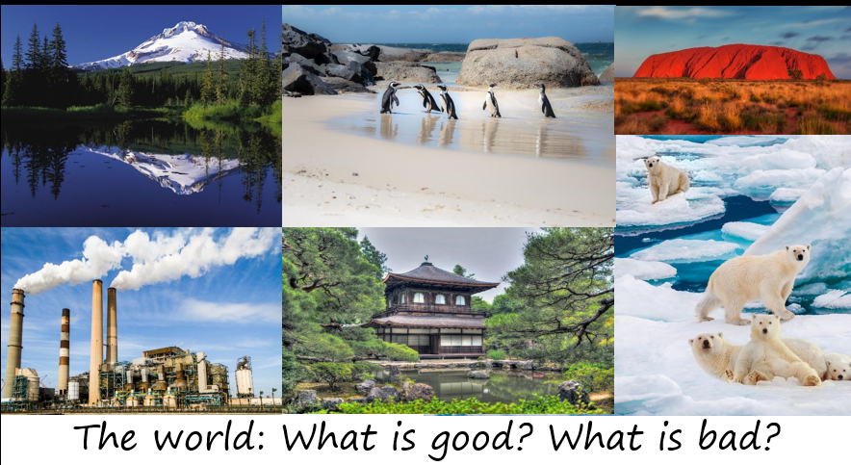
English – Zeraffa Giraffa
We will be writing Planning and writing a persuasive guide for visiting Zeraffa at the Jardin des Plantes in Paris.
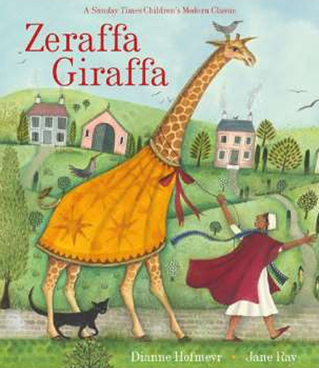

Computing – Data Handling Comparison Cards Databases
We will be exploring the concepts of sorting and filtering by learning about records, fields and data.
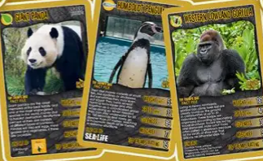
Art – Craft and Design – Ancient Egyptian Scrolls

We will be applying the styles, patterns and techniques of Ancient Egyptian art. We will design scrolls, make paper then make scrolls.

.

