English
Our focus text will be ‘Toys in Space’ by Mini Grey.
We will be building the skills to write a re-tell of the story with the inclusion of a character from our imagination.

Maths
In this half-term we will be focusing on place value within 100, position and direction, money and time.

Science
Making connections
In this unit we will be exploring animals and plants in the UK woodlands. We will be making connections from previous topics and applying our knowledge to investigations.

History
How have explorers changed the world?
In this unit we will be learning more about important explorers from the past and present including Matthew Henson and David Attenborough.

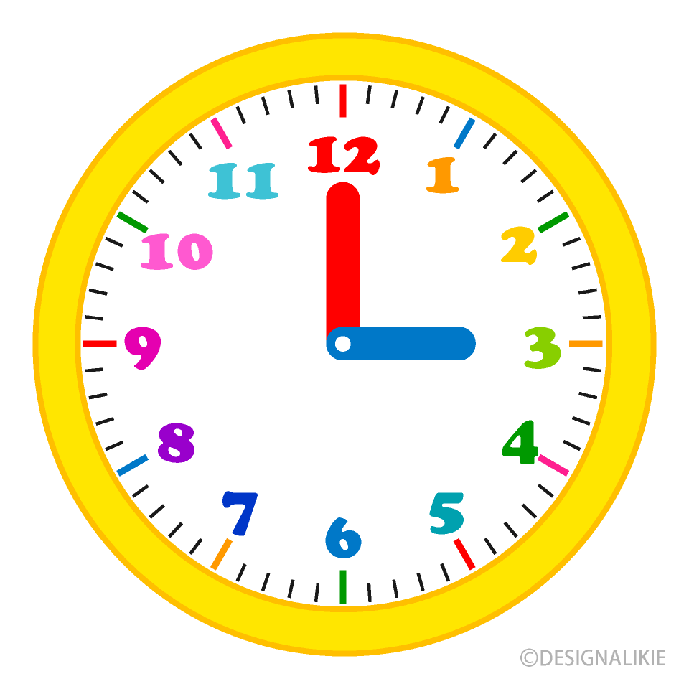

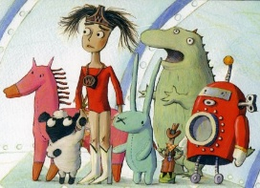
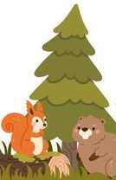


RE
How should we care for the world and why does it matter?
In this unit we will be reflecting on how we can respect God’s world.

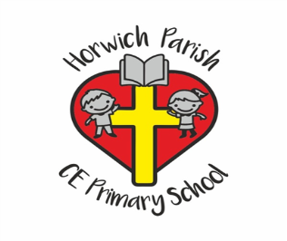
Year 1
Summer 2 2026

PE
Tactics and Strategy
Teddy Cricket


PSHE
Wellbeing
In this unit we will be thinking about how to look after our mental health as well as physical health.
Art
Colour splash
In this unit we will be exploring the basics of colour theory, experimenting with different painting styles and exploring the work of Clarice Cliff.

Music
Musical symbols
In this unit we will focus on recognising simple musical symbols and applying our musical knowledge to an ‘under the sea’ composition.

Computing
Rockets
In this unit children will create digital instructions and follow them to build a rocket.

