Maths 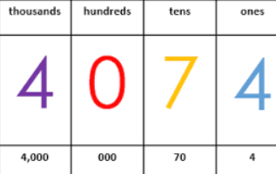
Shape
Position and Direction
Decimals
Negative Numbers
Converting Units
Volume
RE
We will be learning about what Jesus would do and make links to the modern day world.
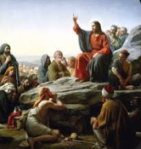

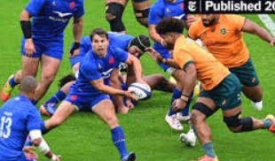
PE
Tactics and strategies
Computing
Throughout this half term, we will be learning about communication.

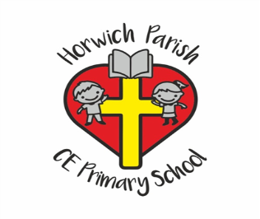
Year 5
Summer 1
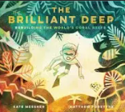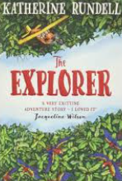
English
In English we will be reading ‘The Brilliant Deep’ and learning about persuasive writing. In reading skills, we will be using the novel ‘Explorer’ to practise daily reading skills.
Science
We will be learning about unbalanced forces.
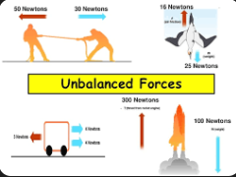
PSHE
We will be learning about wellbeing.

Music
In music, we will be studying looping and remixing.
DT
In DT, we will be designing and creating stuffed toys.
Geography

In geography, we will be studying deserts.

