PE
Mondays – Key PE coach – Pickle ball
Thursdays – Athletics

PSHE – Economic Wellbeing
We will learn about:
- Budgeting
- Methods of payment
- The wide range of jobs and careers
- Our aspirations


Maths – Fractions, Money and Time
We will learn to:
- Add and subtract fractions
- Find fractions of amounts
- Add and subtract money
- Calculate change
- Tell the time to 5 minutes and 1 minute
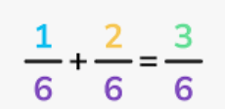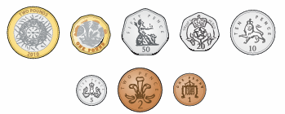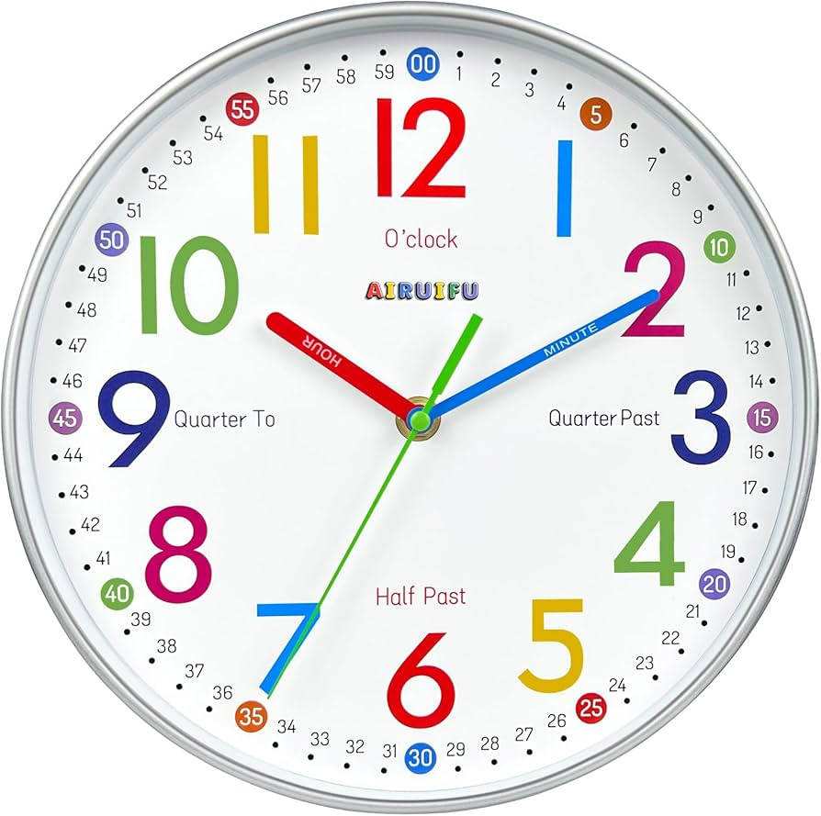

Science – Plants

We will be describing the life cycle of a flowering plant and investigating plant structure and function.
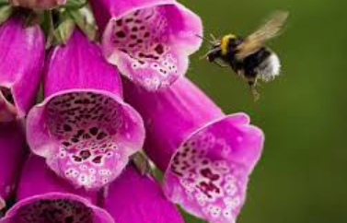

That affect shadows.
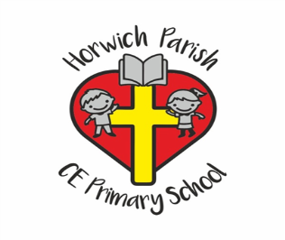
3B
Summer 1
Geography – Are all settlements the same?
We will identify human and physical features in the local area and describe how the local area has changed over time. We will look at land use in New Delhi and make comparisons.
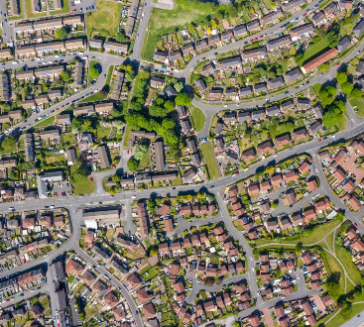

Music – Jazz

We will be learning about jazz and ragtime music and composing and playing a jazz motif.
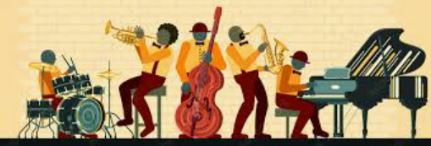

RE – What do Christians learn from the Creation story?
We will be learning about the first Creation story from Genesis and key messages within it then move on to discuss the story of Adam and Eve.

English – Amazing Rivers
We will be writing the text for an information board, designed to give visitors information and persuade them to look after our waterways.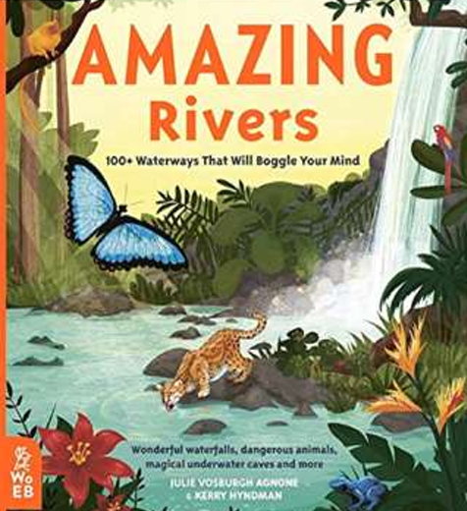

Computing – Journey inside a computer
We will be looking at how the parts of a laptop work together and the purpose of each part. We will consider what memory is for inside a computer and explain what an algorithm is.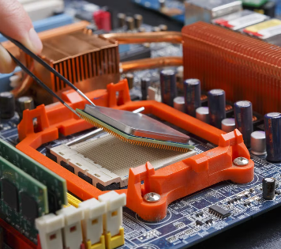
DT – Cooking and Nutrition - Eating seasonally

We will be learning about seasonal foods and using our understanding to create a seasonal food tart.




