History / Geography 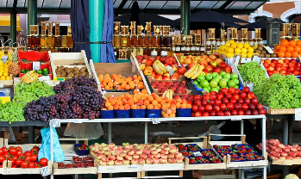
This term we will be focusing on Geography when we will be looking at ‘Where does our food come from?
We will be learning:
- How can our food impact the environment?
- What does it mean to trade responsibly?
Maths
Decimals and Money (Year 4)
Decimals and perimeter and area (Year 5)
- Round to 1 decimal place (Y5)
- Work out the perimeter of polygons (Y5)
- Partition decimals (Y4)
- Write Money using decimals (Y4) 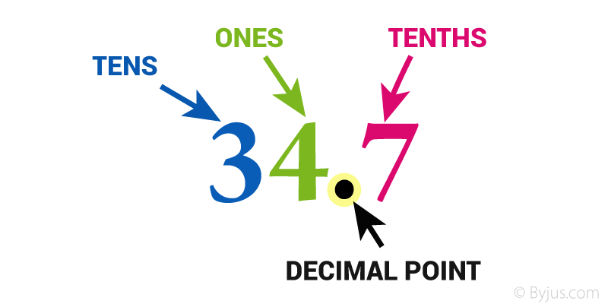

English
This term we will be reading ‘Where the Forest Meets the Sea’ by Jeanie Baker and ‘Jungle Explorer’ by The Literacy Company
The children will write zoo information board for a rainforest exhibit.
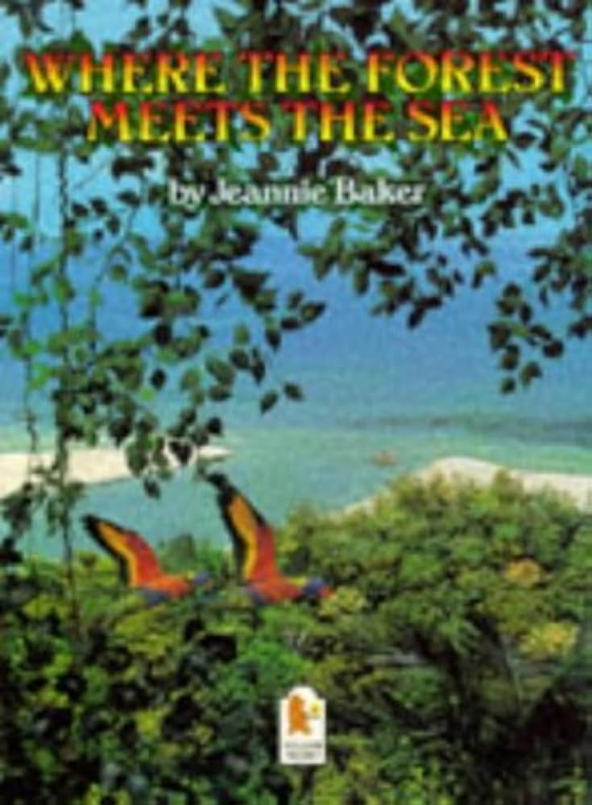
Science
We are going to be learning about Electricity and Circuits
The children will learn about:
- Using electricity
- Building circuits
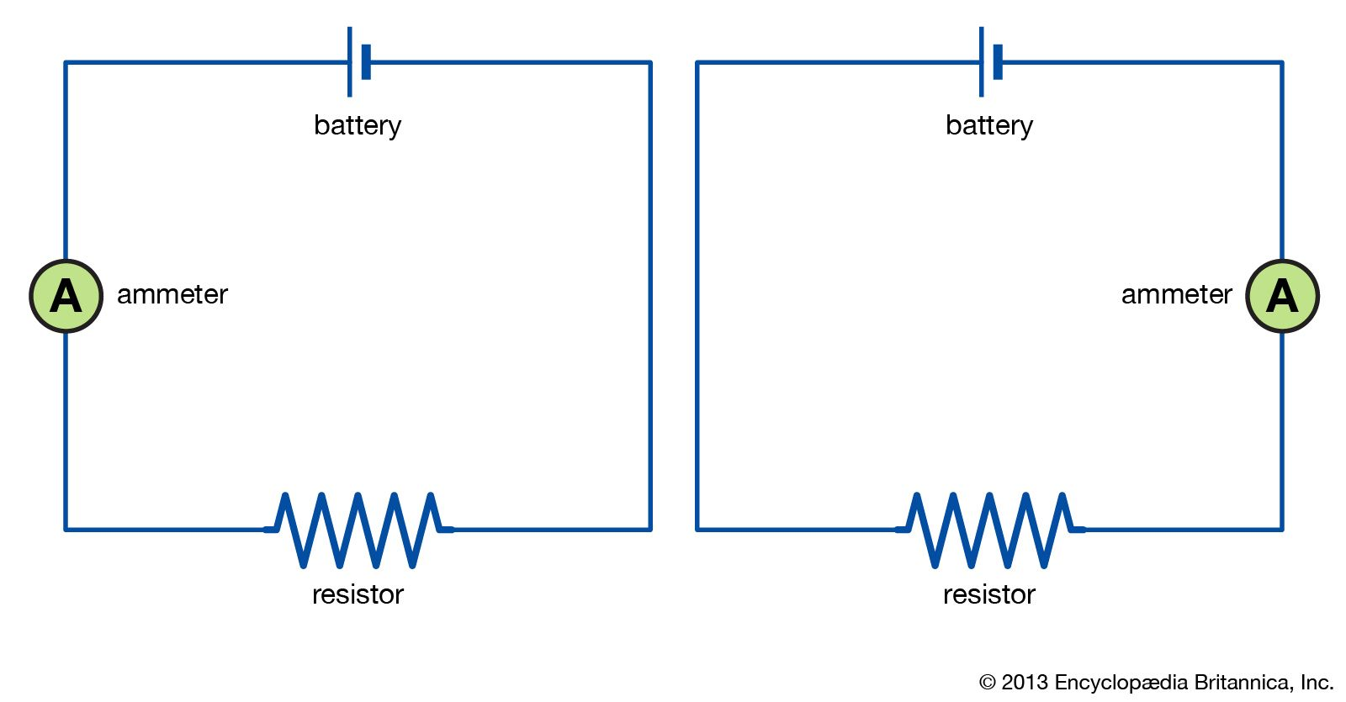

4/5H
Summer one
RE
We will be learning about what kind of world would Jesus want.
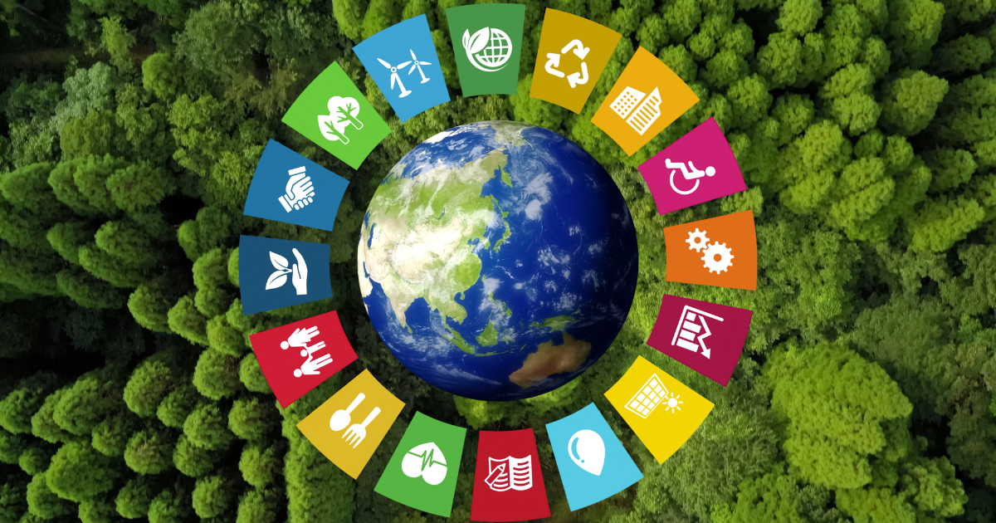
PSHE
This term the children will be learning about Economic well-being
We will be learning about:
- The value you of money
- How to look after money
- Career choices.
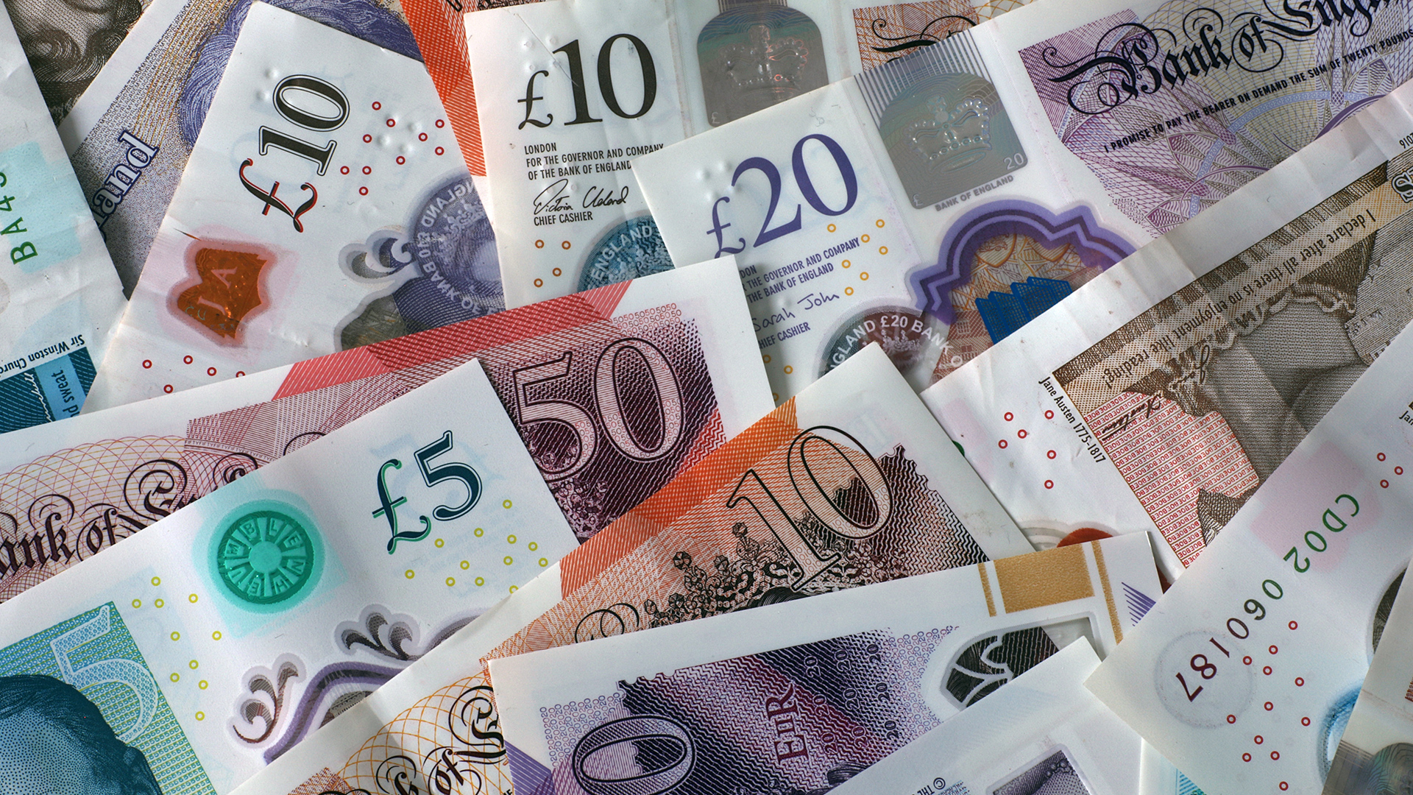
PE
This term we will be focusing on:
- Athletics
- sports day
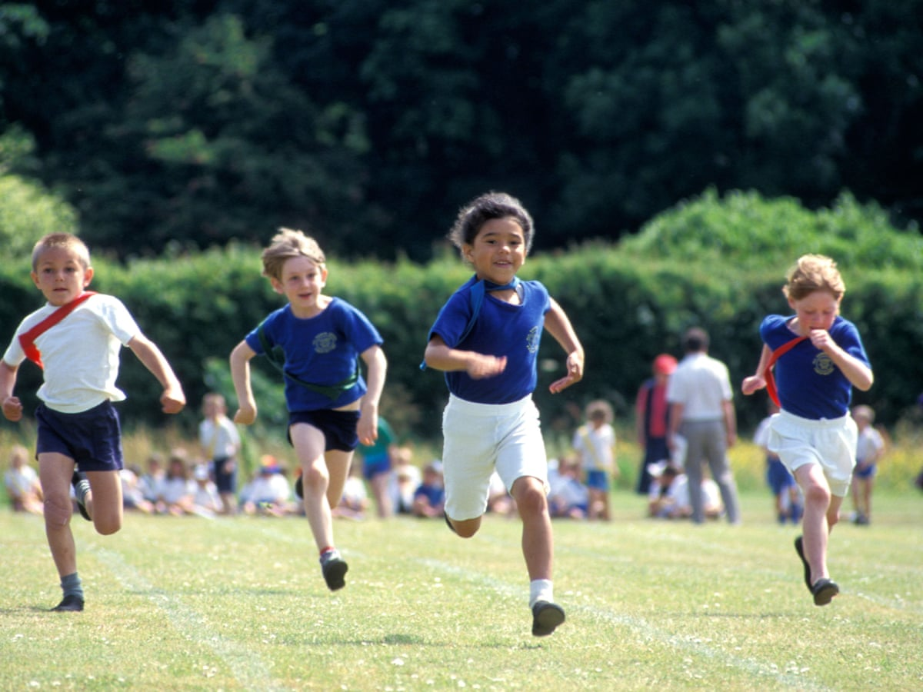

Computing
Computer Systems and Networks 2
We will be learning about:
- Communicating with technology
- Sending an email
- Adding an attachment

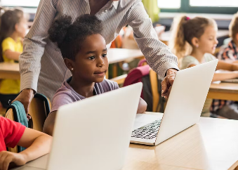
Art / DT
We are doing DT this term and we will be doing textiles.
We will be:
- What is a fastening?
- How to make a book mark
- Evaluate the book mark

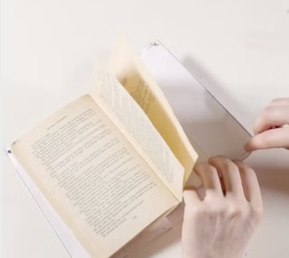
Music
We will be learning about South Africa music (instrument lessons)


