RE
Why is the Torah so important to Jewish people?
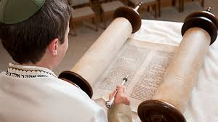

Music
Songs of World War 2
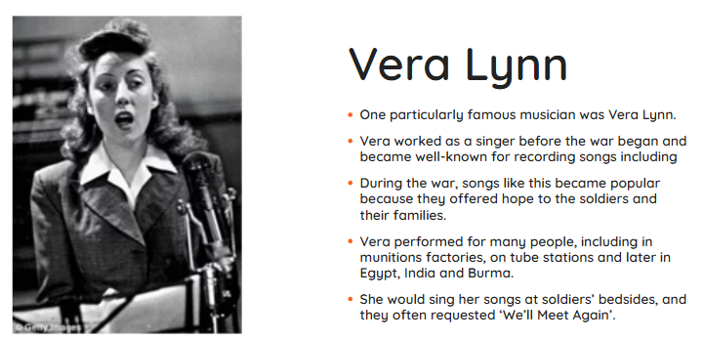

Maths
Geometry
Statistics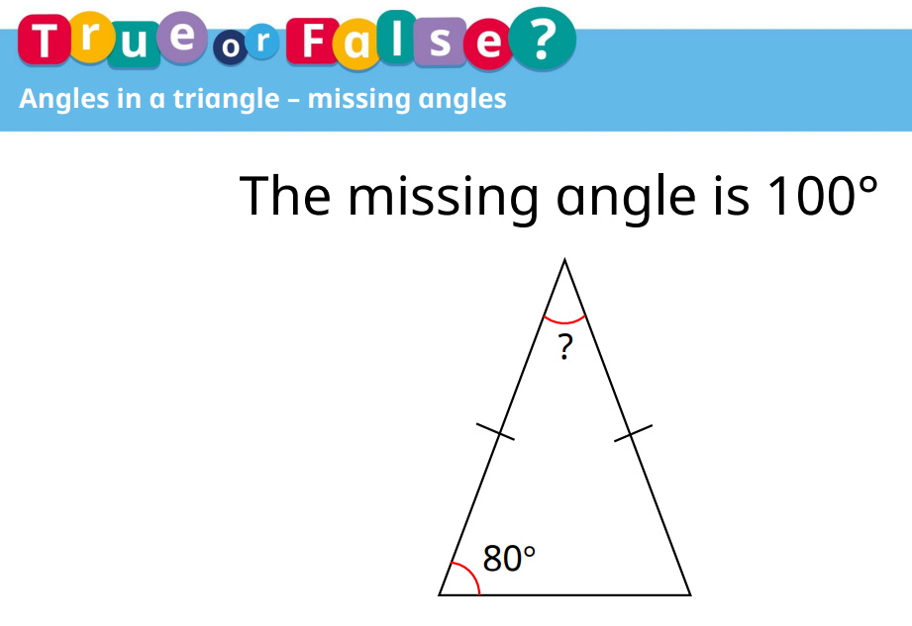

Science
Circuits, batteries and switches
English
This half term we will have a focus on spelling and grammar
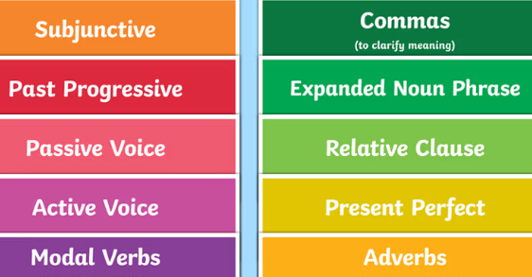

History
What was the impact of World War 2 on the people of Britain?
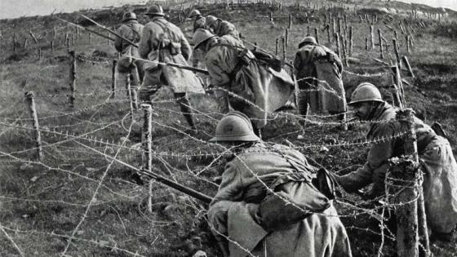

PE
Athletics


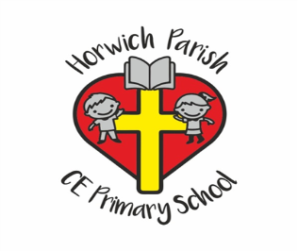
Year 6
Summer 1 2026

Design Technology
Structures: Bridges
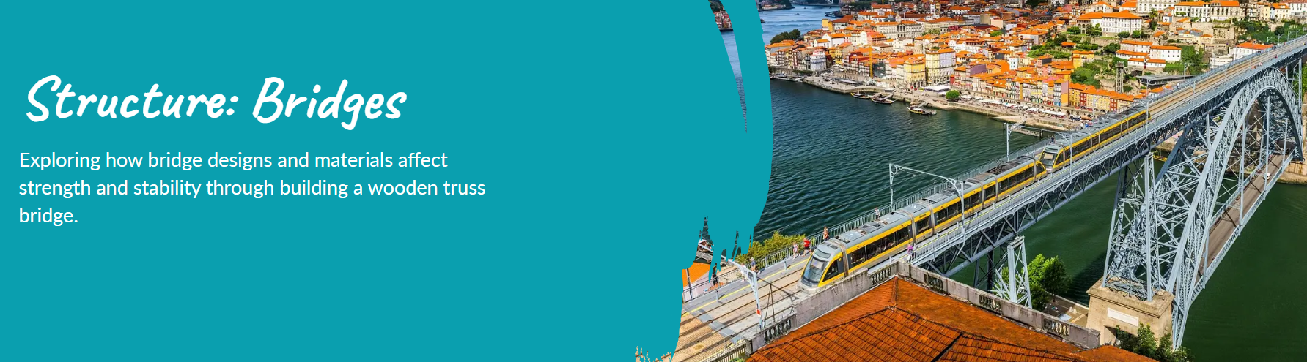

Computing
Data Handling
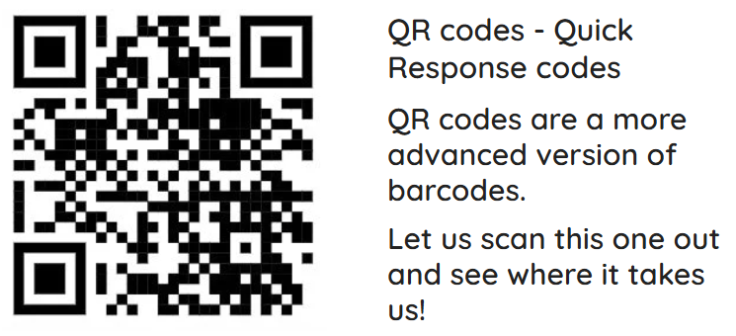

PSHE
Citizenship
