English
Our focus text will be ‘Nibbles the Book Monster by Emma Yarlett’.
We will be focusing on grammatical skills of prefixes and suffixes as well as the chronology of narrative writing.

Maths
In this half-term we will be focusing on multiplication, division and fractions.
We will be building our fluency skills by learning to count in 2s/5s/10s.

Science
Plants
In this topic we will be looking at the parts of plants, how to look after them and the difference between deciduous and evergreen.

Geography
Shanghai
In the topic we will be making a comparison between our local area and Shanghai. We will focus on human and physical features.

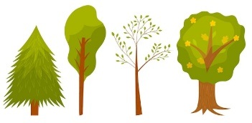
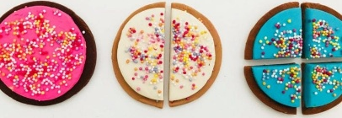
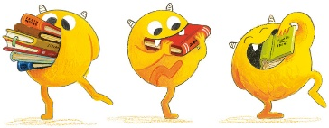


RE
We will be exploring the key question ‘What does it mean to belong to a faith community?’

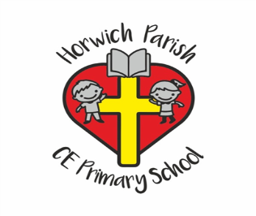
Year 1
Summer 1 2026

PE
Tactics and Strategy
Teddy Tennis
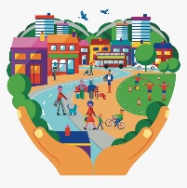

PSHE
Economic Wellbeing.
In this topic we will be thinking about the purpose of a bank, spending and saving and how to make wise money decisions.

DT
Textiles: Puppets
We will be working with felt to create character puppets and experimenting with different methods of joining fabrics.

Music
Pitch
We will be learning about high and low sounds and creating our own superhero theme tunes.

Computing
Creating media: Digital Imagery.
We will be using Google and Sketchpad to cerate and edit digital images.


